

**A STUDY ON JOB SATISFACTION AND MANAGEMENT LEADERSHIP STYLE AFFECTING EMPLOYEE RETENTION IN SUTHERLAND PHILIPPINES**

An Undergraduate Thesis Presented to the

Faculty of the Ramon V. del Rosario College of Business

Decision Sciences and Innovation Department

De La Salle University

In Partial Fulfillment of the Requirements for the

Degree of Bachelor of Science in Interdisciplinary Business Studies

Submitted by:

Dacanay, Miguel Alejandro S.

Gan, Richard Justin

Mr. Patrick Hariramani

Thesis Advisor:

March 9, 2020

**Table of Contents**

Chapter 1: Introduction 1

1.1. Background of the study 1

1.2. Company background 2

1.2.1. Company Products and Services 4

1.2.2. Organizational Chart 6

1.3. Statement of the Problem 6

1.4. Objectives of the study 7

1.5. Significance of the study 8

1.6. Scope and Limitations 11

Chapter 2: Review of Related Literature 12

2.1 Introduction 12

2.1.1 The Economy of the Philippines 13

2.1.2 BPO Industry in the Philippines 14

2.1.3 Operations of a BPO Company 16

2.1.4 Attrition in Sutherland Philippines 16

2.1.5. Global BPO Industry 19

2.1.6. Big Players of the BPO Industry in Asia 20

2.2 Job Satisfaction 21

2.2.1. Job Satisfaction in relation to Turnover 26

2.2.2. The Relevance of Job Satisfaction 30

2.2.3. Factors affecting Job Satisfaction 31

2.2.4. Job Embeddedness 33

2.3 Leadership Style 35

2.3.1 Transformational Leadership 38

2.3.2. Transactional Leadership 39

2.3.3. Laissez-Faire 40

2.4. Employee Retention 41

2.4.1. Employer Branding 42

2.4.2. Employee Retention in The Service Sector 43

2.4.3. Employee retention on Service industry 44

2.4.4. Employee Engagement 46

2.4.5. Employee Retention Strategies 47

2.4.6. Maslow’s Hierarchy of Needs (1943) 47

2.4.7. Retention Strategies in BPO Companies in India 48

2.5. Link of Variables 50

2.5.1. Job Satisfaction in relation to Employee Retention 50

2.5.2 Leadership Style in relation to Employee Retention 53

2.5.3 Leadership Style in relation to Job Satisfaction 54

2.6. Synthesis 55

2.7. Research Gap 58

Chapter 3: Framework of the Study 60

3.1 Theoretical Framework 60

3.1.1 Job Satisfaction 60

3.1.2 Leadership Style 64

3.1.3 Employee Retention 65

3.2 Conceptual Framework 67

3.3 Operational Framework 68

3.4 Hypothesis of the Study 69

3.5 Assumptions of the Study 71

3.6 Operational Definition of Terms 72

Chapter 4: Methodology 77

4.1 Research Design 77

4.2. Research Locale 78

4.3. Profile of Respondents 79

4.4. Sampling Design 79

4.5. Method of Data Collection 80

4.5.1 Survey Instrument 81

4.6. Method of Data Analysis 84

4.6.1 Descriptive Statistics 84

4.6.2 Linear Regression Model 85

4.6.3. Multiple Linear Regression 86

4.6.4. Cronbach’s Alpha 86

Chapter 5: Presentation and Analysis of Data 89

5.1 Description of Data Collection Protocol 89

5.2 Consolidated Results of Demographic Information 90

5.2.1 Consolidated Results of Survey Items 93

5.3 Results of Inferential Statistics 100

5.3.1 Linear Regression results to establish the relationship between Job Satisfaction and Employee Retention 100

5.3.2 Linear Regression results to establish the relationship between Transformational Leadership Style and Employee Retention 101

5.3.3 Linear Regression results to establish the relationship between Transactional Leadership Style and Employee Retention 102

5.3.4 Linear Regression results to establish the relationship between Laissez-Faire Leadership Style and Employee Retention 102

5.3.5 Linear Regression results to establish the impact between Job Satisfaction and Employee Retention 103

5.3.6 Linear Regression results to establish the impact between Transformational Leadership Style and Employee Retention 104

5.3.7 Linear Regression results to establish the impact between Transactional Leadership Style and Employee Retention 104

5.3.8 Linear Regression results to establish the impact between Laissez-Faire Leadership Style and Employee Retention 105

5.3.9 Multiple Linear Regression results to establish the impact between Job Satisfaction and Leadership Style to Employee Retention 105

5.3.10 Multiple Linear Regression results to establish the relationship between Job Satisfaction and Leadership Style to Employee Retention 106

5.3.11 Linear Regression results to establish the relationship between Leadership Style and Employee Retention 106

5.3.12 Linear Regression results to establish the relationship between Pay and Employee Retention 107

5.3.13 Linear Regression results to establish the relationship between Benefits and Employee Retention 107

5.3.14 Linear Regression results to establish the relationship between Promotions and Employee Retention 108

5.3.15 Linear Regression results to establish the relationship between Work Conditions and Employee Retention 108

5.3.16 Linear Regression results to establish the relationship between Participation and Employee Retention 109

5.3.17 Linear Regression results to establish the impact between Pay and Employee Retention 109

5.3.18 Linear Regression results to establish the impact between Benefits and Employee Retention 110

5.3.19 Linear Regression results to establish the impact between Promotions and Employee Retention 110

5.3.20 Linear Regression results to establish the impact between Work Conditions and Employee Retention 110

5.3.21 Linear Regression results to establish the impact between Participation and Employee Retention 111

5.4 Results of Hypothesis Testing 111

Chapter 6: Conclusion and Recommendations 114

6.1 Conclusion 114

6.1.1 Job Satisfaction to Employee Retention 116

6.1.2 Pay to Employee Retention 116

6.1.3 Benefits to Employee Retention 117

6.1.4 Promotions to Employee Retention 117

6.1.5 Work Conditions to Employee Retention 118

6.1.6 Participation to Employee Retention 118

6.1.7 Leadership Style to Employee Retention 119

6.1.8 Transactional Leadership Style to Employee Retention 119

6.1.9 Transformational Leadership Style to Employee Retention 120

6.1.10 Laissez-Faire Leadership Style to Employee Retention 120

6.2 Recommendation 122

6.2.1 PIP 122

6.2.2 Pay 123

6.2.3 Work Conditions 124

6.2.4 Laissez-Faire 124

6.2.5 Transformational Leadership Style 125

6.2.6 Acknowledgement of Statement of the Problem 127

References 131

APPENDICES 143

APPENDIX A: Interview 143

APPENDIX B: Acceptance Letter 147

APPENDIX C: Sample Questionnaire 152

APPENDIX D: Google Form - Survey Questionnaire 153

APPENDIX E: Cronbach Alpha Test 158

APPENDIX F: Regression Analysis 160

APPENDIX G: Pearson’s Correlation Analysis 162

APPENDIX F: REO Forms 167

APPENDIX H: Letter of Removal 179

**List of Figures**

Figure 1: Organizational Chart 6

Figure 2 Economy of the Philippines (Statista, 2019) 13

Figure 3 Leading countries in Offshore business services World-wide (Statista, 2019) 14

Figure 4: Attrition per month for Sutherland (Sutherland Philippines, 2019) 17

Figure 5: Attrition Reasons in Sutherland (Sutherland Philippines, 2019) 18

Figure 6:. Reproduction of the causal model of turnover (Price & Mueller, 1981). 26

Figure 7: A quintessential transformational/transactional leadership framework (Haq and Chandio, 2017) 35

Figure 8: Core Leadership Characteristics (Haq & Chandio, 2017) 37

Figure 9: Characteristics of a Transactional Leadership (Haq & Chandio, 2017) 39

Figure 10: Factors of Employee Retention (Kossivi et al., 2016) 41

Figure 11: Factors of Employee Retention in Determining Job Satisfaction (Bacea and Bordean, 2013) 50

Figure 12: Turnover Model (Shui, 2011) 51

Figure 13: Reproduction of the relationship between factors, intertwining variables, and employee turnover (Price, 1977). 52

Figure 14: Reproduction of the causal model of turnover (Price & Mueller, 1981). 60

Figure 15: Reproduction of the relationship between factors, intertwining variables, and employee turnover (Price, 1977). 63

Figure 16: A quintessential transformational/transactional leadership framework (Flanigan et al., 2017) 64

Figure 17: Employee Retention Framework (Kossivi et al., 2016) 65

Figure 18: Factors of Employee Retention (Kossivi et al., 2016) 66

Figure 19: The effect of Job Satisfaction and Leadership Style on Employee Retention. 67

Figure 20: Operational Framework 68

Figure 21:Vicinity Map 78

Figure 22: Gender Pie Chart 90

Figure 23: Educational Attainment Pie Chart 91

Figure 24: Age Group Frequency 91

Figure 25: Age group percentage 92

Figure 26: Pay Sub-construct Score 93

Figure 27: Participation Sub-construct Score 94

Figure 28: Question #18 Results 98

Figure 29: Question #21 Results 99

**List of Tables**

Table 1: List of common factors distinguished by dissatisfied workers and Satisfied Workers (Shobe, 2018) 32

Table 2: List of common factors distinguished by dissatisfied workers and Satisfied Workers (Shobe, 2013) 62

Table 3: Questionnaire items as defined by Nanjundeswaraswamy (2019), Nanzushi,(2015) and Price & Mueller (1981) 82

Table 4: Questionnaire items to measure as defined by Sinani (2016), Liden et al., (2014), Kyndt et al., (2009), Haq & Chandio, (2017), Nanjundeswaraswamy, (2019) 83

Table 5: Questionnaire items to measure as defined by Kossivi et al. (2016), Mathimaran,B.& Kumar, A. (2017), Nanzushi (2015), Kelchner (2019), Tyler and Blader (2002), Mathimaran,B.& Kumar, A. (2017), Backhaus and Tikoo (2004) 84

Table 6: 32 respondents for Reliability Test 86

Table 7 Cronbach’s Alpha 87

Table 8: Job Satisfaction Survey Results 95

Table 9: Transformational Leadership Style Survey Results 96

Table 10: Transactional Leadership Style Results 96

Table 11: Laissez-Faire Leadership Style Results 97

Table 12: Employee Retention Results 100

Table 13: JS to ER relationship 101

Table 14: Transformational to ER relationship 101

Table 15: Transactional to ER relationship 102

Table 16: Laissez-Faire to ER relationship 103

Table 17: JS to ER impact 103

Table 18: Transformational to ER impact 104

Table 19: Transactional to ER impact 104

Table 20: Laissez-Faire to ER impact 105

Table 21: JS and LS to ER impact 105

Table 22: JS and LS to ER relationship 106

Table 23: LS to ER relationship 106

Table 24: Pay to ER relationship 107

Table 25: Benefits to ER relationship 107

Table 26: Promotions to ER relationship 108

Table 27: Work Conditions to ER relationship 108

Table 28: Participation to ER relationship 109

Table 29: Pay to ER impact 109

Table 30: Benefits to ER impact 110

Table 31: Promotions to ER impact 110

Table 32: Work Conditions to ER impact 110

Table 33: Participation to ER impact 111

Table 34: Hypothesis Testing Table 113

ABSTRACT

Sutherland Philippines is a BPO company located in Ortigas and provides services to clients across the globe. During the month of August to September their attrition rate rose from 1% to 10% which was their highest attrition rate in 2 years. The proponents aim to examine what caused the attrition rate to go up and provide solutions on how to mitigate this based on survey data. With the help of regression analysis and Pearson’s correlation, group aim to determine the relationship and impact of Job Satisfaction and Leadership Style to Employee Retention.

Based on the given data a survey was made consisting of 10 questions for Job Satisfaction wherein Pay, Benefits, Promotions, Work Conditions, and Participation were sub-constructs. 6 questions for Transformational, Transactional, and Laissez-Faire Leadership Style. 7 questions for Employee Retention wherein Development Opportunities, Reward, Work-life Balance, Respect, Recognition, and Employer Branding were sub-constructs.

All variables was determined to be significant except for Job Satisfaction, this resulted in having to include Leadership Style to get a statistically significant result for the study. The group recommended that Sutherland PH increase the pay of the employees, implement an employee feedback system, and install work amenities to help employees decompress.

ACKNOWLEDGEMENT

We would like to express our sincerest gratitude to Mr. Patrick Hariramani for guiding us every step of the way through our research paper. Through his efforts, we were able to accomplish this task and gain irreplaceable knowledge.

To Mrs. Rizalina Gan-Keating of GoDaddy, the client vendor for Sutherland PH, without her as our primary contact we would have a hard time reaching out to Sutherland.

To Francis Delos Juan of Sutherland Philippines for taking our initial interview which provided us with much needed insights on the company and for being our company contact.

To Sutherland Philippines for helping us use their company as the basis for our research. Through this, we were able to fully understand our research

To our panelists, Sir Junius Yu and Miss Charisse Ang for showing us what we have overlooked and provide critical questions to which we can improve upon.

Above everything else, we would like to thank God for providing us the determination and strength to move through this research process for the greater good of education and achieving the dreams of both our parents and for us as well.

Thank you all

# Chapter 1: Introduction

## 1.1. Background of the study

The BPO industry in the Philippines has long been started since the 1990s. It started in 1992 by Mr. Frank Holz, who was the first to set up a contacting firm here in the country. From then on, numerous multi-national accounts have been established which opened our economy to the industry we know today. Over the years, this industry has grown exponentially earning the country a reputation and ranking in the world’s top outsourcing destination as reported A.T. Kearney Global Services Location Index in 2017. According to the said report, the country is at the 7th place among the world’s top outsourcing destinations based on financial attractiveness, people skills, and business environment.

With such rankings, it is logical that it is important for companies to maintain their talented employees. For any organization, employees are considered as the backbone resource that ensures an organization’s sustainability and development. In the business processing outsourcing sector, employees such as call center agents are those vital resources of the company. They are those who take calls from outside the country to help customers with their transactions and inquiries. In a report by the Philippine Statistics Authority in 2018, the total number of persons employed in the BPO industry was estimated to be at 575,600 of which nearly seven out of every eight employees (87.6% or 504,227) worked in the call center companies. Almost twelve percent (11.6%) were involved in computer-related activities, while the rest were employed in a medical transcription (0.5%) and animated films and cartoon production (0.3%). Furthermore, most of these employees are composed of rank and file employees at 89.0 percent or 512,555. Managers/executives and supervisors/foremen accounted for less than 10 percent (3.4% and 7.6%, respectively). Meanwhile, working owners and unpaid workers shared the remaining less than one percent of the total employment (0.03% or 156).

With this number of job employment in the industry, it is a constant challenge for BPO companies to sustain talented employees since their industry is heavily dependent on delivering service across the globe. One of these companies experiencing such a challenge is Sutherland Philippines which mainly provides cloud-based technology with its focus on the customer process improvement approach. In an interview from its management, it is a struggle for them to maintain homegrown talents that they have trained. Although the organizations can strengthen the employability of their employees in the global labor market, employees still leave the company after gaining such. Thus, the research paper will try to look at the issue from the perspective of the employees to identify problems and recommend solutions as needed.

## 1.2. Company background

Sutherland Global Services, Inc., a business process outsourcing and technology-enabled services company, provides an integrated set of back-office and customer-facing front-office services that support the entire customer lifecycle. It offers digital, customer engagement, and business process transformation services. The company’s digital transformation services include design research, design strategy, and digital design; investment research and investment banking/private equity/venture capital research, as well as strategy, market, and business research; analytics and artificial intelligence; enterprise automation; and program management and technology advisory, data integration and stewardship, application services, product development and quality assurance, and service desk and enterprise support.

The company also provides satisfaction and loyalty services; hardware and software installation, remote troubleshooting, product support, and services support; customer engagement transformation services that include Business-to-Customer and Business-to-Business sales, customer activation, renewals, and cross-sell and up-sell; and lead qualification and generation, lead nurturing and customer education, appointment setting, and market and customer profiling. In addition, it offers various services for sales and operations planning and order-to-cash activities. The company serves clients in banking and financial services, healthcare, technology, media and communications, retail, insurance, travel and hospitality, government industries in the United States and internationally. The company was founded in 1986 and is based in Pittsford, New York with locations in San Francisco, California; and London, United Kingdom. It also has operation centers in Australia, Brazil, Bulgaria, Canada, China, Colombia, Estonia, Egypt, India, Jamaica, Malaysia, Mexico, Morocco, the Philippines, Slovakia, Sweden, the United Arab Emirates, the United Kingdom, and the United States.

As a process transformation company, Sutherland rethinks and rebuilds processes for the digital age by combining the speed and insight of design thinking with the scale and accuracy of data analytics. It has been helping customers across industries from financial services to healthcare, achieve greater agility through transformed and automated customer experiences. For over 30 years, Sutherland provides improved processes for its customers and their very first revenue came from process consulting. Three decades later, Sutherland manages 120 clients from the Fortune 1000, and complete 43 million transactions a month on a digital backbone that spans 19 countries around the world.

Sutherland’s process transformation services innovate at the intersection of business and technology to transform processes that realize their client’s vision. They are experts in accelerating performance and achieving high-impact outcomes through winning execution strategies across the entire business and customer lifecycle.

### 1.2.1. Company Products and Services

Sutherland is a service company which provides services that are branched out into five respective areas namely; (1) Design (2) Consulting and Research (3) Analytics and AI (4) Platforms (5) Tech Services.

Under Design Sutherland Lab provides design research which is to see the world through customers’ eyes and understand their complex relationship with the world around them. Design strategy is to help organizations define the right problems to solve and create a road-mapped vision of the future. Digital Design is to translate ideas into concepts, and then brainstorm, prototype, and test solutions to be developed.

Under Consulting and Research: Digital Strategy & Value, Digital Customer Experience, Digital Maturity, Digital Workplace, Enterprise & Process Automation, Analytics & Insights

Sutherland’s Research services include the following: Strategy, Market and Business Research, Investment Research, Investment Banking /Private Equity /Venture Capital Research

Under Analytics and AI: Business Intelligence, Insight, and Reporting Platforms. Predictive, Prescriptive, and Descriptive Analytic models. “Big Data” Machine Learning and AI data intelligence solutions, Social Media and Web Analytics, Customer Data and Database Management Services, Data Advisory and Maturity Assessment Services.

Under Platform and Tools:

Sutherland’s Platform Services leverage a combination of emerging Digital Technologies designed to help their clients increase customer satisfaction and loyalty while driving down Total Cost of Ownership.

Platform and Digital Technologies enable creative customer engagement strategies that expand customer contact channels and bring innovative self-service offerings. Focusing on Customer Communication Channels, AI, Self Help Technology, and Customer 360 Views, services produce measurable results in customer satisfaction and cost reduction.

Enterprise Automation Services help integrate disparate systems in a simple, repeatable and scalable manner which drive increased efficiencies for the clients. Automation and Robotics offerings. Platform Services support all industries and offerings across Sutherland’s ecosystem.

Under Tech Services: Advisory Services which is Program management and technology advisory. Data Services which is Integration and stewardship. Application Services which is Back office automation and user engagement solutions. Product Services which is Development and quality assurance. Cloud Services which is Cloud adoption and consumption. Support Services which is Service desk and enterprise support

### 1.2.2. Organizational Chart

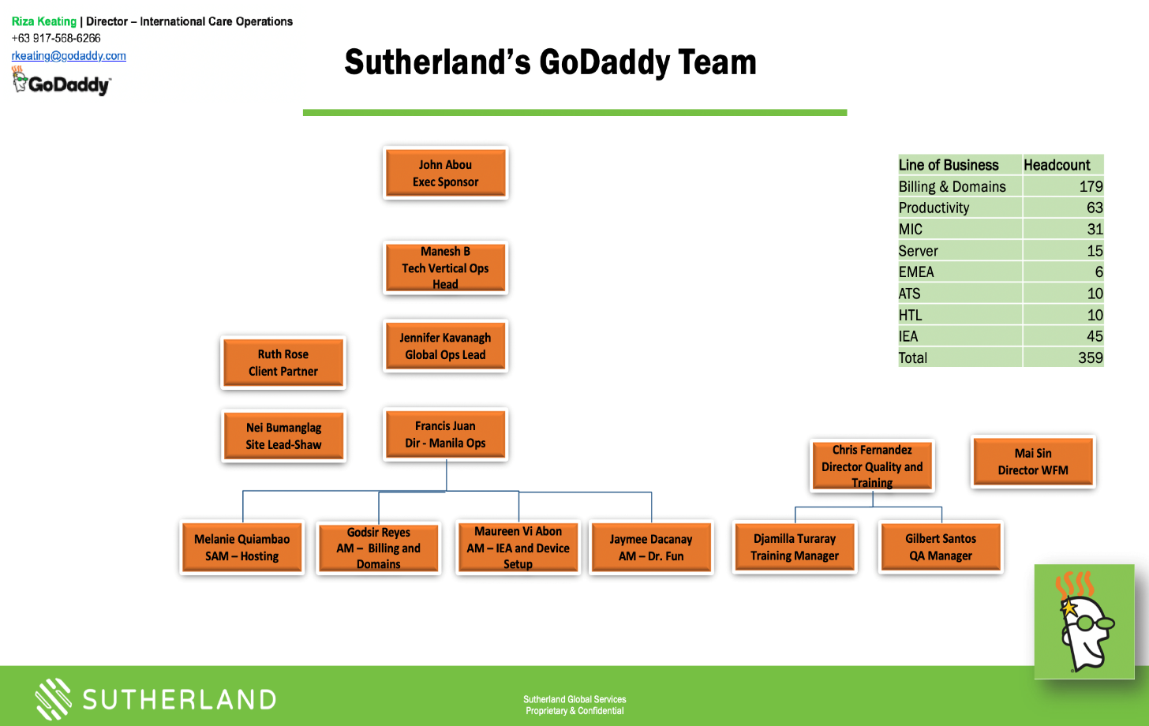

Figure 1: Organizational Chart

## 1.3. Statement of the Problem

The main problem that the researchers want to address is “***What are the effects of Job Satisfaction and Leadership Style to Employee Retention in Sutherland Inc.”.*** With this main problem statement, the researchers also want to address the following questions:

* What are the main factors affecting employee retention in Sutherland Philippines?
* What is the different Leadership style that is being manifested in Sutherland Philippines?
* What are the different methods employed by SP to increase Job Satisfaction of its employees and are these methods able to help?
* What is the employee’s perception of the Management style used in Sutherland?
* What is the degree of Job satisfaction in Sutherland Philippines?
* What relationship does Leadership style have on Job satisfaction in Sutherland Philippines?
* What relationship does Job satisfaction have with Employee retention in Sutherland Philippines?
* Which leadership style would best increase employee retention in Sutherland Philippines?
* What relationship does Job satisfaction have on Leadership style in Sutherland Philippines?
* What impact does Job satisfaction have on Sutherland?
* What impact does management Leadership style have on Sutherland Philippines?
* What impact does improve employee retention in Sutherland Philippines?
* What are the cost benefits of increasing employee retention in Sutherland Philippines?
* What recommendations can be offered to increase employee retention in Sutherland Philippines?

## 1.4. Objectives of the study

The researchers will help the company by identifying the main factors that affect employee retention. With the necessary data at hand, we will then use this information to guide the company in which leadership style and job satisfaction practices would improve employee retention.

The research primarily aims to:

* To discover the different factors in leadership style that could affect employee retention
* To determine whether the turnover rate is affected by the job satisfaction of employees
* To propose strategies to improve the job satisfaction that employees feel in Sutherland Philippines
* To determine which leadership style would retain employees in Sutherland Philippines
* To discover the effectivity of employee satisfaction in Sutherland Philippines
* To discover the cost-benefit of retaining employees in the company
* To know which practices will have a direct impact on retaining employees
* To distinguish the degree of job satisfaction in Sutherland Philippines
* To determine the relationship of Job satisfaction to employee retention
* To determine the relationship of leadership style to employee retention
* To determine the relationship of job satisfaction to the leadership style used by the company
* To identify the impact of job satisfaction and leadership style to employee retention in Sutherland Philippines.

## 1.5. Significance of the study

Over the turn of the millennium, businesses have taken advantage of Business Process Outsourcing (BPO) services provided by local and foreign companies, that cater to the local and international clients. To entice foreign investors, the government has been offering incentives for foreign companies to set-up operations in the country, this also attributable to the generally low wages, operating costs and costs of living in the country.

In recent years, there has been a significant rise and rapid expansion of the Philippine BPO industry, making it a billion-dollar industry, the global BPO sector has taken notice that the country has an ideal location for augmenting the growing demand for outsourcing services, various businesses have contributed to the increasing demand of services, may it be call center and back-end services. Philippine Offshore Gaming Operators, commonly known as POGOs, are accountable for this sudden growth and rapid expansion of the BPO Industry, these companies provide front-end and back-end services, to clients living abroad, notably the Asian market.

As the BPO industry continues to cater to the rising needs of local and foreign companies, it is expected that supply and demand will increase. Along with the need for their operations to keep up with the demands, companies must employ strategies to increase both employee retention and job satisfaction, improve leadership style are interrelated and critical to an organization’s success.

To achieve long term growth, companies have invested in business strategies that increase employee retention. Therefore, the researchers have identified possible stakeholders that make prove the studies beneficial:

* Sutherland Global Services Philippines

Understanding the effect of Job Satisfaction and Leadership inside the company could potentially improve the level of employee retention by improving current strategies being deployed by the company and fine-tuning it to the reception of leadership style and level of job satisfaction. Having a high employee retention rate will yield to the positive reputation of the company to future applicants, while also keeping existing employees satisfied to feel that they are assets to the company.

* Employees

This study can contribute by helping the company improve and develop strategies that would further improve an employee’s general experience with the company and be recognized as an asset to the organization, which could encourage them to stay with the company longer.

* Academe

This study can contribute by establishing whether Job Satisfaction and Leadership Style affect Employee Retention. It can guide researchers by exploring other variables that may or may not affect Employee Retention.

* BPO Industry

The Employee Retention strategy would be beneficial to the BPO industry since it is an opportunity for BPO companies to improve, develop, and modernize their existing Employee Retention strategies which could result in better outputs, increased productivity, more efficient operations to better keep up with the demands of the competitive industry.

* Other Industries

In general, The Employee Retention strategy could be of assistance to companies in other industries, outside the BPO Industry, they could use it as a basis for developing or updating their current strategy. It’s also an opportunity for the company to examine the effectiveness of their existing strategies used.

## 1.6. Scope and Limitations

The researchers will be conducting a study that is solely focused on the management and employees of Sutherland Global Services in Taguig, Philippines. The data that will be used to measure employee retention are data about job satisfaction and leadership styles of the organization, which will be obtained through the data gathered from the survey questionnaires given to the employees and through an initial interview with a company representative. Several survey questions have been adapted from past literature that looked into the same variables, not necessarily in the same industry.

Data will also come from the contact persons that the company provided to the group for interviews. Numbers that will be obtained correspond to the responses of employees exclusively Sutherland Philippines and the duration of data analysis and gathering will happen over 7 months beginning in September of 2019 and concluding in April 2019.

# Chapter 2: Review of Related Literature

This chapter will provide extensive research on the different variables used in this study. Which will, in turn, provide the researchers with much-needed information on why there is a need for this study and will aid in finding the possible answers to our research questions. The areas of this chapter will provide key insights and provide clarity to the readers.

## 2.1 Introduction

The purpose of this study is to determine how employee retention can be improved by identifying the best management leadership styles along with the job satisfaction of employees. Chapter 1 provides us with the context of the study and how important the BPO sector is to the rising Philippine economy. According to the PSA, the Philippines has 8achieved a 5.5 growth rate within the second quarter of the year 2019 with the service industry leading the growth rate by 7.1 percent. This means not only is it important for the company to acquire information on how to retain employees, but it is also paramount for the economy of the Philippines as a whole. Though many studies have been conducted that dive within the topic of employee retention, it is still widely misunderstood as some variables seemingly do not connect with each other and that a lot of companies differ from each other it is hard to pin down the exact cause of employee turnover which makes it harder to solve. Thus, this research study would aim to identify the different factors involved in retaining employees and to provide suggested strategies that would benefit the company by lowering Sutherland’s employee turnover rate. Not only is this paramount for Sutherland, but it can also be a basis for future endeavors that wish to solve the increase of employee turnover in their respective companies and for the service sector of the Philippines as a whole.

### 2.1.1 The Economy of the Philippines

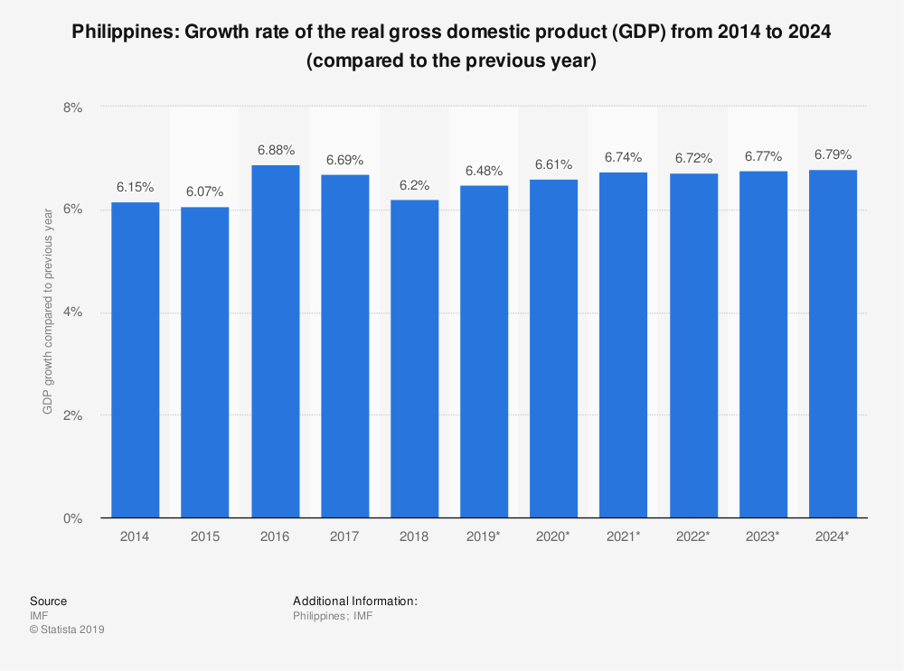

Figure 2 Economy of the Philippines (Statista, 2019)

By the statistics report of Statista, the Philippines from 2018 to 2019 grew 0.46% in real Gross Domestic Product. In the fourth quarter of 2018, the combined goods and services exported by the Philippines was Php.1.36 Million with the service sector accounting for most of the statistics (Euromonitor, 2018). The Philippines has seen a growth in the service sector by which companies from across the globe will outsource their operations to independent companies here in the Philippines, decreasing their costs. Outsourcing business activities has always been a key option when a business wants to expand but incur less cost. Due to the high cost of creating new facilities, employing personnel, foreign corporate tax, and strict government regulations on foreign companies, some companies resort to offshore outsourcing business ventures to accommodate their needs. The Philippines has seen a growth in the BPO sector which was widely accepted in the country. This was partly due to the need for above minimum wage jobs with the job requirement being attainable by those without college degrees. Another key reason why the BPO sector grew to where it is today being because of the fluent English dialect of the Filipinos, due to the American colonial period which still stuck to the country today.

### 2.1.2 BPO Industry in the Philippines

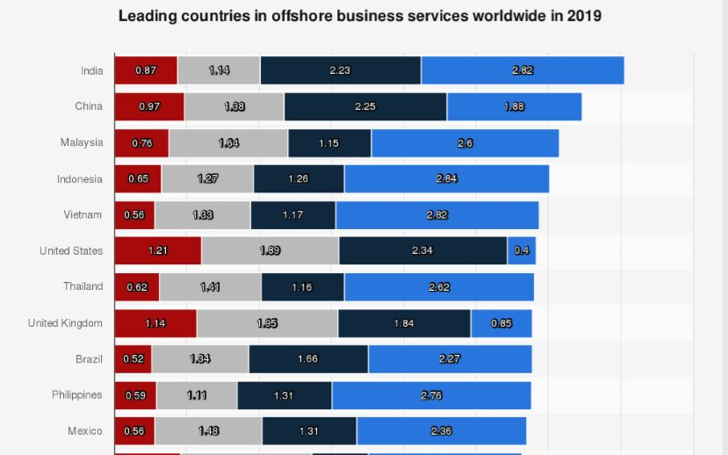

Figure 3 Leading countries in Offshore business services World-wide (Statista, 2019)

In recent statistics conducted by Statista the Philippines ranked 10th in the world’s leading offshore business services (Statista, 2019). With the scores of 2.76 in Financial attractiveness (blue), People skills and availability score of 1.31 (dark blue), Business environment score of 1.1 (Gray), and Digital resonance score of 0.59 (Red). This graph further shows how financially attractive the Philippines is to investors looking to pour time and money into offshore business services or outsourcing. This graph shows the potential growth of the BPO industry in the Philippines and the growth of the service sector. With the increasing trend in the service sector there is a jump in demand for skilled labor, and thus, where retaining employed talents is a must.

In the BPO sector, an increasing number of employees leaving the organization has been occurring noticeably. This issue on the rising attrition rate raises incurring costs for the business, which is a major problem for the human resource managers of the company (Thariq, 2014). Correspondingly, retaining skilled employees is vital for companies, most importantly in the case of business process outsourcing industries since a huge collective amount of time is spent on recruitments and training for their employees (Gupta, n.d.). Hence, this may greatly affect the company's effectiveness and efficiency.

Even though there is an improvement in the BPO industry attrition rate, statistics show that it is still higher than the Philippine standard (“HR Challenges,” 2018). With this, it remains a challenge for the company since it costs more to find and hire new talents than an employee’s salary.

High attrition rates increase training costs, and human resources, recruiting, and productivity costs. (Chipunza, 2009) claims that the challenge in the BPO industry is lack of discipline. BPO employees belong to a generation that does not like rules, they have had multiple choices from the time they were born, and the minute you hurt the dignity and self-respect of the people of this generation, they are bound to leave, which is probably the reason the attrition rate is so high.

### 2.1.3 Operations of a BPO Company

Many organizations now outsource the operation of specific business processes to external service providers which is referred to as Business Process Outsourcing (BPO) (Saito, 2019). The BPO industry is one of the fastest growing industries in the service sector. Their main goal is to provide services for their vendor company in which they will do a whole business processes such as tech support and HR management, in a manner that is regulated and controlled by the vendor company. BPO companies are usually a key factor in businesses since they reduce the costs of operations drastically. Since companies will need to expand to increase their output, they will incur costs associated with expansion like hiring, rent, utilities, and such. BPO works in a way that they will be doing all these said processes for their vendor at a premium that is usually fulfilled by a contract. located in countries where there is cheap labor to decrease the costs further.

Outsourcing is known as a potential source of competitiveness and value creation via decreasing costs, scaling without mass, disruptive innovation, and strategic repositioning (Mahmoodzadeh; Jalalinia; Yazdi, 2009).

### 2.1.4 Attrition in Sutherland Philippines

Sutherland Global Services is world’s leading provider of business process outsourcing (BPO) services in the last 20 years and operates in multiple delivery centers across United States, India, Philippines, and Canada. They are an IT enabled and BPO company specializing in customer management and back-office services. Through their consistent hard work and dedication, they have achieved the reputation of providing reliable services to its customers.  
Founded in 1986, Sutherland has domain knowledge, global delivery options, and follow quality processes. Sutherland provides outsources services which are mainly but not limited to improving sales, marketing and customer support results. Their main clients can thus focus on their core competence and improve customer facing operations with the help of Sutherland’s services, knowledge and tools. Clients can implement the back-office outsourcing services in their existing set-up or can transfer responsibility to Sutherland for them to handle everything,

Since they have started operations here in the Philippines Sutherland has several practices in place to solve employee attrition although since their clients are mainly people it can be quite complicated to pin down the exact cause for employees to leave the company.

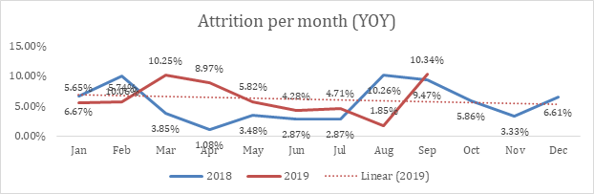

Figure 4: Attrition per month for Sutherland (Sutherland Philippines, 2019)

Sutherland Global Services monthly attrition report starting January 2018 until September 2019. The chart illustrates that between the month of August to September 2019. During the month of August until September 2019, Sutherland has seen an increase of about 8.49% in their attrition rate. If we look at the data during the months of August to September, Sutherland has seen its largest peak which is 10.34% in attrition rate in two years and also its largest variance from the month before which is 8.49%. This means that the company would also need to invest more in training to recuperate the lost workforce and compensate as well for the lost productivity during the months that they will be training them.

Since then Sutherland has been working on the reasons on which why employees leave the company and has kindly provided the researches with a graph presenting the 4 most likely reasons.

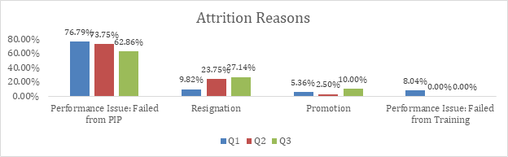

Figure 5: Attrition Reasons in Sutherland (Sutherland Philippines, 2019)

The graph shows four reasons as to why employees are likely to leave Sutherland, this graph is based on the year 2019 and shows Quarters 1-3. If you notice in the graph, the biggest reason for attrition is performance. You need to have to hire the right people, give them good training and a lot of coaching. With success in what they do comes satisfaction. No employee would be happy if they do not perform well at what they do as Francis Delos Juan wrote during an interview by the researchers.

During the first quarter (in blue) Sutherland has seen a 76 percent for Failed from Performance Improvement Plan (PIP) which is the formal coaching an employee receives with targeted goals and dates. While their other three reasons are as follows: (From Highest to Lowest) Resignation, Promotion, and Failed from training. For the purpose of this study the researchers would focus on the Resignation area since resignation is non-performance related and can be mitigated through various strategies like our 2 independent variables in this study (Job satisfaction and Leadership style). Focus on this area would mean that the researchers would have a likely impact for the company. Moreover, the researchers would also like to know how to decrease the attrition rate coming from this area.

### 2.1.5. Global BPO Industry

The Global BPO industry has become a phenomenon in the twenty first century. For the first time as humans we could outsource business processes to different independent organizations that would substantially limit the costs. It is in our human nature to provide services to others; skill is the basis of a service without practice and perseverance we cannot achieve a good service for customers. Organizations today outsource diverse business processes to achieve a wide variety of business objectives ranging from reduction of costs to innovation and business transformation (Mani; Barua; Whinston, 2010). One of the most intriguing part of the service industry is the inability of organizations to pin down the main cause of employee retention. Since people are unpredictable even though we have fully committed to good leadership and job satisfaction employees will still leave the company due to many different personal factors that we may never know and never understand, which makes this topic widely debated yet not fully understood. The beauty of this topic is that the researchers will examine hundreds of references and concepts and come up with their own recommendations, further getting us close to the goal of improve employee retention. As our company representative and the Director of Sutherland Philippines wrote to us during in an interview “Because we manage people and our customers are people. Same reason why Six Sigma is not often as successful in-service industry compared to manufacturing. The Human Behavior is harder to forecast for errors and has multiple solutions to a single problem” as written by Francis Delos Juan. This suggest that we may never understand and fully grasp the reason as to why people leave, we also believe that people leave the boss not only the company which made us conclude to include Leadership style in our research. The beauty is in the struggle to find answers to this topic and to further help other researchers achieve the answers.

### 2.1.6. Big Players of the BPO Industry in Asia

One of the big players is China which comes second in the Leading Countries in Offshore Business Services Worldwide 2019 statistics by Statista as seen in Figure 2 (Statista, 2019). One of the most attractive places for BPO companies includes China, due to its large economy and low cost of labor it has become a HubSpot for offshore BPO companies. Although one downside of the Chinese economy is there English skills as most of the organizations based here can only process Mandarin or Cantonese customers. Although with the new generation of Chinese now able to speak more fluent English in can readily adjust to the Global demand for the most spoken language. To know more how does the BPO industry grow so fast in a rapidly changing environment we must first look back at its history and how it operates throughout the Globe.

The growth of the Internet starting in the early 1980’s and the resulting ease of communications have propelled the prevalence of business process offshoring or as shortly called “BPO” as one of the most major features in the global business industry today. BPO is the process of outsourcing business procedures, processes, or functions supporting domestic and global operations from foreign countries (Contractor, Kumar, Kundu, & Pedersen, 2010; Manning, Massini, & Lewin, 2008). BPO transfers the operational ownership of one or more of the global client's business processes to an offshore service provider (third-party vendor, captive unit, or joint venture), who in turn performs the business process according to a set of predefined set metrics that is also regulated and checked by the client vendor during monthly to weekly checkups (Lewin, Massini, & Peeters, 2009).

In the case of this study our BPO company is Sutherland Philippines while our vendor company is GoDaddy who is represented by Mrs. Rizalina Keating who is currently based here in the Philippines. She checks up on the metrics that is used by Sutherland and report it back to GoDaddy who then tells her to adjust accordingly back to Sutherland. Without the BPO industry it will usually mean expansion into a different country with a new team and site which in turn is very costly and high-risk. BPO providers can offer a wide variety of benefits to global clients and their consumers BPO services provides a wide host of value-added activities, such as research, analytics, consulting, software design, business solutions, and up to back-office support. According to a 2009 report by NASSCOM and Mckinsey & Company, BPO will overtake technology services and become the largest offshoring opportunity, with a total market of up to US$670 billion by 2020 (Luo, Wang, Zheng, & Jayaraman, 2012).

## 2.2 Job Satisfaction

Job Satisfaction as defined by Spector (1997) is the degree to which individual employees are satisfied or dissatisfied with their job and the organization alike, where they are employed. In general, Job Satisfaction is perceived as a multifaceted construct intertwined with an employee’s feelings regarding a combination comprised of internal or external work elements. It covers certain facets of satisfaction related to pay, benefits, promotions, work conditions, leadership style, organizational culture and practices, and relationships among co-workers (Sunejma & Kumar, 2011). (Sunejma & Kumar, 2011) clarifies that there is no specific or universal definition for Job Satisfaction, even if there is an abundance of previous studies regarding the subject, due to different approaches, perspectives, and correlation to a diverse mix of organizational variables. Through the study conducted, it was found that job satisfaction and employee retention has a significant positive relationship, having a correlation r of (r = 19.000) and a p-value of (p=0.002). Hence, it can be concluded that when an employee is continually satisfied, the employee will have a sustained loyalty for the company. Results from the study conducted admit that an increase in job satisfaction often predicts an increase in employee retention. Therefore, employees have a responsibility in keeping their employees satisfied with the intention of improving their individual abilities, and also taking into account that job satisfaction is essential for employee retention (Terera & Ngirande, 2014).

This study clarifies that rewards do not lead to both job satisfaction and employee retention but only to employee retention. Even though, the research sees the significant relationship of rewards and job satisfaction leading to employee retention which is according to Terera & Ngirande (2014). Lastly, by delegating power to individuals in giving sustained power in decision making and in senior management weighing their insights, individuals are more satisfied with their careers further leading to high employee retention. In bureaucratic organizations that highly structure their interactions based on hierarchy, employee retention often decreases (Iqbal, Guohao, & Akhtar, 2017).

Results from the study of Iqbal, et. al. (2017) infers that benefits granted, an improved salary, and an ideal organizational culture does not influence job satisfaction. Hence, there is also no employee retention when all these independent variables are present considering that job satisfaction is not present. The hypothesis stating that organizational culture greatly influences job satisfaction leading to employee retention and job satisfaction has significant impact on employee retention can be accepted to some degree. Current findings show that if salary, benefits, and having a healthy organizational culture were sufficient enough and thus directly resulted to job satisfaction, it will be much easier for organizations to have a competitive advantage over other companies and in obtaining high employee retention. Thus, it would be wise to provide decent levels of organizational culture, salary, and benefits to satisfy their employees, ultimately leading to high retention rates.

Multiple researches imply that companies should effectively deploy effective policies and practices that aid to job satisfaction given the connection between job satisfaction and employee retention (Ahmed et al. 2009, Ongori & Agolla, 2009, Somaya & Williamson, 2008, as cited in Kwenin, et. al., 2013). Factors that lead to lasting job satisfaction are as follows: helping employees see that their decisions, insights, decisions, accomplishments are valued and positively affect their role in the organization; providing opportunities such as training for employees to grow in their fields; having an adaptable schedule; and having a work environment that encourages others to be communicative and collaborative with each other (Branham, 2005, as cited in Kwenin, et. al., 2013).

As defined by Kwenin, et. al. (2013) mentions that strategically planned and properly implemented employee retention programs will improve the productivity of the employees and serve as a means of reducing employee turnover costs as well. Previous findings by Memon et al. (2010) as cited in Kwenin, et. al. (2013) insist that organizations that apply practices of a proper promotional process, a fair and just compensation structure, and fitly training and development programs will aid in the decision of the employee to stay in the organization. These implied policies and practices will surely lead to increased Employee Retention, resulting to Job Satisfaction and overall employee productivity. Memon et al. (2010) as cited in Kwenin, et. al. (2013) firmly believes that human resource practices encourage employee retention, resulting to satisfaction and performance.  According to Sutherland (2004) as cited in Kwenin, et. al. (2013), employees actively contemplate on the idea of staying in their organization, thus, employees expect an effort by the organization to start programs and human resource policies that involve training and development, better promotional processes, and rewards to entice to remain in the organization. Without these changes in the organization, more than half of the responses of the employees are towards the likelihood of termination of their obligation to the organization they are currently working for. Hence, an increase and improvement the in-compensation system, HR policies, and Job Satisfaction efforts positively affects the retention of the company (Kwenin, et. al., 2013, p.67)

Job Satisfaction as defined by Iqbal et al., (2017) is relative to job satisfaction with the pursuit of the organization to satisfy the needs of the individual employees by fulfilling their needs as seen Maslow’s hierarchy of needs which is further discussed in Employee Retention. In helping individuals accomplish each phase of the hierarchy, employee loyalty will increase and result to retained skilled workforce. A recommendation for Vodafone Ghana Limited to attract job satisfaction and employee retention is to ensure that rewards given by the company are enticing and equitable. Apart from this, another factor to encourage employee retention and job satisfaction is for the company to uphold necessary intrinsic values. In considering that this study is limited in its scope, a suggestion in the future is to observe the effect of work/life balance, organizational commitment, supervisor support, and work environment and its influence on employee retention under telecommunication industries (Kwenin, et. al., 2013).

Saranya (2014) defined Job Satisfaction as the extent to which an employee’s job fulfills his or her dominant need and then in line with their expectations and values. Given that these criteria are met; the employee will find the job satisfying. Job Satisfaction as stated by Siddiqui (2015) the importance of five specific dimensions to which work itself, pay, promotion, associates, and opportunities are included Siddiqui stressed the importance to what Job Satisfaction correlates with, it can be connected to job involvement, turnover, job performance, absenteeism, organizational commitment, life satisfaction, motivation, organizational citizenship behavior,

perceived stress and mental health. The work environment strives for production and satisfied employees, since satisfied employees accomplish tasks more and allows for a relatively smooth work environment (Saranya, 2014). Issues revolving around studies conducted for Job Satisfaction can possibly be altered by specific scenarios in an employee’s life, it is likely that an employee will have to deal with unchallenging tasks, not receiving feedback regarding performance from their supervisors, lack of recognition for tasks done, lack of necessary tools to complete tasks, poor communication in the workplace, lastly, lack of adequate training and development programs (Siddiqui, 2015). Usually these are the factors that are used to determine whether or not an employee is satisfied with the tasks they are assigned. Thus, it is possible for the happiest employee to be unsatisfied with their work, since the job does not meet their internal forces of beliefs, interests, feelings, and actions which determines the needed level of job satisfaction of an employee. Most employees strive for a level of a satisfaction with what they’re working on, which leads to either a productive or non-productive employee (Awan, 2013).

In the BPO Industry, Job Satisfaction is a crucial role due to the fact that they are managing processes that are associated with an employee’s health and well-being, and also their work motivation, to accomplish the task assigned within the required amount of time. In a study conducted by Choobineh, Ghanavati, Hoboubi, Hosseini and Keshavarzi (2016) regarding employees in the petrochemical industry that “Work-related stress is a vital factor to job satisfaction.” It was explained on how Job Satisfaction is capable of leading an employee away from stress, thus making it a high priority factor. Result from their survey showed that Job Satisfaction can actually affect productivity, while Job Satisfaction is also affected by an employee’s stress level. The apparent differences indicated was the part-times employees together with employees at around 31-38, are more dissatisfied with their job.

### 2.2.1. Job Satisfaction in relation to Turnover

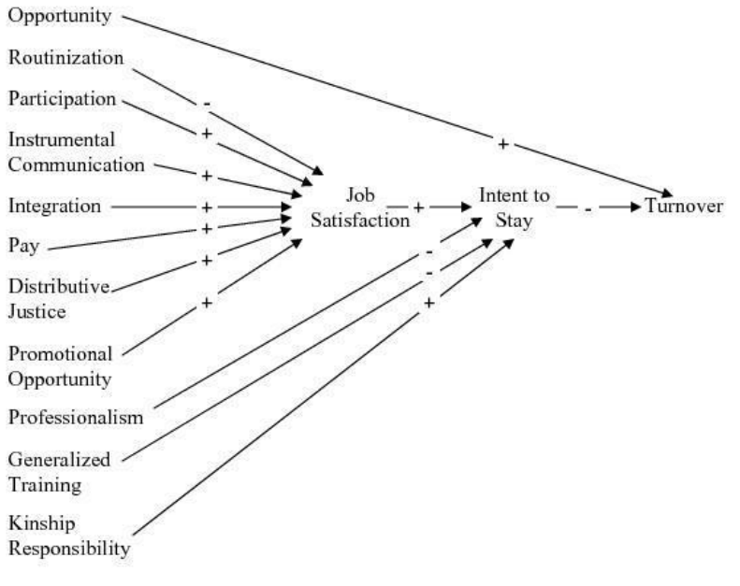

Figure 6:. Reproduction of the causal model of turnover (Price & Mueller, 1981).

The figure above as defined by Price (1981) which shows the 11 determinants starting with Opportunity. Employees are presented with organizational opportunities in forms such as career succession, and trainings for specific skillset are all forms of opportunity that employees can achieve while they are in the organization, Price defined this as a motivating factor in decreasing retention in an organization as it provides the employee loyalty to the company by providing them with something invaluable.

Routinization is described as the routine tasks that employees are faced during their stay in the organization in the figure above it is portrays a negative correlational impact to Job Satisfaction. This is the result of unsatisfied employees who present a negative attitude towards a boring work life without any stimulation and can be detrimental to their sanity. Routine tasks are proven to decrease motivation as employees would have a harder time finding meaning in the tasks they do. This will in turn decrease Job Satisfaction and would ultimately lead to employees resigning. Participation has a positive correlation to Job Satisfaction which is a good thing to consider when an organization would want to retain its work force. Due to theory that employees are likely to be happier when they are participative in team plays and in the organization as a whole. They are more likely to feel as though they are part of something bigger and grander when they are in the organization which in turn would increase their retention. Instrumental communication is a key part in Job Satisfaction as basic communication is the key for people to understand themselves and others as well. If employees are feeling not satisfied with their jobs, communicating this with their direct superior would already have an immediate impact as their concerns and well-being are being heard out by the organization.

Integration in the figure above is positively correlated with Job Satisfaction as employees who are integrated firmly into the organization would have a much harder time to consider leaving them. This is the basic principle in Job Embeddedness as discussed in this Sub Chapter, it is described as the ability of the employee to resist changing an organization due to its key part in the present organization. Since the organization would not function fully without them, they are more inclined to stay as though they are important. Pay is an integral part of Job Satisfaction as employees work for remuneration or pay, this is one of the key factors that improves Job Satisfaction. If there are insufficient pay employees will then start to consider leaving the organization for much higher remuneration opportunity.

Distributive Justice as defined by Price (1981) is the fair share of employees in the things they do for the organization. If there are unfair practices in the way the organization deals with efforts of the employees there would be a decrease in Job Satisfaction as the employees feel that there is injustice. Distributive Justice is defined as the “Fair-share” of everyone in the efforts they have made for someone or something it is also reflective of fair punishments and rewards for an individual.

Promotional Opportunity is defined as the succession planning of an organization towards its employees. This will retain their skilled work force for them to improve themselves and the company as well. Retaining employees for them to become the next superior is essential in creating an efficient working environment as compared to acquiring skilled employees from external sources. This is because externally acquired employees are not familiar with organizational practices and culture. They would have a much harder time adjusting as compared to internally acquired ones.

Professionalism is negatively associated with Job Satisfaction as there is an expectation of employees to become this professional even though they may not be able to achieve this expectation which would then result in lower self-esteem. Employees who are not able to perform to professional level maybe degraded as though they are not seen as worthy. This will in turn drive them to seek out more suitable opportunities elsewhere.

Generalized Training is negatively correlated to Job Satisfaction as because there is also routinization as recently discussed in this sub chapter. This is due to the theory that employees do not seem to like practicing the training tasks every day and if they fall short in motivation or in expectations it would have a negative impact in not only the organization in terms of cost, but for the individual employee themselves.

Kinship Responsibility is positively correlated to Job Satisfaction this is due to the fact that the more our community is concerned with one another, the more they feel that they are secured and taken care off. Kinship responsibility basically means that there is genuine concern of each other in a community and there is an obligation to the well-being of every person within the said community. This is relative to organizations as there are teams within it that serves as the community and employees are obligated to look out for one another. This is proven to result to increased employee retention and job satisfaction.

Price (1981) initially found the 11 determinants mostly independent of each other and individually not strongly related to turnover. All 11 determinants are correlated to Job satisfaction which is positively related to intent to stay, which is then negatively related to turnover. When an employee is satisfied with his or her job there is an intent for them to stay in the organization, which is not a determining reason for them to leave the company (Slugoski, 2008). Moreover, Price and Mueller (1981) found job satisfaction had the strongest influence on intent to stay. Furthermore, based on the results Price and Mueller (1981) determined intent to stay had a direct negative effect on, and explained the greatest amount of variance (10%) in, employee turnover.

(Shui, 2011) writes about key factors that would retain employees. One of them is to improve employee satisfaction, which is the key independent variable in chapter 1, this goes hand in hand in improving how employees feel about their workplace and if they do not feel like they are satisfied they would eventually leave. Employee’s sense of belonging in a company is also paramount in creating a sense of need for the employee. Having to feel a sense of belonging will, in turn, provide job satisfaction in the long run since they are keener to feel comfortable with the work environment. The study made by (Shui, 2011) moves on to the next factor which is creating a people-oriented management in the industry, which is important as well to promote good relationship for the manager and the employee as providing the employees with a feel that they are the focus of the management will inevitably create a sense of need for the employee. (2011) Thus, it is very necessary to study either the relationship between job satisfaction, and employee retention, or its impact on job performance. Which means that job satisfaction and employee retention goes hand in hand but there is also another missing key factor which is leadership style that would be added to our research, this will allow us to examine which leadership style is best to use to improve employee retention and as for now we have people-oriented leadership style as told by Shui., Kammeyer-Mueller, Wanberg, Glomb, and Ahlburg (2005) offer an employee turnover model in an effort to provide insights and understand the complex thought process employees may go through during organizational withdrawal.

### 2.2.2. The Relevance of Job Satisfaction

According to Weiss, Job Satisfaction and a worker’s perception of success and task fulfillment is predominantly recognized to have a direct connection to workplace productivity and an employee’s (personal) wellbeing (Weiss, 2017). (Sunejma & Kumar, 2011) indicates that Job Satisfaction is recognized as a serious issue for a company’s performance. According to (McGrath and MacMillan, 2000) Previous studies done by scholars have clearly indicated the importance of job satisfaction and its influence on a company’s performance, with the same degree of importance as customer satisfaction. Job Satisfaction is relevant given its positive influence in managing a business, making it a vital factor in the inception of well-functioning working conditions. Seeing the bigger picture, it is critical for a company to gain and maintain a competitive advantage, granted it is being implemented at the suitable leadership strategy, according to (McGrath and MacMillan, 2000), as an improvement in performance leads to a better quality of outputs and services rendered. According to (Bontis, Richard, and Serenko, 2011), This leads to client satisfaction that aims to create a loyal following among existing corporate client, to expand to potential clients with the goal to build long-term partnerships, thus securing the company’s sustainability and business development

Looking at the bigger picture, this concept can be viewed both on an organizational level and individual level but only towards employees. Although (Schneider, Erhart, and Macey 2001), argues that individual will be satisfied with a person’s work, only to the extent that the job provides what the person recognizes as a fundamental need, thus differentiates it from the organizational climate perspective, that represents the average employee and/or the collective outlook of company employees towards working for their organization.

### 2.2.3. Factors affecting Job Satisfaction

Janicijevic, Kovacevic, & Petrovic (2015) heavily states the importance for a company’s management to determine the factors for organizational job satisfaction, for at least 2 primary reasons. First, if they are aware of the factors that determines and improves an employee’s satisfaction in an organizational point of view, the company will be able to improve the current level of employee job satisfaction by modifying these factors by developing a strategy. Second, organizational factors are distinctly managed by the corporation to a deeper extent, as compared to individual factors, thus recognized as a more efficient method of improving the level of employee job satisfaction as compared to seeking to influence individual factors

(Shobe, 2018) also indicated that factors that can influence an employee’s job satisfaction level in the work environment or the heavy burden of their workload assigned to them by management (2018). It is to the extent that a company employee being already rewarded monetarily as compensation for work conducted, is still not pleased. Herzberg utilized a theory to prove that the two previously mentioned factors, could shine some light on the perspective on why a company employee feels gruntled, with the second factor leading to hygiene factors as to why are disgruntled.

Table 1: List of common factors distinguished by dissatisfied workers and Satisfied Workers (Shobe, 2018)

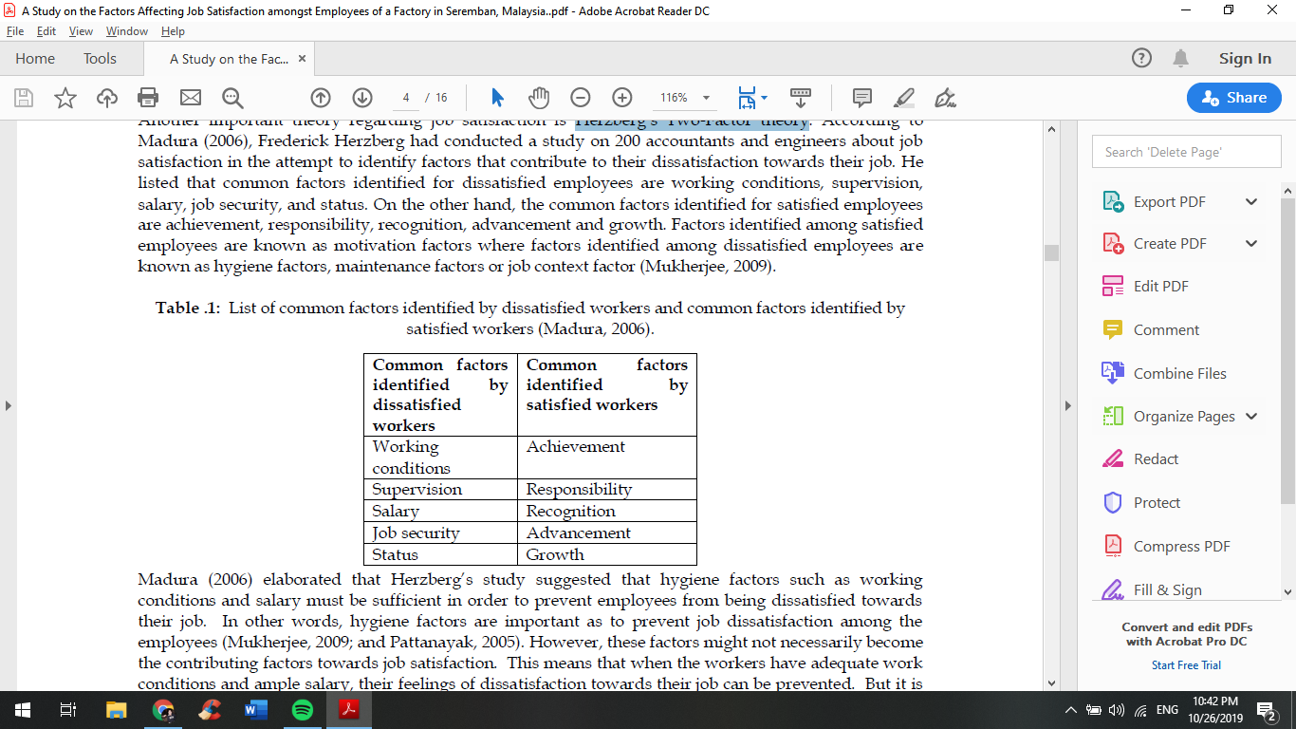

Shobe (2018) wrote about common factors that are identified to have a relationship with dissatisfied workers is seen on the left column, while factors identified by satisfied workers are seen on the right. For dissatisfied we have working conditions, which is an overall important because if the employee’s work area is not comfortable for them, they would have a much harder time focusing on the job at hand, and thus lowering productivity. Supervision, can also be denoted as leadership style which is one of our independent variables in this study, as seen in Chapter 2.2. Salary is the basic employee remuneration which is also seen as a key factor. Job Security which is seen as the feeling of the employee of keeping their job. Status, which is the last but has an effect due to personal issues of the employees. Common factors identified by satisfied starts with achievement, which is a key factor as employees tend to enjoy their jobs more when they achieve something. Responsibility given to the employees provides them with Job Security as they are not easily replaced. Recognition is a key factor as employee’s who are recognized serves as a motivation for other employees as well. Advancement is crucial as employees can build themselves in the organization are satisfied in the long run. Growth is seen as a factor due to its ability to provide employees with a sense of accomplishment as they have improved significantly compared before.

### 2.2.4. Job Embeddedness

Job embeddedness was a relatively new construct developed by Mitchell et al. (2001b) measuring on how well an employee was embedded in his or her job. Job embeddedness was a factor of the strength of an individual’s links to people and events in his or her job and organization, in addition to the strength of the individual’s respective fit with his or her job and community. Another meaning to job embeddedness is sacrifice, how much it would take to break the links. The more embedded an employee, the increasingly difficult it was for him or her to leave his or her job. Considering job embeddedness added new insight into employee staying behaviors. The multi-dimensional cognitive construct assessed an employee’s connectedness both on and off the job. Job embeddedness has been found to be statistically different from the constructs of job satisfaction and organizational commitment measuring an employee’s attachment to the job (Slugoski, 2008). Embeddedness in this context refers to an individual’s perception about how difficult it would be for them to look for career advancement elsewhere based on given variables such as social relationships, financial assistance or work-related projects (Kammeyer-Mueller, 2005).

Work attitudes are influenced by an employee's satisfaction with their work, pay, supervisor, and coworkers. Job satisfaction is probably the most attractive factor when considering how it relates to employee turnover. Since job satisfaction is an independent variable in this study, we would get insights at how this can affect employee retention. A wide variety of studies has been conducted in relation to employee retention and job satisfaction although since human behavior is hard to predict there has been still ongoing research as to which other variables can affect job satisfaction. An employee’s organizational commitment is often seen as an additional reason an individual may choose to leave their employer and is usually seen in the context of leaving their boss as well. Employees may leave their organizations for reasons that are not associated with job dissatisfaction. There are certain situations that would require employees to leave their organization as a result of a critical, personal event.

Organizational withdrawal can be portrayed by a variety of individual behaviors that may result in an employee leaving the organization. Kammeyer-Mueller evaluated two different methods of withdrawal that are differentiated by their motivation. The first method, work withdrawal behavior, is utilized to seek temporary removal from an individual’s career. The second method is an employee’s individual search for alternative opportunities outside of the organization and is seen as an employee's desire to permanently be removed from their career (Kammeyer-Mueller, 2005). Employees who are low in productivity and seems to be distracted from their work are keen to leave the organization. This can take any forms from being late to not finishing the job and sometimes they can go completely AWOL from the organization.

## 2.3 Leadership Style

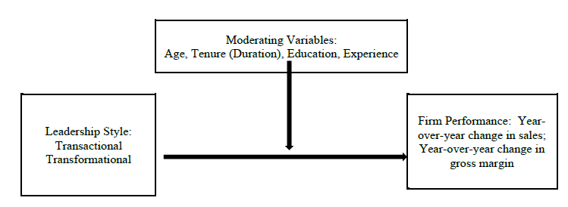

Figure 7: A quintessential transformational/transactional leadership framework (Haq and Chandio, 2017)

Haq & Chandio (2017) defined Leadership Style as a person’s capacity to influence a group towards the accomplishment of a goal. It is the process in which a leader or manager, direct the behaviour of the employees for achieving a certain goal in a certain work scenario, is also the ability to persuade others to find and accomplish objectives willingly. Haq & Chandio (2017) stated that this type of leadership is usually found in bureaucratic organizations deeply dependent on protocols and procedure. According to Northhouse (2016) Leadership Style is a process where a specific individual influences a group of individuals to accomplish a uniform goal. Leadership Style is a leader’s style of providing, directing, implementing plans, and motivating people. Leadership style as defined by Achua and Lussier (2015) as the combination mix of traits, skills and behaviors leaders utilize as they interact within the organization, is also the relatively consistent pattern of behavior that characterizes a leader (Dubrin, 2001).

Leadership is the chief and supervisors leading their team of subordinates, utilizing appropriate strategies and course of actions, with the intention of completing tasks and deliverables as a group due to their collective efforts (Acciaro, 2014). Nanjundeswaraswamy & Swamy (2014) defines Leadership as a social influence process in which the leader pursues the voluntary participation of followers in an effort to accomplish an organizational goal. A leader is a person who assign or influences others to act as to carry out assigned objectives. On an Individual level perspective, (Cheng, T.; Mauno, S., and Lee, C., 2014) states that Leadership assigns and directs a member to complete a meaningful objective, which motivates an employee to work hard to accomplish the objective.

On an interpersonal and group level perspective, (De Sousa Jabboura, A.B.L.; Charbel, J.C.J.; Hengky, L.; Adriano, A.T., and De Oliveria, J.H.C., 2014). mentioned that Leadership Style is a strategy for interpersonal interaction, which affects an individual or a group’s behavior, under specific scenarios, to achieve specific organizational objectives. (Mancha and Yoder 2015) noted that Leadership Style is the capacity to motivate organizational members to be confident in achieving organizational objectives, Leader uses their influence to lead their team, to achieve their goal. This is positively correlated with employee retention as employees are looking up to their mentors and if they leave the company, they are leaving their boss, as said by Francis during a written interview with the proponents

Figure 8: Core Leadership Characteristics (Haq & Chandio, 2017)

Seeing the bigger picture, Huang et al. (2016) describe Leadership Style as the degree to utilize democracy. As show on Figure 7, (Haq and Chandio) Good Leaders are composed of crucial factors such as: Good Judgement, Competence & Knowledge, Interpersonal Skills. It sheds light on the aspects of comprehending the needs and interests of the employees, initiating harmonious relationships among employees and professionalism in the workplace setting, valuing employee’s needs that are within reason, and assessing the quality of work to be produced by the employees.

Nanjundeswaraswamy & Swamy (2014) states that an efficient leadership style will reduce employee attrition rates, complete organizational objectives, and optimize task performance and productivity, to which are crucial for a successful management operation. Therefore, with an established and well-suited professional relationship between the leader and its employees, with the latter being assigned with highly structured tasks, effectiveness will be high on the receiving end of its employees (Nanjundeswaraswamy & Swamy, 2014). In the current business world setting, effective leaders are crucial to an organization, understanding the complexities of the rapidly changing global business landscape. To further stress the importance of Leadership Style, many different leadership styles are displayed by leaders in the political arena, business industry, and other industries, it is very important since it determines the success and failure of an organization has been attributed to the nature of the Leadership Style.

### 2.3.1 Transformational Leadership

Transformational Leadership is the kind of leadership style that involves the leaders inspiring its subordinates to rise above their own self-interests for the greater good of the organization; leaders can deeply influence their subordinates to initiate the needed change (Robbins 2003). Leaders who lead using communication and collaboration. Transformational leaders use communication to motivate employees and change their outlook on the change (Brown, 2013)

Transformational leaders as compared to other leaders that utilizes other leadership styles, are more innovative, efficient, and successful in satisfying followers since mutual trust and respect has been established in accomplishing organizational goals (Avolio et al.1991).

According to Ghadi et al (2013), Transformational leadership is comprised of four elements. Firstly, Idealized Influence talks about a leader’s capacity to increase the degree of loyalty, perseverance, and rapport, while being independent from focusing one’s self-interest. Secondly, Inspiration Motivation involves the leader’s capacity to motivate its followers by creating a vision, which offers them a crucial position in the organization. Thirdly, Intellectual Stimulation refers to the capacity of leaders to challenge employees to think freely, to think outside of the box, to break free from the status quo. Leaders motivate their followers by giving them opportunities to grow and further hone their skills when put into challenging situations for them to improve on how to overcome adversity. Lastly, Empowerment, refers to the degree to which a leader’s act as a mentor towards its followers, listens to the questions and concerns, and offers guidance for their aspirations (*Afshari et al, 2012).*

### 2.3.2. Transactional Leadership

Figure 9: Characteristics of a Transactional Leadership (Haq & Chandio, 2017)

Transactional Leadership relies more on the trades that occur between the Team Leader and Team Member (follower), to which followers are compensated for achieving the specific organizational goal or criteria for job performance. Initially, the leader recognizes the connection between performance and reward, next the leader exchanges it for a proper action that motivates its followers to improve work performance (Trottier, Wart, & Wang, 2008).

Transactional leaders lead using a hierarchy from the top down, uses a reward-based system to show appreciation (Brown, 2013). Transactional leaders motivate its followers through the application of contingent rewards, corrective actions, enforcement of policies (Bass & Avolio, 1990). They are described by Haq et al, (2017) as people who are idealistic in nature and are results driven. Employees who are under these types of leaders are pressured in a way to achieve their superior’s expectations of them, which are sometimes unrealistic to squeeze more out of them. The proponents consider this as the basic and authoritarian standard of organizations which are effective in achieving results but are detrimental in the long-term impact to their employees.

### 2.3.3. Laissez-Faire

Laissez-Faire is a leadership style that delegates an extensive degree of freedom towards its employees. It’s direct translation in French means “leave it be” (Segun-Adeniran, 2015). The leader does not restrict the action of its employees, such to the point the leader is almost inexistent and imaginary, simply described as the “hands-off” style by Ogunola, Kalejaiye & Abrifor (2013). Employees are delegated authoritative power commonly exercised in situation they are to deal with conflict and its resolution. However, this management style is not commonly used since managers are not accountable for and shows little effort to enhance employee productivity. Since Leaders usually let the employees handle the work, they are idle, wasteful, and unproductive, which was the case in previous applications. Lack of Direction in accomplishing the goal is a main culprit for this outcome. Also, Exchanging of Ideas and sharing feedback to management is quite rare since Involvement of managers are very low, while Involvement of employees are very high.

Absolute Freedom is not always the precedent of employee unproductivity. In the contrary, this could even aid in empowering its employees to be more creative and diligent in dealing with situations, independently from manager intervention. Such experiences and trainings aim to enhance and expand their skill level, also a way of grooming them for a potential managerial role.

In simple words, this style delegates a more liberal degree of freedom with regards to fulfilling their duties and deliverables. There is a high level of trust exchanges among managers and employees, since managers deem its employees to be capable enough to be unsupervised. Managers are approached in for consultation when dealt with situations they are unprepared for. It should also be noted that this leadership style is not deemed appropriate for entry-level to middle-level employees, since supervision is more crucial in achieving productivity. These types of leaders usually feel motivated in their own time but can be detrimental if they feel unmotivated.

## 2.4. Employee Retention

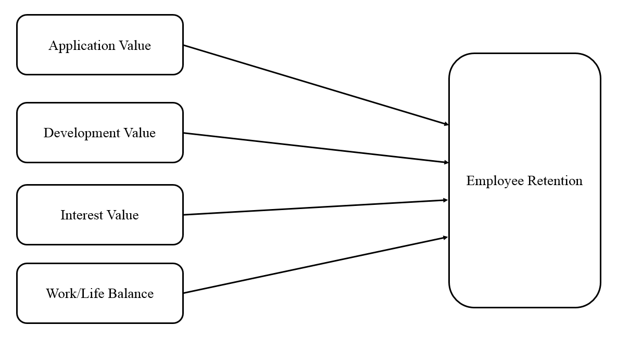

Figure 10: Factors of Employee Retention (Kossivi et al., 2016)

Kossivi et al. (2016) identified development opportunities, compensation, work-life balance, management/leadership, work environment, social support, autonomy, training and development as broad factors that affect employee retention. Moreover, employee retention is explained as not only to attract the best skilled workers but also the necessary procedures to retain employees for a long-term period. Msengeti and Obwogi (2015) states that efforts made by any company or organization to ensue strategies and initiative which support current staff into remaining in the organization is what best describes employee retention. Hence, Employee retention is when employees choose to remain in the workplace since it continuously addresses and satisfy their needs. In relation to that, factors such as customer satisfaction, the increase in sales, good working relationships and employees are equipped with organizational knowledge and learning.

Employee retention addresses organizational issues such as reducing training time and investing in newbies. As a matter of fact, it was discovered that losing a middle manager is equivalent to spending five times the salary of the middle manager. In terms of relationship, it directly affects employee’s performance and quality work, customer satisfaction, company’s reputation and sales. Meanwhile, it has an indirect relationship in terms of working relationships and employees’ knowledge and learning. To improve employee retention, communication is the key as commitment and support builds up through communication. Giving respect, recognition and rewards are the three main factors that encourages employees to retain within the company (Mathimaran, B.& Kumar, A., 2017)

According to Rapport, Bancroft, & Okum (as cited in Sinha, 2012), the critical analysis of workforce trends directly points to the imminent deficiency of highly-skilled employees who have the required knowledge and ability to perform at satisfactory levels, which means that organizations’ frailty to retain these highly-skilled employees will be left with an understaffed, and poorly qualified workforce that inevitably impedes their ability to remain competitive. With the additional challenge of having to motivate and retain these employees an environment that has proven to be increasing in uncertainties (Sinha, 2012, as cited in Mitchell, 2002).

### 2.4.1. Employer Branding

One way to differentiate a firm from others in the same industry is through employer branding, and this is done through inviting, inspiring and engaging both future and current employees. Based on a study, it is said that to secure employee retention is to put great emphasis on a company’s employer branding. Employers, through employer branding, encourage others to believe that the firm is an excellent place to work in (Backhaus and Tikoo, 2004 as cited by Hadi & Ahmed, 2018).

From theindependent variables in the study, only the development value is deemed valuable given that it strengthens employee retention. A reason for employee resignation is due to lack of affirmation or as the organization adopts a culture of constant complaint. Development toward employees must be given more emphasis by the organization. Other factors that will encourage employees to stay in the firm would be to foster an environment of regular appreciation of one’s work/achievements and to provide the needed skills and knowledge for improved job performance. (Hadi & Ahmed 2018).

### 2.4.2. Employee Retention in The Service Sector

The ease of retention would depend on their degree of motivation and involvement. It is desirable to plan employee retention strategy by an organization; which should cover the following aspects;

First is that retention must be part of the organization’s DNA which implies that for a company to strive it must have a predetermined employee retention plan. To fully grasp this model, we must first look at what it can potentially achieve for us, by having an employee that works for the company longer they tend to know the ins and outs of a company which would lead to efficiency and lower time in doing a certain task. With a new employee, however, not only does the company need to invest in training costs but also, they tend to have a higher learning curve which means there is a longer time to do certain tasks.

Second, loyalty is never given; loyalty must be earned. This mostly applies to the manager-employee relationship first before there is a relationship between the company since the manager is the sole person responsible for the work of an employee, they must have an established trust that would encourage employee retention. If an employee does not trust his/her team leader there would be fewer barriers for them to leave the company.

Third, each generation of employees has different reasons for staying. Since everyone has a unique story to tell the company and manager must conform to their reasons for them to stay. If a person has financial troubles the company should consider providing raise for the employee as long as the company is compensated fairly by means of having a wider scope of work.

Fourth, recognize managers who keep employees - this goes without saying that the manager who keeps employees in their team is doing something right that makes them stay. Acquiring leadership knowledge from these types of managers is crucial in determining the factors that affect employee retention in management leadership style, which would also be covered in the study.

### 2.4.3. Employee retention on Service industry

Employee retention refers to the ability of an organization to retain its employees (Vivek; Satyanarayana Rao, 2016). Each research of a given topic is expected to make a definitive contribution to the existing literature and its connected variables. The contribution of this study would be providing some gap-filling information in the field of Employee retention, Job Satisfaction and Leadership style in the BPO service industry and in Sutherland’s organization. Retention of employees is a widely discussed topic in the service industry and due to this reason service sector have high switching level of jobs. Retaining skilled workforce is one of the biggest issues that plague organizations in the competitive marketplace. Employee retention has become the trending topic of the service industry and for the corporate world alike. Each part of the organization globally faces unabated levels of Attrition. This research provides some suggestions and recommendations which will prove useful to the attrition rate of the employees of Sutherland Philippines. The information of this research will be useful to service industry alike and add new information to literature. It will help the organization of Sutherland Philippines to develop their new strategies and plans for employee retention.

Employee Retention has always been the focus of many companies, which their goal is to decrease employee turnover rate. With the high demand for capable employees and the expansion of service industries in recent days has led to an enormous turnover rate, which directly and indirectly affects the employer and ultimately the productivity and profitability of the organization as told by Dr. K and Dr. M (Ganesh and Soundarapandiyan, 2015). Most service industries use employee retention strategies in their business plan to drastically decrease cost and time wasted. Although many of these plans have been thought carefully, there is still no concrete way to radically decrease employee turnover rate in just one day. It would take a change in the leadership style of management and change how the employee sees themselves in the company. Through this study, we would investigate how these different factors play a big role in retaining talents in Sutherland. Dr. M writes about one key factor that affects employee retention and it is the job satisfaction of employees (Ganesh, 2015). Job satisfaction is a key variable in determining if an employee will leave the company as they are likely to be less productive if they feel that they are not satisfied with the work they are doing or with how the company is treating them.

### 2.4.4. Employee Engagement

Employee Engagement as defined by Gopoinath et al, (2016) is the process of which an employee participates in organizational commitments and activities wherein their skills are put to the test. It is also described by Thariq (2014) as a way for employees to prove themselves for their organization and their current team in the company. Effective retention usually addresses issues on career stress, employee opportunity, and decreased motivation. Individual factors responsible for employee retention can also be seen in the organizational culture of the company. (Gopinath & Kumar, 2016). According to studies found by (Thariq, 2014; Samuel & Chipunza, 2009), the key to maintaining workers must support the following variables: growth, rewards/recognition, and a competitive salary. Employee engagement provides another opportunity for the organization to provide stimulating and engaging activities to its employees for them to be better skilled at their work and to increase their retention as well. It is one of the strategies of organizations to provide several key practices to retain their skilled workforce and one of these practices are geared towards engaging activities which promote participation and teamwork.

Based on research by Thariq (2014), organizations that boost employee engagement have sixty-five percent (65%) lower turnover rate. Employees also feel empowered and motivated to invest more time when they are encouraged to be active and feel supported and valued by the company (“HR Challenges,” 2018). This is one key factor that organizations must consider when strategizing their Employee Retention plans is to adapt tried and proven techniques in the industry. One of which is to create opportunities for them to succeed. Encouraging employees to engage the organization and providing rewards such as a career succession is one of the most effective ways to address both Employee Retention and Engagement. This would in turn retain skilled workforce in the organization but to provide them with the necessary skills to move up the organizational ladder.

### 2.4.5. Employee Retention Strategies

Effective retention strategies usually target issues on job stress, employee development, and low salary. Factors responsible for employee retention can also be seen on the organizational culture of the company. (Gopinath & Kumar, 2016). According to studies found by (Thariq, 2014; Samuel & Chipunza, 2009), the key to maintaining workers must support the following variables: growth, rewards/recognition, and a competitive salary.

Based on research, organizations that boost employee engagement have sixty-five percent (65%) lower turnover rate. Employees also feel empowered and motivated to invest more time when they are encouraged to be active and feel supported and valued by the company (“HR Challenges,” 2018).

### 2.4.6. Maslow’s Hierarchy of Needs (1943)

Maslow (1943) explained human motivation behavior as the motivation relating to an employee’s needs at the specific time of the behavior shown. According to Maslow, five levels of needs existed in his theory. The first and lowest level of need in the hierarchy was basic physiological requirements (e.g., food, air, water). The second level of need in the model was the need for basic safety (e.g., physical security and psychological security), as well as peace and assurance in one’s life. Having achieved the second level need, the third level of need would represent the emotional hierarchy was the need for social belonging (e.g., ability to give and receive love and affection, and friendly relationships). Continuing up the hierarchy Maslow proposed, the fourth level of the need to be satisfied was self-esteem (e.g., self-respect, respect from other people, self-confidence, achievement, self-improvement, recognition, and self-worth). Finally, once if all the lower-level needs were met, the fifth and highest level of need occurred, the need for self-realization (e.g., creativity, self-expression, integrity, self-fulfillment, the need to know and understand one’s self, and to be competent and capable).

According to Maslow (1943), a lower level need must be met before a higher level could be obtained. Once the lower level need was satisfied accordingly, the next higher-level need in the Maslow’s hierarchy presented itself and the lower level would not need to influence an individual’s behavior anymore, as satisfied needs are no longer motivated. Unmet needs motivated individuals. The new want of an individual would become the person’s new need which would motivate them even further. Maslow’s (1943) hierarchy of needs theory of motivation provided insight into employee stay behaviors. Employees would be motivated to stay with an organization providing a climate where they could move up their individual hierarchy of needs at a pace suited to them.

### 2.4.7. Retention Strategies in BPO Companies in India

To have a better understanding of how we can improve retention strategies in Sutherland we must first look at what other countries are doing right and the wrong ones as well. One of the best countries to investigate is India, in India, Business Process Outsourcing (BPO) is the fastest-growing segment of the ITES (Information Technology Enabled Services) industry according to Gopinath, T. & Kumar, X (2016). Based on the research questions, 58% of respondents are faced with mental pressure to become better in the BPO industry. This is more than half of the respondents and the data tells us that there is an expectation from them to be the best in their team and can be very challenging for those who are not quite adapted to the industry yet. The youth are encouraged to join the BPO sector as most companies in this sector do not require the employee to have completed college, most only need 1-year college experience. This is also the case here in the Philippines and sometimes people frown upon this type of industry as they belittle those who are working in the BPO sector which could be a reason for an employee to leave this type of industry.

An inverse relationship based on the study, between how much stress the employee feels in the BPO and employee attrition. This suggests that the more stress an employee feels the more they are likely to leave the company. One good way to lessen this in Sutherland is to have a consultation schedule with the employees and managers. This will allow the manager to have a look at what the employee is feeling and what stress they are coping with. This will also provide the employee with a sense of being heard and that what they feel is important for the company. Identifying these stresses will help both managers and employees in dealing with them.

## 2.5. Link of Variables

### 2.5.1. Job Satisfaction in relation to Employee Retention

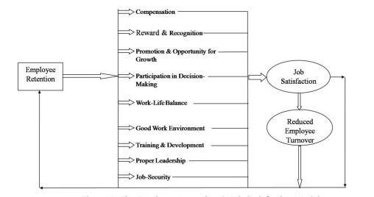

Figure 11: Factors of Employee Retention in Determining Job Satisfaction (Bacea and Bordean, 2013)

The image shown above depicts that employee retention factors have a direct relationship with job satisfaction and employee retention. If the factors shown exist in the organization, then the tendency to leave the job or switch over to some other job would most likely be reduced. Hence, job satisfaction as well as employee turnover are seen to be negatively correlated to one another. The model clearly shows that if the factors mentioned above exist in the organization, it will not only help the company attract new employees into the organization but will also lead to the retention of the existing employees into the organization (Bacea & Bordean, 2013).

Figure below depicts the five distinct points in time that were examined for their two-year period study.

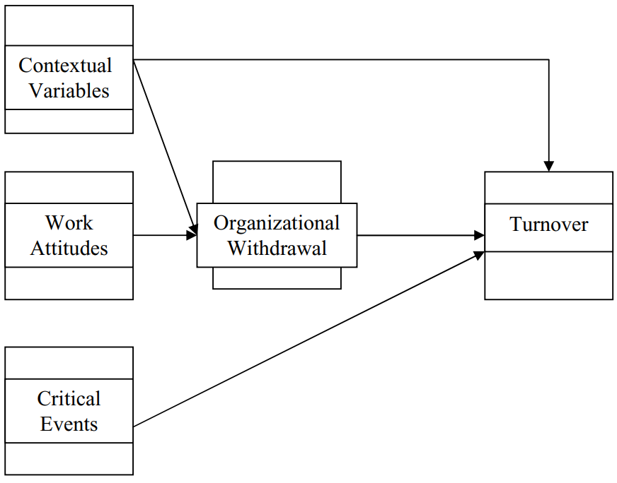

Figure 12: Turnover Model (Shui, 2011)

Contextual variables include factors such as external employee job alternatives, internal employee job alternatives, and the employees perceived cost associated with changing jobs. Individual employees often form their intentions to leave an organization based on their own thought process that they can find career advancement elsewhere. Even though the individuals thought process may not accurately reflect their skill. This miscalculation influences the unemployment rate which impacts job availability, which is used to predict turnover. Although looking for another organization might result in promising returns, this would not be productive for the company and employee alike. Researchers have suggested that employees should rate the overall position of the company and not just their own performance. This will encourage employees to think about their success as their organization’s success and vice versa. This mentality will help improve employee retention in the long run as it will form an emotional bond that will support both organization and employee. Employees will seek another job within the organization for one they perceive is better than their current role. Individuals who are thought to believe that employment in a different organization will have low impact on them financially are said to reflect lower financial embeddedness.

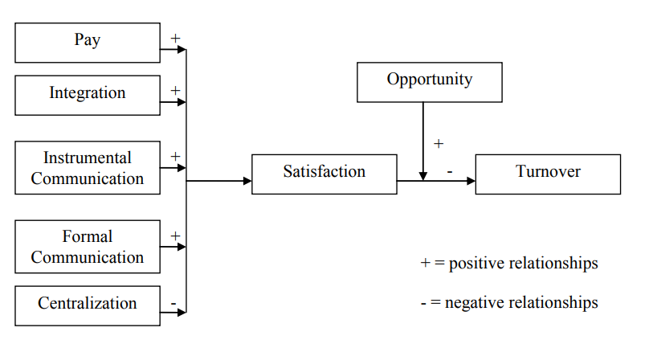

Figure 13: Reproduction of the relationship between factors, intertwining variables, and employee turnover (Price, 1977).

The value individually derived from each determinant affected the determinants overall satisfaction accordingly. For example, if pay was the determinant the intervening factors of job satisfaction derived from pay compensated the relationship between pay and turnover. Price (1977) worked from the assumption individuals achieve to improve their net balance of satisfaction, satisfiers minus dissatisfier. The greater the overall job satisfaction, the more likely the employee is to stay. An intervening variable affecting employee turnover was opportunity. Opportunity represented the relative outcome of supply and demand of other external employment. The easier it was for an employee to find alternate employment, the greater the effect on employee turnover. Job embeddedness negatively correlated in this context in which an employee would be prospecting for new organizations.

### 2.5.2 Leadership Style in relation to Employee Retention

Leaders have a specific purpose for the company and one of them is to be not only the supervisor of a team but also the closest role model for an employee. Some leaders are the employee’s second parents, and this goes to say that they are responsible for their employees’ productivity and for their well-being.

Brown (2011) wrote about the different leadership theories regarding employee turnover, he then discusses how he sees the transactional leaders as the extraverted ones and the transformational leaders as the introverted ones. Employees need a steady flow of information to correct them as they are doing the work. This explains why leaders also need to have a feedback system wherein they can assess their employees’ concerns. Transactional leaders lead from the top-down, they are the provider of specific ways to accomplish goals for their team. Employees who are proactive in nature are a potential threat to the extraverted leaders as they are seen to be controlling and want to be heard. This may cause conflict between the proactive employee and the transactional leader.

Transactional leaders, on the other hand, welcome these proactive employees. They are leaders that will connect with employees that are a team player and provide them with opportunities to be heard. This, in turn, becomes an example for others and creates an environment of creativity and innovation. This type of environment as well provides the company with several options to tackle different challenges as it is not only the leader who is working on the tasks but also the opinion of several other employees. We then believe that having a transformational leadership in Sutherland will provide not only different ways to tackle company issues but to improve employee retention, as well as employees, are heard and their ideas are explored.

### 2.5.3 Leadership Style in relation to Job Satisfaction

The Leadership Style being applied by the Management can affect the level of Job Satisfaction. Leadership Styles are crucial in keeping the employees satisfied with their Jobs, there is an appropriate Leadership Style for each company, to which in certain situations require changing over time.

For Example, in previous studies conducted by Tsai, Lu & Chang (2016) that was directed at nurses in public and private hospitals in Taiwan, the researchers found out that there is remarkable positive effect of Leadership Style on the nurse’s Job Satisfaction, under the aspects of the job itself and interpersonal relationships. In a study conducted by Mancha and Yoder (2015), that was directed at employees in a large service enterprise in the United Kingdom, the results pointed out that there is a significant positive effect of Leadership Style on Job Satisfaction, with regards to the aspects of the job itself, interpersonal relationships, and rate of return.

On a broader aspect, Studies conducted on Marketing & Business Departments (Huang et al., 2016), Bank Employees (Dubey, Gunasekaran, and Ali (2015), Taiwanese Elementary Schools (Chen, Chang, & Lin., 2014), and the International Hotel Tourism Industry (Liang & Wei., 2015) showed that there are direct positive effects of Leadership Style on Job Satisfaction.

## 2.6. Synthesis

According to our company representative, Francis Delos Juan he told the researchers several important aspects while he was working for Sutherland as the Director for Manila Operations (Juan, 2019). One of the key things he said was that “You need to hire the right people, give them good training and a lot of coaching. With success in what they do comes satisfaction. No employee would be happy if they do not perform well at what they do” this resonated with the researchers because as though it would seem to be simple advice some companies tend to overlook how they choose the right people and provide good training. In the service sector training your employees correctly is a must as human interactions are involved and human emotions are hard to predict, let alone teach. Trainers and coachers in the industry must figure out the best way to provide training to each and every person in their team, as people learn differently and has varying capacity to learn. Good coaching with the right protocols and patience are what makes employees do good in their future jobs and with them succeeding in their respective careers comes the satisfaction that provides them the willingness to stay with the company. This implies that when you want your employees to stay in your company, you must provide them with good training as this will build them for success. Those who receive improper training tend to fail more often than those who did, and with failure comes disappointment, which ultimately leads them to leave the company. As Juan said, “Hire them, Train them Right, treat them Right” (Juan, 2019) with the right people who are up to the job, with the right training that will help them achieve their expectations from the job, and with the right treatment for them will they provide you with their loyalty.

Although it seems too good to be true to provide employees with everything right and they would not leave, as this is not always the case. Employees will still have reasons to leave even though all factors are accounted for, this would be in terms of personal issues or problems that may have occurred while they are in the company. Which makes this topic widely discussed but poorly understood, we could never understand the underlying human emotions involved in each and every employee, but we can try to figure out the external controllable forces in the company that can affect employee retention. This is what the researchers want to accomplish, even though human emotions are hard to control, we would focus on the things that we could analyze and have an impact on.

In a newspaper article by Las Vegas Business Press (2019), The Las Vegas Business Press asked 21 business leaders in the Las Vegas Valley what they thought the No. 1 thing Nevada employers could do to improve their employee retention rate in 2020. Most said good pay and benefits are certainly the foundation. Employee remuneration factor is also a key factor in retaining employees, after all employees work to earn compensation in the form of cash funds. Establishing a bonus structure based on employee performance would encourage them to be more productive. It’s important for them to know that their efforts are being seen and shown appreciation to. Employee compensation is not only about the money given but also the work seen and accounted for by the employer will provide a sense of satisfaction for the employee. It’s also a nice gesture the staff may look forward to every few months (LVBP, 2019).

Encourage employees to lead by example to acknowledge their efforts for leading the team. This will allow them to build themselves and in exchange be more productive in the work floor not only for themselves but for the team as well. Having an employee that has a career succession plan is a must as it is always important to have a higher up that came internally instead of those that are hired externally as they know more about the ins and outs of the company.

In an interview conducted by the researchers, Juan answered that an employee does not leave the company, the employee leaves their Boss. Your employee only becomes what you make of them. It suggests that employees who have a career path within the company are more likely to stay as you have made them who they are now. This is an important practice, yet it is hard to accomplish in the BPO industry. As I have worked before in a BPO company employees tend to stay in the rank in file section of the company as there is more benefits and compensation, when they go higher up the ladder, they lose overtime pay which is not attractive to them. So, when they plan to leave, they leave as they were when they entered the company. It is much harder for an employee to leave the company when they have been built there from the ground up, if they have become a senior manager on that company, they are more likely to become loyal as they become part of the company’s success. They will feel more emotionally attached to the company, and the company’s success will become theirs. The person with the most power to help the employee become this is the direct boss of the employee. If it's a rank in file employee that would be the team leader, and for the team leader that would be the general manager and so on. The boss is what helps mold the employees which is a determining factor in employee retention as told by Juan *(Juan F., 2019).* This is also said by Jack Ma, that when looking for your first job find the right mentor as having the right mentor will help you become who you are in the future.

Another crucial factor in relation to Employee Retention is Job Satisfaction. Employees tend to leave when they are discontent with their current job, also they tend to stay longer if they are satisfied with their Job. Job Satisfaction is a multifaceted concept which is intertwined with an employee’s outlook regarding internal and external work elements. Such factors are pay, benefits, promotions, work conditions, leadership style, organizational culture and practices, and relationships among co-workers (*Sunejma & Kumar, 2011*).

Looking at the bigger picture, this concept can be viewed both on an organizational level and individual level but only towards employees. Although *(Schneider, Erhart, and Macey 2001),* argues that individual will be satisfied with a person’s work, only to the extent that the job provides what the person recognizes as a fundamental need, thus differentiates it from the organizational climate perspective, that represents the average employee and/or the collective outlook of company employees towards working for their organization.

Herzberg utilized a theory to prove that the two previously mentioned factors, could shine some light on the perspective on why a company employee feels grunted, with the second factor leading to hygiene factors as to why are disgruntled. Aside from the amount of income being paid, payment distribution, recognition of transparency and fairness of monetary compensation, and compensation security are also critical factors for job satisfaction. Furthermore, monetary compensation is not only critical in meeting an employee’s hygienic and existential needs, it can also influence employee job satisfaction by empowering a person to attain their higher-order needs, also because compensation is also a representative image connected to a person

## 2.7. Research Gap

After evaluating articles, the researchers have concluded that employee remuneration is another possible variable that could be further studied in terms of its relationship to employee retention. Employee Remuneration is defined as the compensation income received by employees from their employers.

The proponents would like to see future studies on this application as compensation is a widely motivational aspect of an individual’s career. A possible research gap as discussed in the Chapter 2.3.3, retention strategies in India is that the Philippines generally frown upon those who work in the BPO industry. This makes it hard for people to enter the industry with confirmation from their friends and family. More studies that would dwell into the current BPO culture in the Philippines and how this bias towards the BPO industry may affect the attrition rate of the company.

People are more likely to consider leaving a BPO organization if they see that the culture towards it is frowned upon. People in the Philippines see this industry as an easy-to-get-in job as they do not have strict requirements in application and some BPO call centers do not require a bachelor’s degree, only 1 year of college study would suffice. This is then the basis of the negative attitude towards people who work here as they are seen as failures who did not finish college. They are not seen as people who are striving to make ends meet which is the general reality of these individuals.

Another possible key area for future studies is the specific type of a BPO Company due to the diversity of the Local BPO Industry, with companies offering varied products and services from one another. The level of the relevancy of the results where the studies were based can be affected due to differences in the culture and economic status between the Philippines and Literature’s source country. Also, since Job Satisfaction is a construct, there are different approaches to the concept, namely: Business and Psychological Perspective, the 2 may have contrasting ideas that can affect probably outcomes of the study.

# Chapter 3: Framework of the Study

## Theoretical Framework

### 3.1.1 Job Satisfaction



Figure 14: Reproduction of the causal model of turnover (Price & Mueller, 1981).

In our theoretical framework for Job Satisfaction we have 8 Factors that are directly affecting Job Satisfaction, they are namely; Opportunity, Routinization, Participation, Instrumental Communication, Integration, Pay, Distributive Justice, And Professionalism. This is based on the Reproduction of the causal model of turnover by Price et al. (1981). Routinization is described as the routine tasks that employees are faced during their stay in the organization in the figure above it is portrays a negative correlational impact to Job Satisfaction. This is the result of unsatisfied employees who present a negative attitude towards a boring work life without any stimulation and can be detrimental to their sanity.

Instrumental communication is a key part in Job Satisfaction as basic communication is the key for people to understand themselves and others as well. Integration in the figure above is positively correlated with Job Satisfaction as employees who are integrated firmly into the organization would have a much harder time to consider leaving them. Pay is an integral part of Job Satisfaction as employees work for remuneration or pay, this is one of the key factors that improves Job Satisfaction.

Distributive Justice as defined by Price (1981) is the “Fair-share” of everyone in the efforts they have made for someone or something it is also reflective of fair punishments and rewards for an individual. Promotional Opportunity is defined as the succession planning of an organization towards its employees. Professionalism is negatively associated with Job Satisfaction as there is an expectation of employees to become this professional even though they may not be able to achieve this expectation which would then result in lower self-esteem

Generalized Training is negatively correlated to Job Satisfaction this is due to the theory that employees do not seem to like practicing the training tasks every day and if they fall short in motivation or in expectations it would have a negative impact in not only the organization in terms of cost, but for the individual employee themselves. Kinship responsibility defined is the genuine concern of each other in a community and there is an obligation to the well-being of every person within the said community.

Table 2: List of common factors distinguished by dissatisfied workers and Satisfied Workers (Shobe, 2013)



Based on Shobe’s research, common factors that are identified to have a relationship with dissatisfied workers is seen on the left column, while factors identified by satisfied workers are seen on the right. For Dissatisfied we have working conditions, which is an overall important because if the employee’s work area is not comfortable for them, they would have a much harder time focusing on the job at hand, and thus lowering productivity. Supervision, can also be denoted as leadership style which is one of our independent variables in this study, as seen in Chapter 2.2. Salary is the basic employee remuneration which is also seen as a key factor. Job Security which is seen as the feeling of the employee of keeping their job. Status, which is the last but has an effect due to personal issues of the employees. Common factors identified by satisfied starts with achievement, which is a key factor as employees tend to enjoy their jobs more when they achieve something. Responsibility given to the employees provides them with Job Security as they are not easily replaced. Recognition is a key factor as employee’s who are recognized serves as a motivation for other employees as well. Advancement is crucial as employees can build themselves in the organization are satisfied in the long run. Growth is seen as a factor due to its ability to provide employees with a sense of accomplishment as they have improved significantly compared before.



Figure 15: Reproduction of the relationship between factors, intertwining variables, and employee turnover (Price, 1977).

Price (1977) portrayed Job Satisfaction as a set of variables that are intertwined with each other. The model depicts Pay, Integration, Instrumental Communication, and Formal Communication has a positive correlation to Job Satisfaction, while Centralization has a negative correlation. Opportunity is seen as a mediating factor for Job Satisfaction and if the employee is satisfied then Turnover has a negative relationship, vice versa.

Price defined the figure above as portraying the different elements that can be seen in assessing why employees are leaving an organization. One key aspect considered by the author was Opportunity as a mediating factor, this is due to the theory that if employees are not given ample opportunities in an organization they would consider leaving. If they are provided with opportunities to improve themselves and their careers, then they are likely to stay within the organization.

### 3.1.2 Leadership Style



Figure 16: A quintessential transformational/transactional leadership framework (Flanigan et al., 2017)

The support for the transactional/transformational leadership model for observing how leadership style affects organizational outcomes like organizational performance and employee outcomes seems unmatched (e.g., Ogbonna & Harris, 2000; Hashmi, Rehman & Ilyas, 2018). Figure 3.3. shows a version of the model utilized by Flanigan and colleagues (2017) adding demographic variables as moderators. It is worth noting here that the demographic variables turned out inconsequential in the results of their study. Although there is enough circumstantial evidence to suggest that there is a correlation between transactional leadership and transformational leadership to firm performance, there is still a key factor in determining the relationship which is Age, Tenure, experience, and education. Moreover, Flanigan et al, observed that the more an individual is Tenure in the company the more they are likely to become a performing individual of the organization.

### 3.1.3 Employee Retention

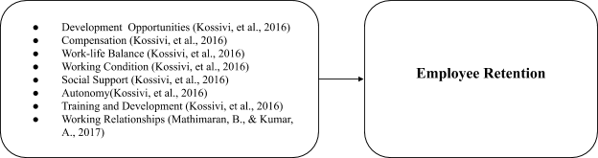

Figure 17: Employee Retention Framework (Kossivi et al., 2016)

The third theoretical framework to be discussed is derived from the variables of Kossivi et al. (2016) and Mathimaran and Jumar (2017). The factors that affect Employee Retention as discussed by Kossivi et al., (2016) are namely; Development Opportunities, Compensation, Work-like Balance, Working Conditions, Social Support, Autonomy, Training and Development, and Working Relationships. In depth explanation per factor can be found in Chapter 2; under Employee Retention. These variables will further help the researchers determine the factors that affect employee retention. Development Opportunities are the opportunities that help employees expand their knowledge, skills and abilities, and apply the competencies they have gained to new situations. Compensation is the money received by an employee form an employer as pay. Work-Life Balance is the balance that a working individual need between time allocated for work and other aspects of life. Working Conditions refers to the working environment and all existing circumstances affecting labor in workplace such as job hours, physical aspects, legal rights, and responsibilities. Social Support is when you have friends and other people, including family, to turn to in times of need or crisis to give you a broader focus and positive self-image. Autonomy is the level of freedom from external control or influence; independence. Training and Development aims to improve the effectiveness of organizations and the individuals and teams within them. Working Relationships is the professional relationship with a colleague, boss or employee. All 8 variables aid in (Kossivi et al., 2016)



Figure 18: Factors of Employee Retention (Kossivi et al., 2016)

Kossivi et al. (2016) identified development opportunities, compensation, work-life balance, management/leadership, work environment, social support, autonomy, training and development as broad factors that affect employee retention. In depth analysis can be found in Chapter 2; Employee retention. Kossivi et al. defined application value as the continual improvement of applications in the data supply chain that are being used live by the employees. Constant improvement in this area depicts the need satisfied by the employee in helping to improve the systems in place. Systems that are efficient would result to more productive employees which in turn drive job satisfaction of employees.

## 3.2 Conceptual Framework

Job Satisfaction

Leadership Style

Employee Retention

Figure 19: The effect of Job Satisfaction and Leadership Style on Employee Retention.

For the Conceptual Framework the researchers made us of the Independent variables which are Job Satisfaction and Leadership Style which is also both the determining factor for Employee Retention. The researchers want to test if there is a correlation between these two variables to Employee Retention. Job satisfaction as defined by Shobe (2018), is proportional to the happiness felt by the employees. This means that the more employees feel satisfied with their organization the more they are likely to feel happy and therefor stay. Leadership styles are defined by Brown (2011) to have 3 distinct characteristics, which are as follows, Transactional, Transformational, and Laissez-faire leadership styles. The researchers would then further discuss these three variables in detail by separating them from one another. The leadership style employed in Sutherland is geared towards transactional and the researchers would like to study the possibility of using transformational or laissez-faire to see if there would be an impact to employee retention.

The proponents aim to study these variables as they are the ones, they deem would have the most impact within Sutherland. As the organization currently uses transactional leadership style the proponents would like to explore different leadership styles and its impact.

## 3.3 Operational Framework

**H5**

**H4**

**H1**

**Job Satisfaction**

* Pay (Sunejma & Kumar, 2011)
* Benefits (Sunejma & Kumar, 2011)
* Promotions (Sunejma & Kumar, 2011)
* Work Conditions (Sunejma & Kumar, 2011)
* Participation (Price & Mueller, 1981).

**Employee Retention**

* Development Opportunities (Kossivi et al., 2016)
* Reward (Mathimaran and Kumar, 2017)
* Work-life balance (Kossivi et al., 2016)
* Work environment (Kossivi et al., 2016)
* Respect (Mathimaran and Kumar, 2017)
* Recognition (Mathimaran and Kumar, 2017)
* Employer Branding (Ahmed 2018)

**Leadership Style**

* Transformational Leadership (Ghadi et al., 2013)
* Transactional Leadership (*Haq & Chandio, 2017)*
* Laissez-Faire Leadership (Ogunola, Kalejaiye & Abrifor, 2013)

**H3**

**H2**

Figure 20: Operational Framework

The Operational Framework of the researchers depicts the independent variables which are Job Satisfaction and Leadership Style and how it is connected to the Dependent variable which is Employee Retention. Factors within the variables are analyzed in Chapter 2 of this research. The proponents would then study the different factors within each variable and how they affect each other. Job Satisfaction as defined by Shobe (2018) is one of the main components when retaining skilled workforce, the proponents would use this information and study how its different factors would impact Employee Retention and its factors as well. Leadership Style would be explored by the researchers and its three (3) different styles would be separated to emphasize the accuracy of the research. By separating Transactional, Transformational, and Laissez-Faire; the proponents would then see which specific leadership style impacts Employee Retention.

## 3.4 Hypothesis of the Study

The following hypothesis statements proposed by the researchers as possible outcomes of the study. The hypothesis was formed through synthesis of literature linked to the research being undertaken. For this study, four (8) pairs of hypothesis statements which are largely grounded on the results of empirical studies completed by the following scholars: (a) Brian Joo (2010) and Papa et al., (2018) concluded that Job Satisfaction directly affects employee retention and that the increase of commitment increases the retention rate of an organization, (b) Spence et al (2009), Bibi et al., (2018), Rhoades et al. (2001) and Blau (1964) all supports the idea that a satisfying work environment encourages employees to reside in the company but more importantly it contributes to a high employee retention, (c) Loon, et. al. (2017), (Michael et al. (2016) and Memon et al. (2010) states that highly satisfied and engaged employees are willing to perform great lengths for their organization and making it a direct indicator on employee morale. With all those in mind, the researchers hypothesize that these variables all-together will positively affect the employee retention in Sutherland Philippines. What is to be measured in this study is the level of significance and impact of the independent variables, Job Satisfaction and Leadership style, toward the dependable variable which is employee retention.

**Ho1:** There is no significant relationship between Job Satisfaction and Employee Retention to the employees of Sutherland Philippines.

**Ha1:** There is a significant relationship between Job Satisfaction and Employee Retention to the employees of Sutherland Philippines

**Ho2A:** There is no significant relationship between Transformational Leadership and Employee Retention to the employees of Sutherland Philippines.

**Ho2B:** There is no significant relationship between Transactional Leadership and Employee Retention to the employees of Sutherland Philippines.

**Ho2C:** There is no significant relationship between Laissez-Faire and Employee Retention to the employees of Sutherland Philippines.

**Ha2A:** There is a significant relationship between Transformational Leadership and Employee Retention to the employees of Sutherland Philippines.

**Ha2B:** There is a significant relationship between Transactional Leadership and Employee Retention to the employees of Sutherland Philippines.

**Ha2C:** There is a significant relationship between Laissez-Faire and Employee Retention to the employees of Sutherland Philippines.

**Ho3:** There is no significant impact between Job Satisfaction and Employee Retention to the employees of Sutherland Philippines.

**Ha3:** There is a significant impact between Job Satisfaction and Employee Retention to the employees of Sutherland Philippines.

**Ho4A:** There is no significant impact between Transformational Leadership and Employee Retention to the employees of Sutherland Philippines.

**Ho4B:** There is no significant impact between Transactional Leadership and Employee Retention to the employees of Sutherland Philippines.

**Ho4C:** There is no significant impact between Laisezz-Faire and Employee Retention to the employees of Sutherland Philippines.

**Ha4A:** There is a significant impact between Transformational Leadership and Employee Retention to the employees of Sutherland Philippines.

**Ha4B:** There is a significant impact between Transactional Leadership and Employee Retention to the employees of Sutherland Philippines.

**Ha4C:** There is a significant impact between Laissez-Faire and Employee Retention to the employees of Sutherland Philippines.

**Ho5:** There is no significant impact between Job Satisfaction and Leadership Style to Employee Retention to the employees of Sutherland Philippines.

**Ha5:** There is a significant impact between Job Satisfaction and Leadership Style to Employee Retention to the employees of Sutherland Philippines.

## 3.5 Assumptions of the Study

For this study, the following assumptions have been made:

* Employees in Sutherland Philippines are more likely to stay in the organization if they feel that their boss is listening to them and that they have a succession plan or career path within the company *(Kammeyer-Mueller, 2005).*
* Employees of Sutherland Philippines. to be more likely to want to stay in the organization, the management can increase the organizational commitment by improving on the affective, continuance and normative aspects of their daily jobs (*Meyer and Allen, 1997 as cited by Chelliah et al., 2015).*
* Improving the Leadership Style whether it be Transactional or Transformational, the employees will have a nicer experience and thus making him/her a more satisfied *employee (Haq & Chandio, 2017)*
* Satisfying the employees needs concerning their job requirements in which they are servicing customers of Sutherland, the employees are to have a nicer experience working for the organization. Motivating, attracting and retaining their employees will greatly decrease their intention to leave the organization *(Aslam,H., Khan,R. & Irfan Lodhi,2011).*
* Alleviating the lack of satisfaction concerning compensation, work-life balance and social support, the intent to leave the organization will decrease within an individual and simultaneously increase their want to stay in the organization (*Kossivi et al., 2016*).
* All survey participants are assumed to be honest with their responses.
* All expert respondents are assumed to be qualified and knowledgeable in their field of work and are to be answering the questions honestly.

## 3.6 Operational Definition of Terms

|  |
| --- |
| * **Benefits** - this aspect of job satisfaction pertains to magnitude of benefits, benefits compared to other organizations, and benefits compared to another co-worker as measurable values (*Nanjundeswaraswamy, 2019)*; benefits is measured by item numbers 39-41 found in section 3 of the adapted research questionnaire and respondents can express their level of agreement or disagreement using the 5-point Likert scale. |
| * **Communication** - this aspect of job satisfaction pertains to the proper channels in place, proper direction of assigned work, accurate organizational goal, and accurate information sharing (*Nanjundeswaraswamy, 2019*); communication is measured by item numbers 42-45 found in section 3 of the adapted research questionnaire and respondents can express their level of agreement or disagreement using the 5-point Likert scale. |

* **Employee Retention** - is when an effort is made to ensure strategies and initiatives which support current employees into remaining in the organization (*Kyndt, Dochy, Michielsen, and Moeyaert, 2009*); this dependent variable is measured in section 4 of the adapted questionnaire using 12 items clustered around 2 dimensions the respondents can express their level of agreement or disagreement using the 5-point Likert scale.

|  |
| --- |
| * **Job Clarity** - this aspect of job satisfaction pertains to the clear understanding of the job as well as clearly defined responsibility for the task at hand.(*Nanjundeswaraswamy, 2019)*; job clarity is measured by item numbers 46-47 found in section 3 of the adapted research questionnaire and respondents can express their level of agreement or disagreement using the 5-point Likert scale. |
| * **Job Satisfaction** - pertains to the relation on the employees with regards to their own assessment on his/her job against the matters and concerns that matter to them, and these sentiments and emotions involved will considerably have an influence on their work attitude (*Roodt, Rieger, & Sempane, 2002, as cited by Nanjundeswaraswamy, 2019*); this independent variable is measured in section 3 of the adapted questionnaire using 21 items clustered around 7 dimensions the respondents can express their level of agreement or disagreement using the 5-point Likert scale. |
| * **Leadership Skills** - this dimension of employee retention is expressed by the employees of Sutherland Philippines when they are competent communicators, susceptibility to stress, and their overall interest in being a leader in their organization (*Kyndt, Dochy, Michielsen, and Moeyaert, 2009)*; leadership skills is measured by item numbers 61-64 found in section 4 of the adapted research questionnaire and respondents can express their level of agreement or disagreement using the 5-point Likert scale. |
| * **Management/ Leadership Style** - is an aspect of work environment that pertains to what may positively or negatively impact employee morale *(Nanzushi, 2015*); management/ leadership style is measured by item numbers 24-25 found in section 2 of the adapted research questionnaire and respondents can express their level of agreement or disagreement using the 5-point Likert scale. |

* **Organizational Commitment** - is shown by the employees of Sutherland Philippines when they easily glue and or adopt their organization along with its present goals (*Allen and Meyer, 1996, as cited by Alam, 2011*); this independent variable is measured in section 1 of the adapted questionnaire using 18 items clustered around 3 dimensions the respondents can express their level of agreement or disagreement using the 5-point Likert scale

|  |
| --- |
| * **Promotion** - this aspect of job satisfaction pertains to fair promotions, chances of promotion, performance-based promotion, and promotion opportunities as measurable values (*Nanjundeswaraswamy, 2019);* promotion is measured by item numbers 35-38 found in section 3 of the adapted research questionnaire and respondents can express their level of agreement or disagreement using the 5-point Likert scale. |
| * **Reward** - is an aspect of work environment that pertains to what truly motivates employees, intrinsic which means joy that comes with completing a task or extrinsic which consists of pay, work condition, fringe benefits, security, and contract of service (*Luthans, 2000, as cited by Nanzushi, 2015*); reward is measured by item numbers 22-23 found in section 2 of the adapted research questionnaire and respondents can express their level of agreement or disagreement using the 5-point Likert scale. |
| * **Training and Development** - is an aspect of work environment that pertains to an organization's capability of providing employees with the skills, abilities and knowledge required by the post and process that enables people to progress from a present state of understanding and capability to a future state in which higher level skills, knowledge and competencies are required. It takes the form of learning activities that prepare people to exercise wider or increased responsibilities (*Tzafrir, 2005 and Armstrong, 2006, as cited by Nanzushi, 2015*); training and development is measured by item numbers 26-28 found in section 2 of the adapted research questionnaire and respondents can express their level of agreement or disagreement using the 5-point Likert scale. |
| * **Work Environment** - refers to the way an employee’s environment at work can impact the way he/she works in the organization *(Nanzushi, 201*5); this independent variable is measured in section 2 of the adapted questionnaire using 13 items clustered around 5 dimensions the respondents can express their level of agreement or disagreement using the 5-point Likert scale. |
| * **Work-life Balance** - is an aspect of work environment that pertains to an organizational support for dependent care, flexible work options, and family or personal leave (*Estes and Michael, 2005, as cited by Nanzushi, 2015*); work-life balance is measured by item   numbers 29-31 found in section 2 of the adapted research questionnaire and respondents can express their level of agreement or disagreement using the 5-point Likert scale.   * **Job embeddedness** - a relatively new construct developed by Mitchell et al. (2001) measuring on how well an employee was embedded in his or her job * **Laissez-Faire** – “Leave it be” in French. A leadership style that delegates an extensive degree of freedom towards its employees. * **Distributive Justice** – Fairness in what people receive (Fair share) * **Kinship Responsibility** – Degree of an individual’s obligation to relatives in a community * **Maslow Hierarchy of Needs (***1943***)** - Physiological, safety, emotional, self-esteem, and self-realization * **Contextual variables** (*Shui, 2011*) – employees perceived cost of changing organizations based on their own thought process, even though it may not accurately reflect their skill * **Employer Branding** – described as an employer’s reputation as a place to w |

# Chapter 4: Methodology

## 4.1 Research Design

For this study, the researchers will be following three types of research designs; causal, correlational and descriptive. Causal research which is also known as explanatory research identifies the extent and nature of a cause and effect relationship. They can also assess the impact of changes in specific situations. These types of studies focus on first analyzing the situation or problem before trying to explain the patterns of relationships between the variables included (Dudovskiy, n.d.).

The correlational research design is appropriate for this study since the researchers will be associating the relationship of job satisfaction and leadership style to employee retention. The research is also correlational as it intends to determine the relationship of each of the independent variables to the dependent carriable.

Descriptive research studies are used to describe the current situation. The descriptive research design will also be applied for the objective to determine what causes the independent variables to be detrimental to the retention of employee's in Sutherland. The researchers will be conducting a survey for Sutherland employees in Taguig site. Then verify the quantitative data through the pattern matching method. To further explain, the quantitative and qualitative data will be obtained using an interval scale such as a Five Point Likert scale which measures the variables in this paper. The responses that are to be gathered will test the gathered information from the collated literature in this study as against the contextual difference and or similarity present in the company.

## 4.2. Research Locale

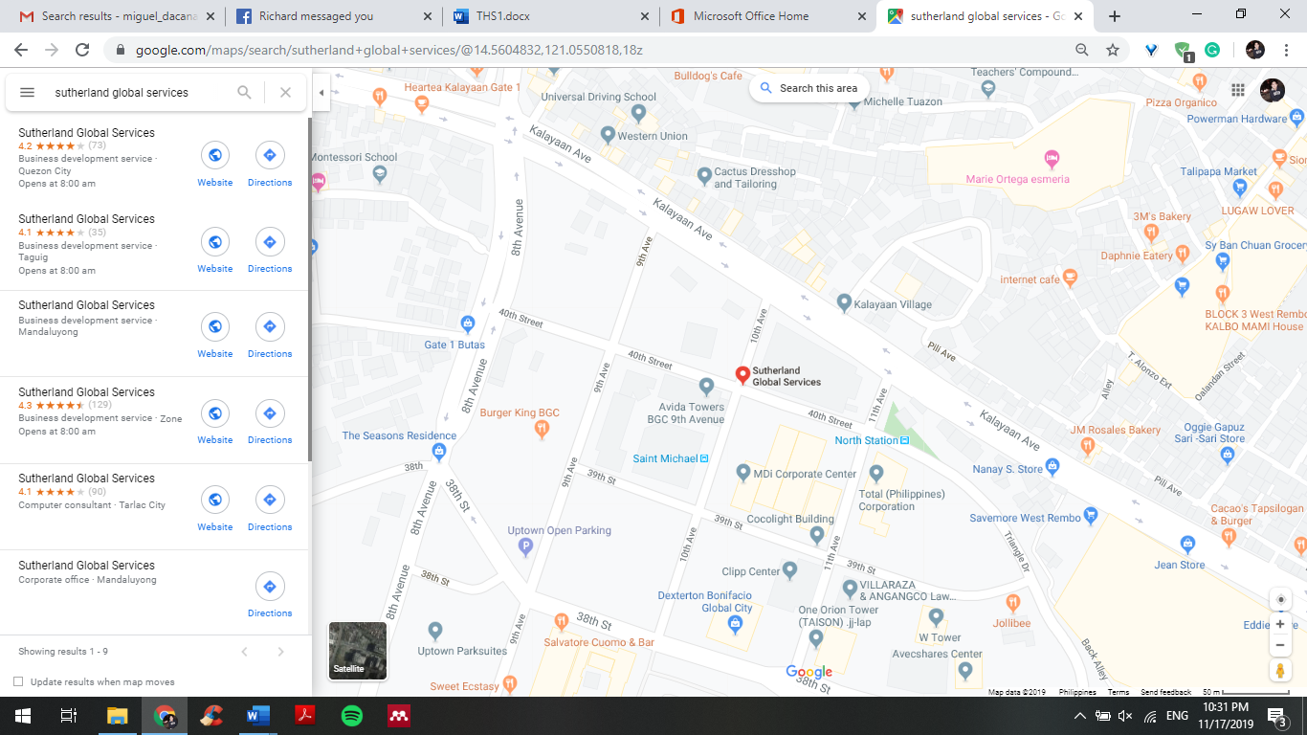

Figure 21:Vicinity Map

The research would be conducted in Sutherland Global Services, 12F PhilPlans Corporate Center 1012 North, in Taguig which the chosen company is located.

Sutherland Global Services in Taguig currently employees an estimated 359 employees, staff, HR personnel and managers. The researchers would like to focus on the rank and file employees of this location. Sutherland has been operating in the Philippines for roughly 9 years, it employs people who are tenure and would be instrumental to the study.

## 4.3. Profile of Respondents

The researches assumed that they think the employees of Sutherland Philippines should be appropriate and knowledgeable within their subject interest. Accordingly, the researchers reached out to conduct personal interviews to management and supervisors to partake in the study in order assess the current practices and culture of Sutherland Philippines. Respondents were drawn out from employees of Sutherland Philippines, provided that the individuals agreed to participate in the study and satisfied conditions set by the researchers based on their demographic information. The following criteria were met by the respondents to qualify:

(a) must be of legal age - 18 years and above,

(b) must be an employee of Sutherland Philippines

## 4.4. Sampling Design

To garner substantial and reliable data, the respondents will include those employees who are in rank and file, team managers, operations manager, and Quality Assurance. The group will be utilizing Slovin’s formula as there is a large sample size.

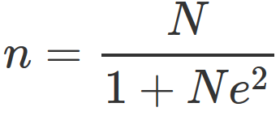

n = N / (1 + Ne2) where n = number of samples, N = total population and e = error tolerance.

The researchers will use Microsoft Excel Data analysis to conduct a simple and multiple linear regression analysis with a confidence level of 95% which suggests the normal error rate for business research.

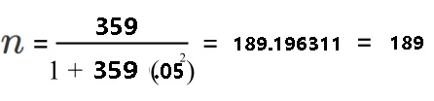

The researchers have estimated a total population size of 359 with an error margin of 5% (0.5), this resulted to a required sample size **of 189 respondents** with 95% level of confidence.

## 4.5. Method of Data Collection

Primary data will be collected by distributing surveys via Google Forms that is to be answered by our chosen respondents to strengthen the quantitative data. There will be three parts to the questionnaire; Job Satisfaction, Leadership Style and Employee Retention. These parts will have questions within them pertaining to the retention of employees in Sutherland. The researchers used a 5-Point Likert scale for the entirety of the questionnaire with 1 being the lowest and 5 being the highest. The survey would be then summarized via Microsoft Forms for the data to be converted into useful information.

### 4.5.1 Survey Instrument

**Job Satisfaction**

|  |  |
| --- | --- |
| **Statement** | **Sub-construct** |
| P1: I feel I am being paid a fair salary for the work I do  *Sa pakiramdam ko ako ay binibigyan ng sahod katumbas sa mga gawain ko.* | **Pay** |
| P2: I am satisfied with allowance (if there's no allowance automatically put strongly disagree)  *Sapat ang ibinibigay sa akin na allowance (kung wala, ilagay sa matindi na di pag-sangayon)* |
| B3: I am not satisfied with the benefits I receive  *Hindi ako kuntento sa mga benepisyo na natatanggap ko* | **Benefits** |
| B4: The benefits I receive are as good as the offers in other agencies  *Ang mga benepisyo natatanggap namin ay kasing buti ng mga offer ng ibang ahensiya* |
| P5: I feel that performance is one of the important factors for promotion  *Performance ay isa sa mga pinaka-importanteng kadahilanan sa pagsulong* | **Promotions** |
| P6: I am satisfied with my chances for promotion  *Ako ay kuntento sa mga mga pagkakataon para sa promotion* |
| WC7: I perceive that my workplace provides a peaceful environment  *Tahimik at mapayapa ang kapaligirang pinagtatrabahuan ko, bagay na nakakatulong upang mapalaganap ang akin trabaho* | **Work Conditions** |
| WC8: I think that a better work environment will make me perform better at my tasks  *Sa tingin ko mapapalaaganap ang aking tungkulin kapag maganda ang kapaligiran* |
| P9: I am willing to put in effort to help my organization grow  *Gagawin ko ang aking kaya para maitulungan ang organisasyon na ito umunlad* | **Participation** |
| P10: I would accept any form of job assignment in order to keep  working for this organization.  *Handa ako kumuha nang kahit anong trabaho upang manatili ako sa aking organisasyon* |

Table 3: Questionnaire items as defined by Nanjundeswaraswamy (2019), Nanzushi,(2015) and Price & Mueller (1981)

**Leadership Style**

|  |  |
| --- | --- |
| **Statement** | **Sub-construct** |
| TS11: My direct superior(s) accepts my ideas and encourages me to be more involved in the company  *Ang mga idea ko ay napapakinggan ng aking boss* | **Transformational Leadership** |
| TL12: I always take the initiative to lead when working as a team  *Kapag ako ay nagtatrabaho bilang bahagi ng isang grupo, sinisikap kong manguna bilang lider.* |
| TC13: My direct superior(s) gives appropriate rewards and punishments for my performance  *Ang aking direktang (mga) superyor ay nagbibigay ng akmang gantimpala at parusa base sa aking takdang tuparin.* | **Transactional Leadership** |
| TC14: My direct superior(s) monitor my performance and keeps track of mistakes.  *Ang aking direktang (mga) superyor ay nakabantay sa aking pagganap at sinusubaybayan ang mga pagkakamali.* |
| LL15: My direct superior(s) allows me to work at my own pace  *Hinahayaan ng aking tagapamahala ang mga gawain ko sa akin sariling oras* | **Laissez-Faire Leadership** |
| LL16: My direct superior(s) provides me freedom to make important decisions regarding my work  *Mayroon akong kalayaan na gumawa ng mahahalagang desisyon na may kaugnayan sa aking trabaho* |

Table 4: Questionnaire items to measure as defined by Sinani (2016), Liden et al., (2014), Kyndt et al., (2009), Haq & Chandio, (2017), Nanjundeswaraswamy, (2019)

**Employee Retention**

|  |  |
| --- | --- |
| **Statement** | **Sub-Construct** |
| DO17: I am satisfied with the ample development opportunities offered at work.  *Ako ay nasiyahan sa mga programang pag-unlad na inaalok sa amin sa trabaho.* | **Development Opportunities** |
| R18: I feel that my organization provides adequate rewards for my efforts  *Nagbibigay ang aking organisasyon ng mga insentibo at benepisyo na nakakatulong sa aking trabaho.Ako ay nakakatanggap ng sapat na kabayaran para sa mga ginagawa ko.* | **Reward** |
| WB19: I can balance work priorities with my personal life.  *Nababalanse ko ang aking mga prayoridad sa trabaho sa buhay-personal.* | **Work-life Balance** |
| WE20: I perceive my workspace to be an ideal environment for me to work  *Tamang-tama ang aking pangkalahatang pagtratrabahuhan upang makatrabaho nang pinakamainam.* | **Work Environment** |
| RP21: My direct superior(s) and co-workers treat me appropriately  *Ang aking boss at katrabaho ay mabait sa akin* | **Respect** |
| RG22: I notice that my efforts are properly recognized  *Kinikilala ng organisasyon ang aking mga kontribusyon upang makamit ang mga layunin ng organisasyon.* | **Recognition** |
| EB23: I demonstrate concern about the image of the organization.  *Nagpapakita ng pag-aalala tungkol sa imahe ng organisasyon.* | **Employer Branding** |

Table 5: Questionnaire items to measure as defined by Kossivi et al. (2016), Mathimaran,B.& Kumar, A. (2017), Nanzushi (2015), Kelchner (2019), Tyler and Blader (2002), Mathimaran,B.& Kumar, A. (2017), Backhaus and Tikoo (2004)

## 4.6. Method of Data Analysis

### 4.6.1 Descriptive Statistics

To evaluate the independent variables in relation to the chosen dependent variable, the researchers will utilize the multiple regression analysis tool. Having that there is more than one variable in which is being measured, using such tool is appropriate After the collection of data from the survey, the researchers will convert the raw data gathered from the Likert scale to numerical data and useful information. The numerical data will be put into a spreadsheet application specifically Microsoft Excel which then linear and multiple linear regression is computed. Data analysis function will be used to get the simple linear regression and multiple linear regressions. The group only used the multiple R, R squared, and adjusted R squared for the results because it is the related data that should be used to measure the relationship of the variables. In addition, to interpret the data collected a descriptive analysis tool is used to present the mean response based on the results of the survey. *Descriptive statistics* which will be used to obtain the following: (a) the mean response and standard deviation (b) the grand mean. *Descriptive statistics* is used to describe, show or summarize the raw data from the results of the survey. It describes data through statistics and graphs. And presents the Mean, Median, Mode, Grand Mean and Standard Deviation of the quantitative results gathered (Vetter, 2017).

### 4.6.2 Linear Regression Model

In order to examine the relationship between each of the independent variables: Job satisfaction and Leadership style on the dependent variable, which is employee retention, the researchers have decided to make use of a linear regression model. This will allow us to show if the independent variables are significant to the model and by how much each would increase employee retention. Shown below are each of the linear regression models to be used.

#### 4.6.2.1. Job Satisfaction and Employee Retention

*EmployeeRetention = β0 + β1JobSatisfaction + ε*

#### 4.6.2.2. Leadership Style and Employee Retention

*LeadershipStyle = β0 + β1Employee Retention + ε*

### 4.6.3. Multiple Linear Regression

In order to collectively examine the relationship of the independent variables: Job satisfaction and Leadership Style on the dependent variable, which is Employee Retention, the researchers have decided to make use of a multiple linear regression model. This will be able to show if collectively, the independent variables are significant to the model and by how much each would increase Employee Retention. Shown below is the multiple linear regression model to be used.

*EmployeeRetention = β0 + β1JobSatisfaction + β1LeadershipStyle + ε*

### 4.6.4. Cronbach’s Alpha

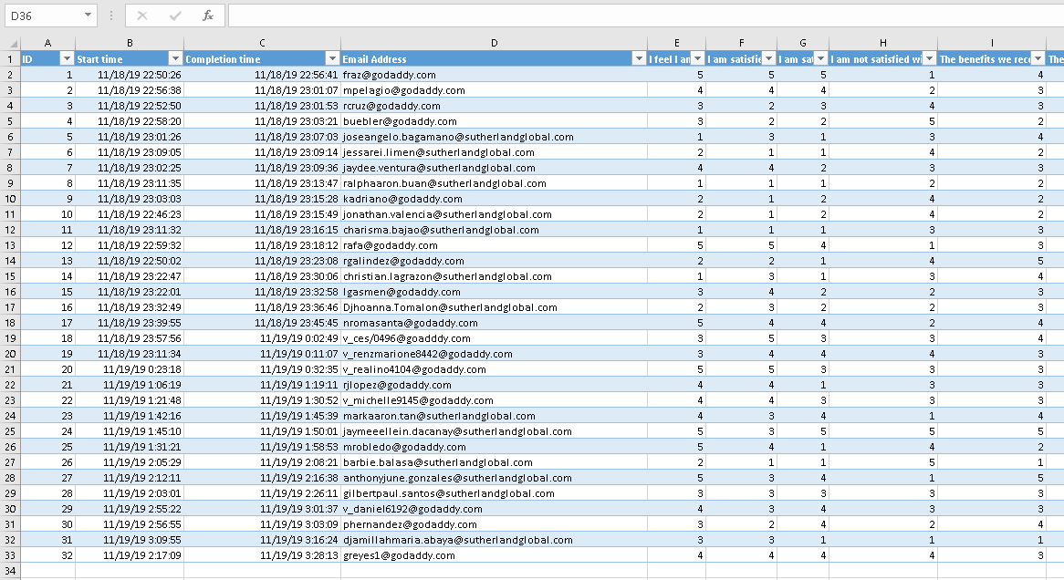

Table 6: 32 respondents for Reliability Test

The researchers will make use of Cronbach’s Alpha to test the reliability of the answers. This model was developed by Lee Cronbach in 1951 as it measures the reliability and internal consistency of questions within the Likert scale surveys. In Cronbach’s Alpha higher value, means that the items in the questionnaire are highly correlated (Glen, 2014).

The proponents then used Google Forms to collect the data portrayed above and rendered them into Microsoft excel for calculations. By aligning the questions into a horizontal list in which Question “1” is attached to Letter “A”, Question 2 is to Letter “B”, and so on until 45 questions is assessed. The researchers then conducted the reliability test by following a simple procedure.

For multiple question Likert scale items, Cronbach’s Alpha is said to measure the latent variables in a questionnaire and will also show the accuracy of the instrument. The following criteria shall be used to gauge the Cronbach’s Alpha score:

|  |  |
| --- | --- |
| **Cronbach’s Alpha** | **Internal Consistency** |
| 0.9 ≤ α | Excellent |
| 0.8 ≤ α < 0.9 | Good |
| 0.7 ≤ α < 0.8 | Acceptable |
| 0.6 ≤ α < 0.7 | Questionable |
| 0.5 ≤ α < 0.6 | Poor |
| α < 0.5 | Unacceptable |

Table 7 Cronbach’s Alpha

The group has achieved a score of 0.963709064 ~ 0.9 which based on Cronbach’s Alpha Internal Consistency is a score of “Excellent”. This suggest that the questionnaire used has an excellent reliability test. The proponents used Microsoft Excel’s Data Analysis Function to solve the Anova: Two Factor without replication which then supplied the proponents with the results of 20.83 in Rows MS 20.83, Error of 0.755, divide the two would result in 0.963.

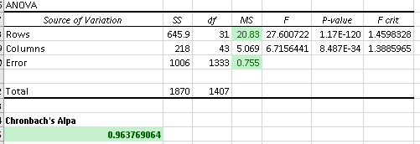

# Chapter 5: Presentation and Analysis of Data

## 5.1 Description of Data Collection Protocol

The research study was conducted with the intention of determining the relationship and impact of Job Satisfaction and Management Leadership Style to Employee Retention as well as the sub-constructs within the two independent variables. The proponents conducted a written interview with a senior manager and sent out survey requests to a population of more than 200 employees 145 of which were answered. Out of 145 respondents only 58 of whom were female, and the rest were male (See Figure 22). Furthermore, the data portrayed a significant score for employees within the age of 25-30 years old, accounting for 62 out of 145. The respondents were also asked their highest educational attainment wherein most of them answered with a college degree, while the other 40% accounted for those who received at least 2 years of college education (See Figure 23). The youngest was 21 years old while the oldest was 45 years old, giving us a range of 22. The respondents average age was 28.71 with a median age of 28 (See Figure 24).

Based on the regression analysis of the survey data, the proponents conclude that there was a statistically significant relationship between Job Satisfaction and Leadership Style to Employee Retention based on the resulting P-Value of 0.03 which is less than the 0.05 threshold. Moreover, a regression analysis performed for Job Satisfaction and Employee Retention resulted in a P-Value of 0.74 which means they are not statistically significant. The proponents then performed regression analysis on the three Leadership Styles; Transformational, Transactional, and Laissez-Faire, which resulted in P-Values 0.0003, 0.107-11 ,0.11-04, respectively. The data shows that all three Leadership Styles were statistically significant in relation to Employee Retention. Furthermore, the proponents examined the impact of the variables using Pearson’s correlation which was also tested on each of the sub-construct of the variables and be further discussed on the next sub-chapter (See Chapter 5.3)

## 5.2 Consolidated Results of Demographic Information

The researchers were able to gather a Total of 145 Survey Respondents of which are composed of 87 Males and 58 Females Employees of Sutherland PH.

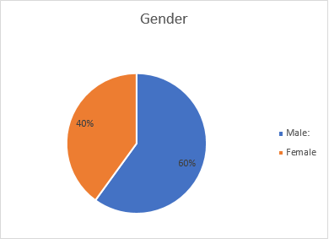

Figure 22: Gender Pie Chart

The researchers were able to gather a Total of 145 Survey Respondents of which are composed of 60% Male Employee and 40% Female Employees, 87 and 58 Females Employees of Sutherland Philippines.

Figure 23: Educational Attainment Pie Chart

Of the total 145 respondents, 36% attained at least second year of college while the other 64% are college degree holders. This suggests that the work environment caters to those who have finished and to those who have not finished their college degrees. This creates a mixed environmental culture inside the company

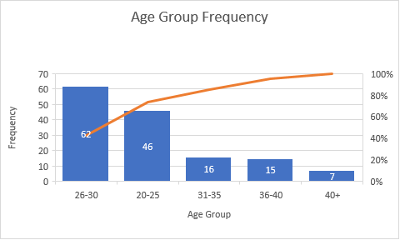

Figure 24: Age Group Frequency

The proponents examined 145 respondents wherein most of them answered that they are in the ages between 26-30, suggesting that the workforce of Sutherland Philippines are young adults. The next age group is 20-25 which suggests that they have just finished college or is still finishing college. Since they are figuring out what they want in life they are more likely to be unstable with their careers and would likely shift career options. This must be considered since the proponents are studying the causes of attrition in Sutherland Philippines.

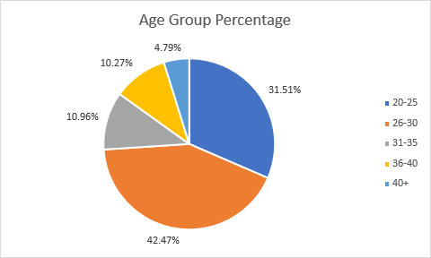

Figure 25: Age group percentage

### 5.2.1 Consolidated Results of Survey Items

**JOB MEAN VERBAL SD**

**SATISFACTION INTERPRETATION**

1. I feel I am being 3.359 Neither agree nor 1.09

paid a fair salary disagree

for the work I do

1. I am satisfied with 2.703 Neither agree nor 1.22

my allowance disagree

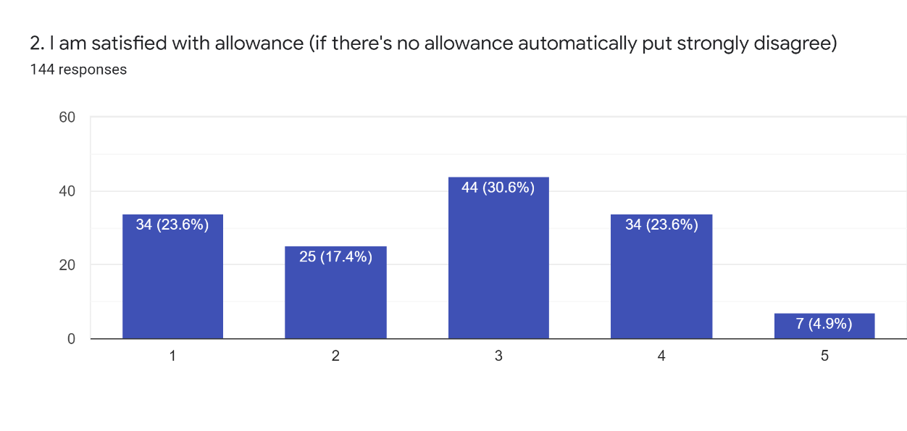

Figure 26: Pay Sub-construct Score

Question number 2 garnered the lowest score for Job Satisfaction and for the entire survey as well. It is based on the Pay sub-construct and suggests that employees feel that they are not being compensated enough for the work they provide for the company. This suggests that the company is either underpaying their employees or they are overworking their employees without enough compensation or benefits.

1. I am not satisfied 3.028 Neither agree nor 1.16

with the benefits disagree

I receive

1. The benefits I receive 3.028 Neither agree nor 1.20

are as good as the offers disagree

in other agencies

1. I feel that performance 4.079 Agree 1.00

is one of the important

factors for promotion

1. I am satisfied with my 3.648 Agree 1.13

chances for promotion

1. I perceive that my 3.931 Agree 0.93

workplace provides

a peaceful environment

1. I think that a better 4.393 Agree 0.83

work environment

will make me perform

better at my tasks

1. I am willing to put in 4.414 Agree 0.77

effort to help my

organization grow

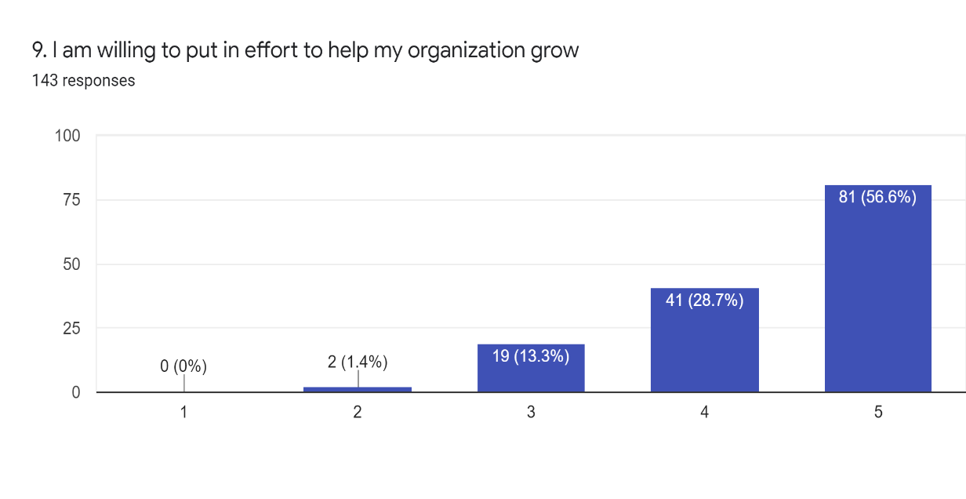

Figure 27: Participation Sub-construct Score

Employees tend to feel better about their work when they see that they are part of something bigger and that they contribute towards this common goal. They see themselves as an important part of a company and tend to have better attitude when helping the company grow.

1. I would accept any 4.152 Agree 0.88

form of job assignment

in order to keep working

for this organization.

_____________________________________________________________________________

**GRAND MEAN 3.673 Level of job satisfaction 0.16**

**is above average**

**_____________________________________________________________________________**

Table 8: Job Satisfaction Survey Results

Job Satisfaction garnered a total of 3.673 average score for the survey. This suggests a moderate level of Job Satisfaction employees have towards the company and that the biggest detractor employees feel is that they are not being compensated enough for the work they do as seen in Question number 2. The highest attractor is that employees feel they help the company grow as a whole and provide the company with the needed skillset. This helps the employee feel important and needed in the company which raises the Job Satisfaction employees feel.

**TRANSFORMATIONAL MEAN VERBAL SD**

**LEADERSHIP STYLE INTERPRETATION**

1. My direct superior(s) 4.262 Agree 0.78

accepts my ideas

and encourages me

to be more involved

in the company

1. I always take the 3.917 Agree 0.85

initiative to lead

when working as

a team

_________________________________________________________________________

**GRAND MEAN 4.090 Level of transformational 0.05**

**leadership is high**

**_________________________________________________________________________________**

Table 9: Transformational Leadership Style Survey Results

The employees feel that their direct superior is adequately listening to their ideas and that they provide ample opportunities for them to be heard. This encourages the employee to have a sense of responsibility towards their tasks and thus supports the Transformational Leadership Style. Number 12 with an above average score of 3.9 suggests that the supervisors of Sutherland encourages their employees to be more active in their respective teams. This provides them with potential and skills needed for career advancement.

**TRANSACTIONAL MEAN VERBAL SD**

**LEADERSHIP STYLE INTERPRETATION**

1. My direct superior(s) 4.083 Agree 0.98

gives appropriate

rewards and

punishments for my

performance

1. My direct superior(s) 4.283 Agree 0.94

monitor my performance

and keeps track

of mistakes.

_______________________________________________________________________________

**GRAND MEAN 4.183 Level of transactional 0.02**

**leadership is high**

**______________________________________________________________________________**

Table 10: Transactional Leadership Style Results

Both questions in Transactional Leadership Style scored a score of higher than 4 which suggests that employees are being treated fairly in terms of rewards and punishment. They feel that their boss is providing them with adequate recognition for their achievements and just punishment for their mishaps. This encourages a just and fair working environment which provides the employees with a sense of stability and that they can count on the decisions of their superior(s). The superior(s) of Sutherland garnered high score in terms of keeping track of their employee’s performance and mistakes, this supports the fairness inside the work environment and also supports the Transactional Leadership Style of the direct and stern treatment of employees.

**LAISSEZ-FAIRE MEAN VERBAL SD**

**LEADERSHIP STYLE INTERPRETATION**

1. My direct superior(s) 4.31 Agree 0.83

allows me to work at

my own pace

1. My direct superior(s) 4.324 Agree 0.75

provides me freedom

to make important

decisions regarding

my work

_______________________________________________________________________________

**GRAND MEAN 4.317 Level of Laissez-Faire 0.05**

**leadership style is high**

**_______________________________________________________________________________**

Table 11: Laissez-Faire Leadership Style Results

The Laissez-Faire Leadership Style garnered the highest score of 4.3 out of the 3 Leadership Styles. This suggest that employees feel better when they can work at their own pace and is given freedom in delegating their own tasks at work. They are also given the chance to impose their own important decisions regarding the work that they do which means employees are more likely to be positive and productive when they are given the chance to manage their work and time.

**EMPLOYEE MEAN VERBAL SD**

**RETENTION INTERPRETATION**

1. I am satisfied with 3.759 Agree 0.94

the ample development

opportunities offered

at work.

1. I feel that my 3.297 Neither agree nor 1.11

organization provides disagree

adequate rewards for

my efforts

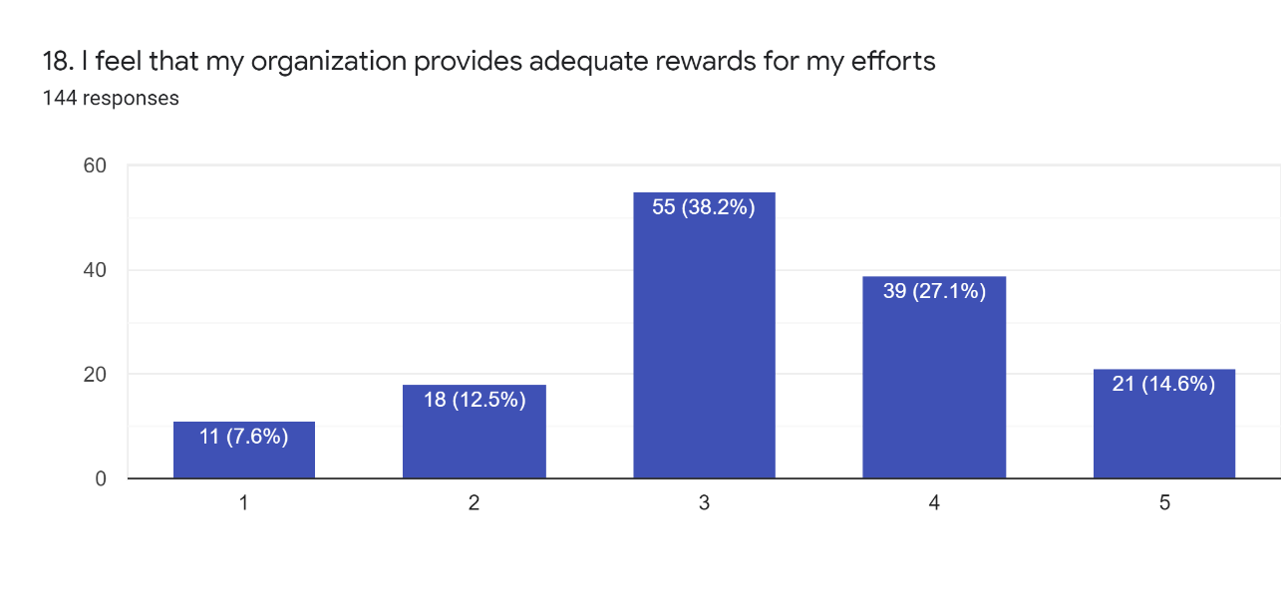

Figure 28: Question #18 Results

Based on the results of number 18 on the survey questionnaire, the researchers have seen a decline in satisfaction attaining only a 14% score on the 5th Likert scale and most of the answers are in the 3rd which means they are neutral. This suggests that employees do not feel they are being paid well for the work they provide but they also feel that they may not provide enough work to be paid for, thus, they chose mostly the middle-ground answer.

1. I can balance work 4.028 Agree 1.03

priorities with my

personal life.

1. I perceive my 3.979 Agree 0.89

workspace to be

an ideal environment

for me to work

1. My direct superior(s) 4.297 Agree 0.91

and co-workers treat

me appropriately

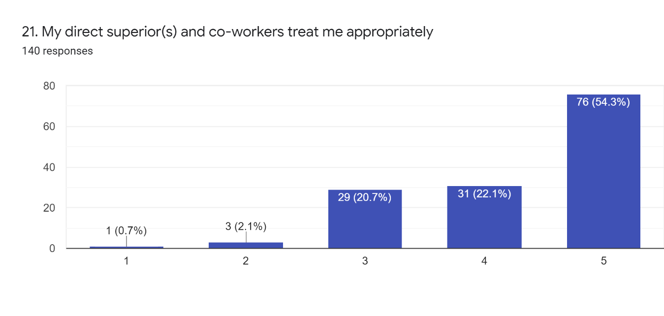

Figure 29: Question #21 Results

Based on the conclusive results of the survey question number 21, we can assume that the employees feel they are being treated well by their superior(s). This means that the management is doing a good job of treating their subordinates nicely. We can correlate this result with number 16 which suggests that the issue does not lie within how the superior(s) act but within how the leadership system works in general and that employees feel more likely to stay with the company if they are given a chance to delegate their own tasks.

1. I notice that my efforts 3.648 Agree 1.11

are properly recognized

1. I demonstrate concern 4.097 Agree 0.86

about the image of the

organization.

______________________________________________________________________________

**GRAND MEAN 3.872 Level of Employee 0.10**

**retention is above**

**average**

______________________________________________________________________________________

Table 12: Employee Retention Results

Based on the results of number 17 to 23 of the survey questionnaire. We can assume that the Employee Retention score of 3.8 is moderately high and comes second to leadership style which garnered the highest results in the survey. This score suggests that employees feel they are comfortable with the company and tend to stay with the company. They are happy with how their superior(s) treat them although they are not satisfied with the rewards they earn from the company, based on the score of 3.2 in number 18. This is because employees feel that they are doing more work than what they are being paid for. This can be compensated by restructuring the reward system of Sutherland, they can provide monthly top performers a chance to get rewards and even promotions.

## 5.3 Results of Inferential Statistics

### 5.3.1 Linear Regression results to establish the relationship between Job Satisfaction and Employee Retention

**Ho1:** There is no significant relationship between Job Satisfaction and Employee Retention to the employees of Sutherland Philippines.

**Ha1:** There is a significant relationship between Job Satisfaction and Employee Retention to the employees of Sutherland Philippines

|  |  |
| --- | --- |
| SUMMARY OUTPUT | VARIABLES |
| **Job Satisfaction** to ER |  |
| *Regression Statistics* | |
| Multiple R | 0.761991943 |
| R Square | 0.580631721 |
| Adjusted R Square | 0.577699076 |
| Standard Error | 0.482724048 |
|  |  |

**P-Value**   **0.743154419**

_________________________________________

Table 13: JS to ER relationship

### 5.3.2 Linear Regression results to establish the relationship between Transformational Leadership Style and Employee Retention

**Ho2A:** There is no significant relationship between Transformational Leadership and Employee Retention to the employees of Sutherland Philippines.

**Ha2A:** There is a significant relationship between Transformational Leadership and Employee Retention to the employees of Sutherland Philippines.

|  |  |
| --- | --- |
| SUMMARY OUTPUT |  |
| **Transformational** to ER |  |
| *Regression Statistics* | |
| Multiple R | 0.66252385 |
| R Square | 0.438937852 |
| Adjusted R Square | 0.435014341 |
| Standard Error | 0.558350142 |

**P- Value 0.000317557**

__________________________________________

Table 14: Transformational to ER relationship

### 5.3.3 Linear Regression results to establish the relationship between Transactional Leadership Style and Employee Retention

**Ho2B:** There is no significant relationship between Transactional Leadership and Employee Retention to the employees of Sutherland Philippines.

**Ha2B:** There is a significant relationship between Transactional Leadership and Employee Retention to the employees of Sutherland Philippines.

|  |  |
| --- | --- |
| SUMMARY OUTPUT |  |
| **Transactional** to ER |  |
| *Regression Statistics* | |
| Multiple R | 0.652927765 |
| R Square | 0.426314667 |
| Adjusted R Square | 0.422302881 |
| Standard Error | 0.564596289 |

***P-Value 1.07406E-11***

***___________________________________________***

Table 15: Transactional to ER relationship

### 5.3.4 Linear Regression results to establish the relationship between Laissez-Faire Leadership Style and Employee Retention

**Ho2C:** There is no significant relationship between Laissez-Faire and Employee Retention to the employees of Sutherland Philippines.

**Ha2C:** There is a significant relationship between Laissez-Faire and Employee Retention to the employees of Sutherland Philippines.

|  |  |
| --- | --- |
| SUMMARY OUTPUT |  |
| **Laissez-Faire** to ER |  |
| *Regression Statistics* | |
| Multiple R | 0.605969345 |
| R Square | 0.367198847 |
| Adjusted R Square | 0.362773664 |
| Standard Error | 0.592972806 |

***P-Value 1.12801E-05***

***________________________________________***

Table 16: Laissez-Faire to ER relationship

### 5.3.5 Linear Regression results to establish the impact between Job Satisfaction and Employee Retention

**Ho3:** There is no significant impact between Job Satisfaction and Employee Retention to the employees of Sutherland Philippines.

**Ha3:** There is a significant impact between Job Satisfaction and Employee Retention to the employees of Sutherland Philippines.

|  |  |  |
| --- | --- | --- |
|  | ***Job Satisfaction*** | *ER* |
| JS | 1 |  |
| ER | **0.761996** | 1 |

Table 17: JS to ER impact

### 5.3.6 Linear Regression results to establish the impact between Transformational Leadership Style and Employee Retention

**Ho4A:** There is no significant impact between Transformational Leadership and Employee Retention to the employees of Sutherland Philippines.

**Ha4A:** There is a significant impact between Transformational Leadership and Employee Retention to the employees of Sutherland Philippines.

|  |  |  |
| --- | --- | --- |
|  | ***Transformational*** | *ER* |
| TRANSFORM | 1 |  |
| ER | **0.662482692** | 1 |

Table 18: Transformational to ER impact

### 5.3.7 Linear Regression results to establish the impact between Transactional Leadership Style and Employee Retention

**Ho4B:** There is no significant impact between Transactional Leadership and Employee Retention to the employees of Sutherland Philippines.

**Ha4B:** There is a significant impact between Transactional Leadership and Employee Retention to the employees of Sutherland Philippines.

|  |  |  |
| --- | --- | --- |
|  | ***TRANSACT*** | *ER* |
| TRANSACT | 1 |  |
| ER | **0.652940277** | 1 |

Table 19: Transactional to ER impact

### 5.3.8 Linear Regression results to establish the impact between Laissez-Faire Leadership Style and Employee Retention

**Ho4C:** There is no significant impact between Laissez-Faire and Employee Retention to the employees of Sutherland Philippines.

**Ha4C:** There is a significant impact between Laissez-Faire and Employee Retention to the employees of Sutherland Philippines.

|  |  |  |
| --- | --- | --- |
|  | **LAISSEZ**  **-FAIRE** | *ER* |
| ER | 1 |  |
| LAISSEZ-FAIRE | **0.606024598** | 1 |

Table 20: Laissez-Faire to ER impact

### 5.3.9 Multiple Linear Regression results to establish the impact between Job Satisfaction and Leadership Style to Employee Retention

**Ho5:** There is no significant impact between Job Satisfaction and Leadership Style to Employee Retention to the employees of Sutherland Philippines.

**Ha5:** There is a significant impact between Job Satisfaction and Leadership Style to Employee Retention to the employees of Sutherland Philippines.

|  |  |  |  |
| --- | --- | --- | --- |
|  | ***JS*** | ***LS*** | *ER* |
| JS | 1 |  |  |
| LS | **0.58307** | 1 |  |
| ER | **0.761992** | **0.717639** | 1 |

Table 21: JS and LS to ER impact

### 5.3.10 Multiple Linear Regression results to establish the relationship between Job Satisfaction and Leadership Style to Employee Retention

|  |  |
| --- | --- |
| MULTIPLE REGRESSION |  |
| **Job Satisfaction & Leadership Style** to ER |  |
| SUMMARY OUTPUT |  |
|  |  |
| *Regression Statistics* | |
| Multiple R | 0.832967146 |
| R Square | 0.693834266 |
| Adjusted R Square | 0.689522073 |
| Standard Error | 0.413907489 |

***P-Value 0.030758132***

***___________________________________________***

Table 22: JS and LS to ER relationship

### 5.3.11 Linear Regression results to establish the relationship between Leadership Style and Employee Retention

|  |  |
| --- | --- |
| **Leadership Style** to ER |  |
| SUMMARY OUTPUT |  |
|  |  |
|  |  |
| *Regression Statistics* | |
| Multiple R | 0.717638683 |
| R Square | 0.51500528 |
| Adjusted R Square | 0.511613709 |
| Standard Error | 0.519122259 |

***P Value 0.00826568***

_____________________________________________

Table 23: LS to ER relationship

### 5.3.12 Linear Regression results to establish the relationship between Pay and Employee Retention

|  |  |
| --- | --- |
| **PAY** |  |
| SUMMARY OUTPUT |  |
|  |  |
| *Regression Statistics* | |
| Multiple R | 0.513864866 |
| R Square | 0.2640571 |
| Adjusted R Square | 0.258910646 |
| Standard Error | 0.639474463 |

***P-Value 1.61546E-34***

_____________________________________________

Table 24: Pay to ER relationship

### 5.3.13 Linear Regression results to establish the relationship between Benefits and Employee Retention

|  |  |
| --- | --- |
| **BENEFITS** |  |
| SUMMARY OUTPUT |  |
|  |  |
| *Regression Statistics* | |
| Multiple R | 0.214745376 |
| R Square | 0.046115577 |
| Adjusted R Square | 0.039445056 |
| Standard Error | 0.728029579 |

***P-Value 1.66501E-29***

_____________________________________________

Table 25: Benefits to ER relationship

### 5.3.14 Linear Regression results to establish the relationship between Promotions and Employee Retention

|  |  |
| --- | --- |
| **PROMOTIONS** |  |
| SUMMARY OUTPUT |  |
|  |  |
| *Regression Statistics* | |
| Multiple R | 0.535275449 |
| R Square | 0.286519806 |
| Adjusted R Square | 0.281530434 |
| Standard Error | 0.629639705 |

***P-Value 9.2919E-17***

_______________________________________________

Table 26: Promotions to ER relationship

### 5.3.15 Linear Regression results to establish the relationship between Work Conditions and Employee Retention

|  |  |
| --- | --- |
| **Work Conditions** |  |
| SUMMARY OUTPUT |  |
|  |  |
| *Regression Statistics* | |
| Multiple R | 0.647451007 |
| R Square | 0.419192807 |
| Adjusted R Square | 0.415131218 |
| Standard Error | 0.568089993 |

***P-Value 0.000548678***

________________________________________________

Table 27: Work Conditions to ER relationship

### 5.3.16 Linear Regression results to establish the relationship between Participation and Employee Retention

|  |  |
| --- | --- |
| **PARTICIPATION** |  |
| SUMMARY OUTPUT |  |
|  |  |
| *Regression Statistics* | |
| Multiple R | 0.61182088 |
| R Square | 0.374324789 |
| Adjusted R Square | 0.369949438 |
| Standard Error | 0.589624635 |

***P-Value 2.17783E-05***

***__________________________________________***

Table 28: Participation to ER relationship

### 5.3.17 Linear Regression results to establish the impact between Pay and Employee Retention

|  |  |  |
| --- | --- | --- |
|  | *ER* | ***PAY*** |
| ER | 1 |  |
| PAY | **0.51384** | 1 |

Table 29: Pay to ER impact

### 5.3.18 Linear Regression results to establish the impact between Benefits and Employee Retention

|  |  |  |
| --- | --- | --- |
|  | *ER* | ***BENEFITS*** |
| ER | 1 |  |
| BENEFITS | **0.214654** | 1 |

Table 30: Benefits to ER impact

### 5.3.19 Linear Regression results to establish the impact between Promotions and Employee Retention

|  |  |  |
| --- | --- | --- |
|  | ***PROMOTIONS*** | *ER* |
| PROMOTIONS | 1 |  |
| ER | **0.535342** | 1 |

Table 31: Promotions to ER impact

### 5.3.20 Linear Regression results to establish the impact between Work Conditions and Employee Retention

|  |  |  |
| --- | --- | --- |
|  | *ER* | ***Work Conditions*** |
| ER | 1 |  |
| WC | **0.64746212** | 1 |

Table 32: Work Conditions to ER impact

### 5.3.21 Linear Regression results to establish the impact between Participation and Employee Retention

|  |  |  |
| --- | --- | --- |
|  | ***PARTICIPATION*** | *ER* |
| PARTICIPATION | 1 |  |
| ER | **0.611879** | 1 |

Table 33: Participation to ER impact

## 5.4 Results of Hypothesis Testing

|  |  |  |  |  |  |
| --- | --- | --- | --- | --- | --- |
| **Hypothesis** | **P-Value /**  **Correlation** | | β | | **Decision** |
| **Ho1:** There is no significant relationship between Job Satisfaction and Employee Retention to the employees of Sutherland Philippines.  **Ha1:** There is a significant relationship between Job Satisfaction and Employee Retention to the employees of Sutherland Philippines | **0.74** | | **1.03** | | **Accept Null;**  Reject Alternative |
| **Ho2A:** There is no significant relationship between Transformational Leadership and Employee Retention to the employees of Sutherland Philippines.  **Ha2A:** There is a significant relationship between Transformational Leadership and Employee Retention to the employees of Sutherland Philippines. | **0.0003** | | **0.70** | | **Reject Null;**  Accept Alternative |
| **Ho2B:** There is no significant relationship between Transactional Leadership and Employee Retention to the employees of Sutherland Philippines.  **Ha2B:** There is a significant relationship between Transactional Leadership and Employee Retention to the employees of Sutherland Philippines. | **1.07-11** | | **0.53** | | **Reject Null**;  Accept Alternative |
| **Ho2C:** There is no significant relationship between Laissez-Faire and Employee Retention to the employees of Sutherland Philippines.  **Ha2C:** There is a significant relationship between Laissez-Faire and Employee Retention to the employees of Sutherland Philippines. | **1.13-05** | | **0.60** | | **Reject Null**;  Accept Alternative |
| **Ho3:** There is no significant impact between Job Satisfaction and Employee Retention to the employees of Sutherland Philippines.  **Ha3:** There is a significant impact between Job Satisfaction and Employee Retention to the employees of Sutherland Philippines. | **0.76** | |  | | There is a **significant** impact |
| **Ho4A:** There is no significant impact between Transformational Leadership and Employee Retention to the employees of Sutherland Philippines.  **Ha4A:** There is a significant impact between Transformational Leadership and Employee Retention to the employees of Sutherland Philippines. | **0.66** | |  | | There is a **moderately** significant impact |
| **Ho4B:** There is no significant impact between Transactional Leadership and Employee Retention to the employees of Sutherland Philippines.  **Ha4B:** There is a significant impact between Transactional Leadership and Employee Retention to the employees of Sutherland Philippines. | **0.65** | |  | | There is a **moderately** significant impact |
| **Ho4C:** There is no significant impact between Laissez-Faire and Employee Retention to the employees of Sutherland Philippines.  **Ha4C:** There is a significant impact between Laissez-Faire and Employee Retention to the employees of Sutherland Philippines. | **0.61** | |  | | There is a **moderately** significant impact |
| **Ho5:** There is no significant impact between Job Satisfaction and Leadership Style to Employee Retention to the employees of Sutherland Philippines.  **Ha5:** There is a significant impact between Job Satisfaction and Leadership Style to Employee Retention to the employees of Sutherland Philippines. | | **0.03** | |  | **Reject Null**;  Accept Alternative |

Table 34: Hypothesis Testing Table

# Chapter 6: Conclusion and Recommendations

## 6.1 Conclusion

Sutherland incurred a spike in their attrition rate during the month of August to September from 1%-10%, respectively (See Figure 4). Not only was it the highest variation of 9% in two years, but it was also their highest attrition percentage in the span of two years. Attrition not only affects the productivity of the company, but it also affects their asset, as employees are treated as an asset by the company and complicated/specified jobs that companies have would spend a lot to train their employees. Moreover, in the BPO industry when there is a low number of employees there isn’t enough workforce to handle the sudden influx of clients to mitigate this the company would either reduce their customers or over-work their employees, both of which have their own downsides. The company would implement detrimental strategies while they look and train more employees resulting in more time and money invested. Therefore, companies do their best to filter out employees who are likely to leave the company in their early years, they check the location of the employee, educational attainment, and other environmental factors.

The research, entitled “A Study on a Job Satisfaction and Management Leadership Style affecting Employee Retention in Sutherland Philippines.” aims to understand how Job Satisfaction and Management Leadership Style affects Employee Retention, specifically in the Business Process Outsourcing (BPO) Industry such as Sutherland Philippines. Thus, the objectives of the research study were the following:

* To discover the different factors in leadership style that could affect employee retention
* To determine whether the turnover rate is affected by the job satisfaction of employees
* To propose strategies to improve the job satisfaction that employees feel in Sutherland Philippines
* To determine which leadership style would retain employees in Sutherland Philippines
* To discover the effectivity of employee satisfaction in Sutherland Philippines
* To discover the cost-benefit of retaining employees in the company
* To know which practices will have a direct impact on retaining employees
* To distinguish the degree of job satisfaction in Sutherland Philippines
* To determine the relationship of Job satisfaction to employee retention
* To determine the relationship of leadership style to employee retention
* To determine the relationship of job satisfaction to the leadership style used by the company
* To identify the impact of job satisfaction and leadership style to employee retention in Sutherland Philippines.

To gather the data needed, a manager was interviewed and a total of 145 employees were given a survey to answer. Of the 145 employees, 60% are Males while 40% are Females, with most of the employees (64.14%) being College Graduates. Majority of the employees, being 73.98% of the respondents are in the Under 30 range, with 42.47% being on the 26 – 30 range with the 21 – 25 range as a close second only representing 31.51% of the population. Employees that are aged 31 and above, represent a minority of 26.02% of the 145 employees in the survey, the 31 – 35 age group is 10.96% while the 36 – 40 is 10.27%, lastly the “40 and above” age group represents the lowest of all 4 brackets, yielding 4.79% of the total respondents. With those figures we could assume that the workforce is quite young and productive. Moreover, having a young workforce suggests that they are more likely to resign as they are still figuring out what they want to do and focus on in life. This goes true without saying as young people tend to switch jobs often, testing out the waters and figuring out what works for them.

### 6.1.1 Job Satisfaction to Employee Retention

The proponents studied the relationship and impact of the Job Satisfaction and Leadership Style to Employee Retention. Based on the survey results the data shows that there was no significant relationship between Job Satisfaction and Employee Retention, with a P-Value of 0.74 it is already considered highly insignificant. This indicates that the model cannot be proven to be a reliable model as there is no conclusive evidence to prove this, based on the results of the hypothesis testing. Moreover, the impact of Job Satisfaction to Employee Retention garnered a correlation coefficient of 0.76, this suggests that the questions for the variables indicated a strong positive correlation to each other. A strong positive correlation indicates that the questions pertaining to Job Satisfaction was deemed strongly related to Employee Retention, which makes sense since employee satisfaction is a key role in attrition, employees also perform better when they are satisfied with the work they accomplish. This strong positive relationship indicates that the respondents who answered high marks for Job Satisfaction also answered high marks for Employee Retention, and they both move in tandem.

### 6.1.2 Pay to Employee Retention

The proponents then tested the sub-constructs of Job Satisfaction to see if they would provide a significant result when collectively they have not. Starting off with Pay, which garnered a result of 1.61-34 suggesting that the model is highly significant and reliable when determining the relationship of Pay to Employee Retention. Then proponents conducted a Pearson’s correlation analysis to examine the strength of impact between the two variables and acquired a result of 0.51 which suggests a moderately positive strength between the two variables. This means that there was a determined positive linear relationship between the two variables and that Pay can somewhat be a representation of Employee Retention. The employees of Sutherland would then have a positive impact on the attrition rate if their pay was subsequently increased.

### 6.1.3 Benefits to Employee Retention

Benefits is the second sub-construct tested using regression analysis and garnered a result of 1.67-29 this indicates that the model used was reliable and that the two variables shows a significant relationship to each other. Moreover, based on the correlation coefficient result of Benefits to Employee Retention, the proponents discovered that there was a weak positive relationship between the two variables this suggests that the survey result for Benefit and Employee Retention, although positive, shows little evidence that they are correlated to each other. In other words, employees answered questions on Benefits that are linear to Employee Retention but account for only a small amount.

### 6.1.4 Promotions to Employee Retention

The proponents then examined the 3rd sub-construct under Job Satisfaction which is promotions and it garnered a result of 9.29-17 using the regression analysis, indicating a reliable model for our variables. Promotions to Employee Retention acquired a correlation coefficient of 0.54 suggesting a moderately positive relationship to each other. This means that the employees of Sutherland PH tend to stay longer if they are given the right opportunities to advance for the work they provide to the company. This is in relation to the low mean value of question number 2 which explains that the employees of Sutherland feel that they are not having enough allowances for them to work with. Both data coincide with each other indicating that if the management of Sutherland increase the employee’s chances of promotion or increase their pay for them to be retained longer within the company.

### 6.1.5 Work Conditions to Employee Retention

Work Conditions is the 4th sub-construct within Job Satisfaction garnered a result of 0.0006 using regression analysis and a correlation coefficient of 0.65. This indicates that the model used is reliable for testing and the relationship between Work Condition and Employee Retention was significant. A correlation coefficient of 0.65 is moderately positive indicating that the survey results for both the variables show a positive linear trend with each other. This means that they are strongly tied to each other and, thus, conclusive results from this model is reliable. Employees of Sutherland PH tend to stay longer if the work environment inside the office is comfortable for them and that they feel safe with the work area, this is positively related to Employee Retention and employees tend to stay longer if good working conditions are adequately met.

### 6.1.6 Participation to Employee Retention

The last remaining sub-construct within Job Satisfaction is Participation which means that the employees are given enough chance to participate in the subject matter within their designated teams. This implies a subtle aspect to leadership style as well as superiors are designated to provide ample participative opportunities to employees. Participation garnered a result of 0.00002 in the regression analysis test which suggest that the model used is not only reliable but can be used as a good basis as there is a proven relationship between the two variables. A resulting correlation coefficient of 0.611 for Participation suggests that the survey results of the two variables are moderately positive to each other and they follow a linear path. This indicates that the answers provided by the respondents for Promotions can be moderately linked to Employee Retention. Sutherland employees are more likely to stay within the company if they are provided ample opportunities for promotion within the company. Employees also feel good about their stay in the company if they are given the right job for their skillset.

### 6.1.7 Leadership Style to Employee Retention

The proponents then examined the Leadership Style Sub-constructs and their respective relationship to Employee Retention wherein Transformation Leadership Style comes first out of the three Leadership Style. Transformation Leadership Style is generally referred to as the way of delegating tasks to employees wherein they are provided opportunities to be heard by the leader and adjust to the needs of the employees. This encourages inspiration for both leader and employee of an organization. Acquiring a mean score of 4.0 Likert scale suggests that the employees of Sutherland tend to feel this style as an integral part of their stay in the company. Transformational Leadership Style also resulted to a 0.00031 regression analysis which suggests that it is statistically significant and that the model is reliable. A correlational coefficient of 0.66 indicates that the impact of Transformational Leadership Style to Employee Retention is moderately positive and follows a linear path. It means that the answers in the survey coincide with the variables and is relational to each other. This suggest that the employees of Sutherland react to the transformational leadership style and would likely stay longer if they are given the chance to practice this option.

### 6.1.8 Transactional Leadership Style to Employee Retention

The proponents examined how Sutherland employees feel towards the Transactional Leadership Style which is the old way of portraying leadership wherein there is a reward and punishment for employees for the quality of work they have done. It is the authoritarian way of leading where the leader often does not consider what their employees have to say and is also the sole delegator of tasks for the employees. This option accumulated a Likert scale mean of 4.183 which is slightly higher than transformational suggesting that employees of Sutherland are accustomed to this type of leadership style and are more comfortable towards this. A regression analysis calculated for Transactional Leadership Style to Employee Retention resulted in a P-value of 1.07-11 which means that the model is reliable and that the variables are statistically significant. Which means conclusions drawn from these two variables are proven to be reliable. A correlational coefficient score of 0.65 which is slightly higher than that of Transformational suggest also that employees tend to have no difference over the two styles or does not necessarily mean they prefer one over the other due to the lack of variation.

### 6.1.9 Transformational Leadership Style to Employee Retention

The Transformational Leadership Style garnered a result of 0.66 for Pearson’s Correlation which is the highest among the three leadership styles indicating that this Leadership Style resonated the most with the respondents. The result of Pearson’s correlation portrays that Transformational Leadership Style to Employee Retention have a moderately positive relationship to each other and that the survey results are somewhat tied to each other. This indicates that the employees connect the two variables with each other moderately. Using Simple Linear Regression, the proponents then analyzed the results of Transformational Leadership Style hypothesis testing with a P-Value of 0.0003 which indicates that the results are reliable and that there is statistical significance between the two variables.

### 6.1.10 Laissez-Faire Leadership Style to Employee Retention

Laissez-Faire which means “Let do” is a form of Leadership Style wherein there is a lack of intervention from the superiors and in most cases, there is individualism and no separation between a leader and an employee. Employees are considered their own leaders and they are in control of their work in which they are the ones delegating their own tasks at hand. It is uncommon in the business setting since we are accustomed to either Transactional or Transformational Leadership Style, but the proponents considered this as a sub-construct based on previous studies and to test its viability. The Likert scale garnered an average score of 4.3 for Laissez-Faire making it the highest mean for the Leadership Styles and for Job Satisfaction as well. This suggests that the employees of Sutherland tend to like the idea of them delegating their own tasks to a certain degree. This can also be a result of the harsh pressure employees feel in a BPO company where they must perform the tedious task of confronting people, people are also considered a hard product to predict making it tedious for the employees. The proponents examined the regression analysis of the variable wherein it garnered a result of 0.00011 making it statistically significant and that the model used is reliable. The proponents then examined the Pearson’s correlation of the model wherein it scored a 0.60 impact for Laissez-Faire and Employee Retention, this indicates that there is a moderately positive linear relationship between the two variables. This means that employees of Sutherland would feel better if they have control over their tasks at the workplace and that they would tend to stay with the company longer if they are given the chance to do so.

The proponents then computed the Leadership Style as a whole and included all the three sub-constructs when computing for regression and Pearson’s correlation. The Likert Scale mean garnered a result of 4.2 which shows that the employees answered an average of 4 for the Leadership Style questions. The regression analysis showed a result of 0.008 for Leadership Style which shows that the model is reliable and that the variables are statistically significant when computed together. The correlation coefficient of 0.71 indicates a strong positive correlation between Leadership Style and Employee Retention, suggesting that the employees tend to feel the same way when answering both variables. The correlation coefficient of 0.71 also suggest that there is a positive linear relationship between the variables. Employees of Sutherland are more likely to stay when they are provided the right leadership style to suit their needs.

The proponents then examined the impact and relationship of all the three variables in the study; Job Satisfaction and Leadership Style to Employee Retention. The regression analysis showed that the variables were statistically significant, and the model is reliable. This shows that the data observed in the study can be used as a good basis for the study and is proven to be a reliable model. The regression analysis scored a P-Value of 0.03 which is below the 0.05 threshold for it to be statistically significant. The proponents then assumed the data observed from the study to be reliable. A Pearson’s correlation for Job Satisfaction to Leadership Style resulted in 0.58 which shows a moderately positive relationship between the two variables. Leadership Style to Employee Retention resulted in 0.71 which indicates a strong positive relationship between the two variables. Lastly, Job Satisfaction to Employee Retention resulted in 0.76 which also shows a strong positive relationship between the two variables. All the variables portrayed a strong positive relationship with a mean score of 0.69 ~ 0.7. This indicates that the survey results of the study showed a linear relationship to each other and that the questions follow a conclusive path with each other. This suggests that the employees of Sutherland PH are more likely to stay in the company given that the needs of the variables are satisfied. Moreover, the statistically significant result of the regression analysis means that the proponents can help provide reliable data to other participating future studies and the data acquired during this study could provide impactful information for Sutherland and other business ventures.

## 6.2 Recommendation

The proponents would like to recommend the following concepts and ideas to further improve the attrition rates in Sutherland PH

### 6.2.1 PIP

Provide a feedback system for Employees to show their concerns and needs regarding the Performance Improvement Plan. PIP as its also called in SP, is the monthly formal coaching an employee receives (See Figure No. 5). This way the superiors can improve themselves in areas where they lack upon and so that the employees have a chance to be heard. This is also in relation to the Laissez-Faire leadership style where it scored the highest mean out of all the variables. This indicates that the employees tend to feel the need to delegate their own tasks. If they are given an opportunity to implement their ideas it can provide a sense of relief or satisfaction that they were understood, and their concern was considered by the management. This suggests that if an employee wants to learn at their own pace, they can have it brought up by the feedback system to be heard by the managers. The managers would consider this for people who aren’t able to learn efficiently by other people telling them what to do and that these types of people are able to learn better given their own pace.

### 6.2.2 Pay

Sutherland PH can implement a “performing team” of the month wherein a team of employees under a supervisor will have 10% salary bonus at the end of the month. It is a team-based effort so that the employees are motivated to as a group to work towards a common goal. This would also benefit multiple employees in a month instead of only a few. This would mold a sense of achievement for the winning team and inspire other teams to strive. This will initiate an environment of competitiveness within the company which is connect with Work Environment in Job Satisfaction. Also, the second runner up team up can enjoy free gym membership and lunch benefits which would be further discussed within the recommendation.

It would be strategic for the company to increase the salary and compensation of each employee, as understood from the survey results, pay as a sub-construct of Job Satisfaction, is highly significant and reliable in determining the relationship of Pay to Employee Retention. It is also supported by the results that there is a moderately positive strength between the two variables. Pay can somewhat be used as a representation of Employee Retention since the researchers were able to determine that the survey respondents scored Pay the lowest compared to the other means of the variables with a Likert Scale average of 2. Increasing an employees’ salary and/or offering them incentives can improve an employees’ overall satisfaction, which in turn can impact the Employee Retention Rates of the Company.

### 6.2.3 Work Conditions

Install an integrated sports complex within or near the company vicinity and other recreational activities to their existing Human Resources Program, would further improve the current working conditions in the company. Based on the survey results, Work Condition as a sub-construct of Job Satisfaction is significant and reliable in determining the relationship of Work Condition to Employee Retention. It is also supported by the results that there is a moderately positive strength between the two variables. Work Condition can somewhat be used as a representation of Employee Retention since there is a positive linear relationship between the two-variables. Sports and Recreational Activities will help employees decompress from work. Employees of Sutherland PH will tend to stay longer if the work environment inside the office is pleasant and comfortable for them to relaxed.

### 6.2.4 Laissez-Faire

Based on the survey mean results Laissez-Faire Leadership Style was the most suitable and well-received Leadership Style for Sutherland and its employees, with the Likert scale having an average score of 4.3, the highest among the 3 Leadership Styles. The researchers recommend that the Sutherland PH utilize and further adopt Laissez-Faire Leadership Style, also its average score of 4.3 was the highest mean for the Leadership Style and Job Satisfaction, this further emphasizes that the employees are keen to the idea of the management delegating tasks to them, them being in control of their work which further empowers them, which in turn improves their Job Satisfaction that positively impact the Employee Retention rates. Moreover, the proponents discovered that Job Satisfaction was determined to be insignificant, although when combined with Leadership Style there was a statistical significance. This indicates that Leadership Style is a key factor in retaining employees in Sutherland and is also supported by having the largest overall means in the Likert Scale.

### Transformational Leadership Style

The proponents decided to use recommendations under Job Satisfaction due to it being significant when paired with Leadership Style in relation to the Multiple Linear Regression. Therefore, Leadership Style is key to our research as without it Job Satisfaction would be insignificant. Recommendations are then relative to having a good Leadership Style within the company which is then paired with our recommendations for pay. More so, having only pay would not make a company great but having both exceptional leadership and a good pay would make it so. In the end of the day both variables are needed to make a good company and thus predict our dependent variable which is employee retention.

The proponents suggest for the company to integrate a Transformational Leadership Style into their existing Training and Human Resources Programs, as this would complement the company’s current efforts in motivating its employees, and in preventing burnouts, doing so would improve employee turnover rates. Transformational Leadership Style was chosen since it has a higher P-Value towards Employee Retention. The Program will be first implemented to Managers since they are Role Models to their employees, this is also done to first establish the needed work culture, the benefits of this program will trickle down to employees as the programs are implemented.

Managers will be provided with training to further improve them as effective Transformational Leaders, focusing on how to inspire their employees to change expectations, exceptions, and motivation to lead them towards a common goal. Effective Transformational Leaders garner trust, respect, and admiration from their employees. Transforming the personal values of their subordinates to support the vision and goals of the organization by establishing a culture where rapport can be formed and by launching an environment of trust and open communication where visions can be shared.

As Role Models to their followers, The Training Program for Managers will show them the importance of being genuinely concerned and involved in the work process they are managing, focused on helping each subordinate of the group to succeed as well, doing so would help the managers and subordinates advance to a higher level of motivation and work morale.

The Program will focus on how Effective Transformational Leaders: Provide Encouragement to Employees, Set Clear Goals for Teams, Providing Recognition and Support to Employees, Model Fairness and Integrity as an example to employees to follow, Evoke Positive emotion in their followers to accomplish the goal, and Inspire their Followers to achieve the common goal. Managers will gain insights on how they can improve as effective leaders, while establishing a culture of respect and open communication as the Program is being implemented, Managers must aim to be more team-oriented, acting as mentors to their followers, for their team to feel inspired and empowered at work, so that they can do their very best.

The program will also be used as an opportunity for Managers and Employees to further clearly understand Sutherland’s Mission and Vision. Under Mission, Managers must give employees a clear understanding of their clients and the expected level of quality for their services. With regards to Vision, Leaders will outline the steps that are needed that the team must make to bring the company towards its vision statement. Furthermore, Employees must be genuinely aligned with Sutherland’s Vision and Mission Statements.

Depending on the degree and timeframe of the implementation, it can be integrated into the existing PIP, or the PIP be used as a way to gather the feedback of the improvements. The Transformational Leadership will help BPO Companies such as Sutherland grow and improve the work culture, Teams that are having difficulty in collaborating and identifying with the company’s mission and vision may become more involved, with intervention from effective Transformational Leaders and the improvements in the company’s culture.

### 6.2.6 Acknowledgement of Statement of the Problem

What are the main factors affecting employee retention in Sutherland Philippines?

Job Satisfaction is not a significant factor to Employee Retention, meaning Job Satisfaction alone is not enough to keep your employees. However, when Leadership Style is added as another variable, it turns it into a significant factor. Pay has the lowest mean in the results making it. Pay is a factor to Employee Retention since it has the lowest mean in the survey results, interpreted that the employees don’t feel that they are properly compensated for the work they do. Laissez-Faire Leadership Style is a factor to Employee Retention since it has the highest mean not just among the 3 Leadership Styles mentioned, but also the highest all throughout the survey. Leadership Style is a factor to Employee Retention, Sutherland currently implements as Performance Improvement Plan (PIP) to their employees.

What is the different Leadership style that is being manifested in Sutherland Philippines?

The leadership style being manifested in Sutherland is a transactional leadership style wherein the superior rewards and punishes employees according to their actions.

What are the different methods employed by SP to increase Job Satisfaction of its employees and are these methods able to help?

The methods employed by Sutherland PH is having a monthly coaching session with an employee, rice benefits, and bonuses. These are able to work but only to a certain degree of Job Satisfaction. The Pay related question yielded the lowest mean in the entirety of the survey results; thus, the employees feel that they are underpaid for the work they are doing.

What is the employee’s perception of the Management style used in Sutherland?

The employees perceive a transactional leadership style wherein they are provided rewards for the effort they put into the company and are also punished for their incompliance. Based on the survey results, the Laissez-Faire yielded the highest mean among the 3 Leadership Styles, the employees are leaning towards it.

What is the degree of Job satisfaction in Sutherland Philippines?

The degree of Job Satisfaction in Sutherland PH according to the survey result is a mean of 3.6, which is the lowest out of the 3 variables in the survey. The company can take strategic actions to further improve the existing Job Satisfaction levels.

What relationship does Leadership style have on Job satisfaction in Sutherland Philippines?

There is a strong positive correlation between Leadership Style and Job Satisfaction in Sutherland PH. There is also a significant relationship between the two variables indicating a reliable model.

What relationship does Job satisfaction have with Employee retention in Sutherland Philippines?

Job Satisfaction has no proven relationship with Employee Retention in Sutherland PH based on the regression analysis of the model. This means that there is no statistical significance between the two variables. Job Satisfaction may not be a significant factor to employee Retention, meaning Job Satisfaction alone is not enough to retain employees; however, when Leadership Style is added as another variable, it turns into a significant one.

Which leadership style would best increase employee retention in Sutherland Philippines?

The Laissez-Faire Leadership Style was the most well-received leadership style by the employees based on the survey results, having the highest mean among the 3 Leadership Styles. This show that the employees of Sutherland would feel better if they have control over their tasks at the workplace and that they would tend to stay with the company longer if they are given the chance to do so.

What impact does Job Satisfaction have on Sutherland?

It may not have a proven relation with the Company’s employee retention but seeing the bigger picture, it still has an impact to the company. When employees feel that they are helping the company grow, that they are part of something bigger and that they are making a significant contribution towards the company's goal, while providing the company with their superb skillset, employees feel that they important when their efforts are recognized and validated, which in turn raises the Job Satisfaction level. Satisfied Employees may result to a boost in productivity and overall performance.

What impact does Management Leadership style have on Sutherland Philippines?

The 3 Leadership Styles namely: Transactional. Transformational and Laissez-Faire all have impact to Sutherland Philippines. It has a significant impact to Employee Retention since Employees of Sutherland are more likely to stay when they are provided the right leadership style to suit their needs. When added together with Job Satisfaction, it has a significant relationship with Employee Retention.

What impact does improve employee retention in Sutherland Philippines?

Both Job Satisfaction and Leadership Style have a significant impact to Sutherland’s Employee Retention. Providing solutions to improve the existing Job Satisfaction levels, such as increasing Pay, adding Sports and Recreational Activities, and Adopting a feedback system for the company’s existing Performance Improvement Plan, which is a one-on-one session with management, can help improve the existing Job Satisfaction levels. With regards to Leadership Style, adopting Laissez-Faire Leadership Style would be beneficial to the company as most employees are interested in integrating it into their existing Leadership Style.

What are the cost benefits of increasing employee retention in Sutherland Philippines?

Increasing Employee Retention could lower the company’s operating costs mainly under their Human Resources – Training and Development Programs. It can minimize the possibility of replacing an employee which is costly and can cause delays and a series of problems inside the company. Turnovers are expensive for a company, it is more cost-efficient to retain an employee, than to replace the said employee since replacing an employee involves lots of direct and indirect costs such as screening and hiring costs, training costs for new hires. It can also affect the operations of the company since it will take some time to find a replacement for that position, it may lead to more operational delays which can result to an increase of expense or loss of opportunity to make more money.

A major limitation of this study is that it only has 145 respondents, a short time span in conducting the research and was conducted only using Google Form. In addition to these limitations, the company suddenly failed to follow through multiple request for more respondents. Moreover, due to the time constraint that resulted by waiting for the respondents the proponents had no other choice but to make use of the 145 available survey respondents.

The proponents aim to share the results of this study to Sir Francis Delos Juan of Sutherland Philippines. We hope through our findings Sutherland PH may be able to decrease their attrition rates and improve both their employee Job Satisfaction and Management Leadership Style.

# References

Acciaro, M.; Vanelslander, T.; Sys, C.; Ferrari, C.; Roumboutsos, A.; Giuliano, G., and Kapros, S., (2014) Environmental sustainability in seaports: A framework for successful innovation. Maritime Policy and Management, 41(5), 480-500.

Afshari, M., Siraj, S. & Bakar, K.A. (2012) Factors affecting transformational leadership role of

principals in implementing ICT in schools. Retrieved from https://www.researchgate.net/

publication/233944708_Factors_Affecting_the_transformational_Leadership_Role_of_Principals_in_Implementing_ICT_in_Schools

Ahmed, M., Nawaz, N. (2015) *Impact of Organizational Commitment on Employee Turnover: A*

*Case Study of Pakistan International Airlines (PIA).* Retrieved from

<https://pdfs.semanticscholar.org/3c8d/4a1afe5dce6b3e1ad6a41a880a91550a853f.pdf>

Alam, A. (2011). *Evaluation of Allen and Meyer’s Organizational Commitment Scale: A*

*CrossCultural Application in Pakistan*,1, 80-86. Retrieved from

https://www.researchgate.net/publication/236107921_Evaluation_of_Allen_and_Meyer's

_Organizational_Commitment_Scale_A_Cross-Cultural_Application_in_Pakistan/stats.

Antilla, E. (2014). *Components of Organizational Commitment.* Retrieved From https://trepo.tuni.fi/bitstream/handle/10024/96724/GRADU-1424344150.pdf?sequence=1

Awan WA (2013) Determinants of shift work impacting job satisfaction: A study

on service sector organizations in Pakistan. International Journal of Research

in Business and Social Science 2: 49-59.

Bacea, A., & Bordean, O. (2016). Employee job satisfaction and retention factors in outsourcing companies. *Managerial Challenges of the Contemporary Society,09*, 02nd ser., 97-101. Retrieved March 21, 2019, from http://0-eds.b.ebscohost.com.lib1000.dlsu.edu.ph/ehost/detail/detail?vid=0&sid=89495b7c-1f8f-4175-bc1b-2286b263db3f@sessionmgr101&bdata=JnNpdGU9ZWhvc3QtbGl2ZQ==#db=bth&AN=122476818

Bass, B.M. & Avolio, B.J. (1990). Transformational leadership development: Manual for the multifactor leadership questionnaire. Consulting Psychologists Press Palo Alto, CA.

Bibi, P.; Ahmad, A.; and Majid, A. H. Abd. [(2018).](http://0-eds.a.ebscohost.com.lib1000.dlsu.edu.ph/eds/pdfviewer/pdfviewer?vid=4&sid=581dfbe6-546b-4082-97f1-fc546c12f941%40sdc-v-sessmgr02) The Impact of Training and

Development and Supervisors Support on Employees Retention in Academic

Institutions in Pakistan: The Moderating Role of the Work Environment. Retrieved from: http://0-eds.a.ebscohost.com.lib1000.dlsu.edu.ph/eds/pdfviewer/pdfviewer?vid=4&sid=581dfbe6-546b-4082-97f1-fc546c12f941%40sdc-v-sessmgr02

Bontis, N., Richards, D., & Serenko, A. (2011). Improving service delivery: Investigating the role of information sharing, job characteristics, and employee satisfaction. *The Learning Organization*, *18*(3), 239–250. doi: 10.1108/09696471111123289

Boyad, A., Lyndon, S., Malekar, S. (2012). An Empirical Study of Employee Satisfaction in Textile Industries. *Journal of Strategic Human Resource Management, 1*(1), 38-48. Retrieved from http://www.publishingindia.com/GetBrochure.aspx?query=UERGQn JvY2h1cmVzfC85NzQucGRmfC85NzQucGRm

Brown, O. L. (2013). *Employee retention during a leadership change* (Order No. 3578625). Available from ProQuest Central; ProQuest Dissertations & Theses A&I. (1498133721). Retrieved from https://0-search-proquest-com.lib1000.dlsu.edu.ph/docview/1498133721?accountid=190474

Chen, Y.S.; Chang, C.H., and Lin, Y.H., 2014. Green transformational leadership and green performance: The mediation effects of green mindfulness and green self-efficacy. Sustainability, 6(10), 6604-6621.

Cheng, T.; Mauno, S., and Lee, C., (2014). Do job control, support, and optimism help job insecure employees? A three-wave study of buffering effects on job satisfaction, vigor and work family enrichment. *Social Indicators Research*, 1183, 1269-1291.

Contractor, F. J., Kumar, V., Kundu, S. K., & Pedersen, T. 2010. Reconceptualizing the firm in a world of outsourcing and offshoring: The organizational and geographical relocation of high-value company functions, journal of Management Studies, 47(8): 1417-1613.

Creech,S.(2019).*Statistics Tutorial*. Retrieved from https://www.statisticallysignificantconsulting.com

De Cremer, D., T. R. Tyler. 2005. A matter of intragroup status: The importance of respect for the viability of groups. M. C. Thomas Hunt, ed. Status and Groups: Research on Managing Groups and Teams, Vol. 7. Elsevier Sci

De Sousa Jabboura, A.B.L.; Charbel, J.C.J.; Hengky, L.; Adriano, A.T., and De Oliveria, J.H.C., (2014). Quality management, environmental management maturity, green supply chain practices and green performance of brazilian companies with iso 14001 certification: Direct and indirect effects. *Transportation Research Part E: Logistics and Transportation Review*, 67, 39-51.

Dalkrani, M., & Dimitriadis1, E. (2018). The Effect of Job Satisfaction on Employee Commitment. *International Journal of Business and Economic Sciences Applied Research*, *11*(3), 16–23. DOI: 10.25103/ijbesar.113.02

DuBrin, A. J. (2019). Leadership: research findings, practice, and skills. Australia: Cengage.

Digital Transformation. (2018, January 3). Retrieved from https://www.sutherlandglobal.com/services/digital-transformation.

Dubey, R.; Gunasekaran, A., and Ali, S.S., 2015. Exploring the relationship between leadership, operational practices, institutional pressures and environmental performance: A framework for green supply chain. International Journal Production Economics, 160, 120-132.

Dudovskiy, J. (n.d.). Exploratory research. Retrieved from https://research-methodology.net/research-methodology/research-design/exploratory-research/https://research-methodology.net/research-methodology/research-design/exploratory-research/

Flanigan, R. L., Bishop, J. L., Brachle, B. J., and Winn, B. A. (2017). Leadership and small firm performance: The moderating effects of demographic characteristics. *Creighton Journal of Interdisciplinary Leadership*, *3*(1), 2-19.

Ghadi M, Fernando M, Caputi P (2013) Transformational leadership and work engagement: the mediating effect of meaning in work. Leadership & Organization Development Journal 34 (6): 532-550. https://doi.org/10.1108/LODJ-10-2011-011

Glen,S. (2014).*Cronbach’s Alpha: Simple Definition, Use and Interpretation*. Retrieved from

https://www.statisticshowto.datasciencecentral.com

Gopinath, T. & Kumar, X (2016). *An Empirical Study on Employee Engagement and Retention Strategies in BPO Companies in India.*, Bonfring International Journal of Industrial Engineering and Management Science,6(2), 24-27, DOI: 10.9756/BIJIEMS.8143Gopinath

Gupta, S. (n.d.). *Employee Attrition and Retention: Exploring the dimensions in the urban centric BPO Industry*. Jaypee Institute of Information Technology. doi:10.1.1.722.5054

Haq, S. & Chandio, J. (2017). Transactional leadership and its impact on organizational performance: A Critical analysis 2(1). Retrieved from https://www.academia.edu/35965721/Transactional_Leadership_and_its_Impact_on_the_Organizational_Performance_A_Critical_Analysis

Herzberg, F. (1964). The Motivation-Hygiene Concept and Problems of Manpower. Personnel Administrator, 27, pp.3–7

Honeycutt, A., & Milliken, M. E. (2012). *Understanding human behavior: a guide for health care providers*. Clifton Park, NY: Delmar.

Hoboubi, N., Choobineh, A., Kamari Ghanavati, F., Keshavarzi, S., & Akbar Hosseini, A.

(2017). The Impact of Job Stress and Job Satisfaction on Workforce Productivity in an

Iranian Petrochemical Industry. *Safety and health at work*, *8*(1), 67–71.doi:10.1016/j. shaw.2016.07.00

Holland, J. L. (1996). Exploring careers with a typology: What we have learned and some new directions. *American Psychologist*, *51*(4), 397–406. doi: 10.1037/0003-066x.51.4.397

Huang, X.X.; Hu, Z.P.; Liu, C.S.; Yu, D.J., and Yu, L.F., (2016). An examination of corporate reporting environmental management practices and firm performance. Journal of Cleaner Production, 112, 3456-3433.

Iqbal, S., Guohao, L., & Akhtar, S. (2017). Effects of job organizational culture, benefits,

salary on job satisfaction ultimately affecting employee retention. *Review of Public*

*Administration and Management*, *5*(3). Retrieved from: https://www.longdom.org

/open-access/effects-of-job-organizational-culture-benefits-salary-on-job-satisfactionulti

mately-affecting-employee-retention-2315-7844-1000229.pdf

Janicijevic, N., Kovacevic, P., & Petrovic, I. (2015). Identifying organizational factors of job satisfaction: The case of one Serbian company. *Ekonomski Anali Economic Annals*, *60*(205), 73–104. doi: 10.2298/eka1505073j

Kammeyer-Mueller, J., Wanberg, C., Glomb, T., & Ahlburg, D. (2005). The role of temporal shifts in turnover processes: It's about time. Journal of Applied Psychology, 90(4), 644-658. doi:10.1037/0021-9010.90.4.644.

Kossivi, B., et al. (2016) *Study on Determining Factors of Employee Retention.* Received

from https://pdfs.semanticscholar.org/1d6e/719e080e19d47301b6303a

5fc1a4849ac7ea.pdf

Kumar, A. & K. Mathimaran. (2017). *Employee Retention Strategies â€ An Empirical Research.*

*Global Journal of Management and Business Research,* Retrieved from https://journalofbusiness.org/index.php/GJMBR/article/view/2243

Kwenin, D. O., Muathe, S., & Nzulwa, R. (2013). The influence of employee rewards,

human resource policies and job satisfaction on the retention of employees in Vodafone

Ghana Limited. *European Journal of Business and Management*, *5*(12), 13-20. Retrieved

from:https://ir-library.ku.ac.ke/bitstream/handle/123456789/7051/The%20Influence%20

f%20Employee%20Rewards, %20Human%20Resource%20Policies.pdf? sequence=4

Kyndt, E., Dochy, F., Michielsen, M., & Moeyaert, B. (2009). Employee Retention: Organisational and Personal Perspectives. *Vocations and Learning,2*(3), 195-215. doi:10.1007/s12186-009-9024-7

Liang, M.H. and Wei, H.C., (2015). Experiencing lifelong learning after retirement: exploring learning needs of retirees. *International Journal of Humanities Social Sciences and Education*, 2(7), 131-136.

Liden, R. C., Wayne, S. J., Zhao, H., & Henderson, D. (2008). Servant Leadership Scale

[Database record]. Retrieved from PsycTESTS. doi: http://dx.doi.org/10.1037/t04900-000

Linge, T. K., Shikalieh, D., & Asiimwe, J. B. (2016). The Relationship between Leadership Styles and SMES’ Growth in the Top 100 SMES in Kenya. International Journal of Business and Social Science, 7(7), 74–81.

Lewin, A. Y., Massini, S., & Peeters, C. 2009. Why are companies offshoring innovation? The emerging global race for talent. *Journal of International Business*, 40(6):901-925

Luo, Y., Wang, S. L., Zheng, Q., & Jayaraman, V. (2012). WebOPAC. Retrieved November 11, 2019, from https://0-www-jstor-org.lib1000.dlsu.edu.ph/stable/23256583?Search=yes&resultItemClick=true&searchText=China&searchUri=/action/doBasicSearch?Query=BPO+industry+in+China&ab_segments=0/basic_SYC-4802/test1&refreqid=search:5c6b882196e939c562d65ddc4b483cf6&seq=1#metadata_info_tab_contents.

Lussier, R. N., & Achua, C. F. (2004). Leadership: Theory, application, skill development. Mason, Ohio? Thomson/South-Western.

MacGrath, R. G., & MacMillan, I. C. (2004). *The entrepreneurial mindset: strategies for continuously creating opportunity in an age of uncertainty*. Boston, MA: Harvard Business School Press.

Madura, J. (2004). *Introduction to business: Business plan package*. Mason: Thomson/South-Western.

Mahmoodzadeh, E., Sh. Jalalinia, & Yazdi, F. N. (2009). A business process outsourcing framework based on business process management and knowledge management. Business Process Management Journal, 15(6), 845-864. doi:http://0-dx.doi.org.lib1000.dlsu.edu.ph/10.1108/14637150911003748

Mancha, R.M. and Yoder, C.Y., (2015). Cultural antecedents of green behavioral intent: an environmental theory of planned behavior. *Journal of Environmental Psychology*, 43, 145-154

Malik, S. H. (2012). A study of relationship between leader behaviors and subordinates job expectancies: A path goal approach. Pakistan Journal of Commerce & Social Sciences, 6(2), 357-371.

Manil, D., Barua, A., & Whinston, A. (n.d.). WebOPAC. Retrieved November 11, 2019, from https://0-www-jstor-org.lib1000.dlsu.edu.ph/stable/20721414?Search=yes&resultItemClick=true&searchText=industry&searchUri=/action/doBasicSearch?Query=BPO+industry&acc=on&wc=on&fc=off&group=none&ab_segments=0/basic_SYC-4802/test1&refreqid=search:42a88b2751460a345f476c3c25fc8cf9&seq=1#metadata_info_tab_contents.

Maamari BE (2014) Changing management history, gender moderating pay

to job satisfaction for IS users. Journal of Management History 20: 311-332.

Maslow, A. H. (1943). A theory of human motivation. Psychological Review, 50(4), 370- 396. Retrieved February 15, 2007, from PsycARTICLES database.

Michael, B.; Prince, A. F.; Chacko, A. (2016). IMPACT OF COMPENSATION PACKAGE

ON EMPLOYEE RETENTION. Retrieved from: http://eds.b.ebscohost.com/eds/pdfviewer/pdfviewer?vid=3&sid=9c6017d3-4c2a-4f61-a043-033837bfb2ef%40sessionmgr101

Mitchell, T. R., Holtom, B. C., Lee, T. W., Sablynski, C., & Erez, M. (2001b). Why people stay: Using job embeddedness to predict voluntary turnover. Academy of Management Journal, 44(6), 1102-1122. Retrieved June 1, 2006, from ProQuest database.

Nanjundeswaraswam, T. S., & Swamy, D. R. (2014). Leadership Styles. *Advances in Management*, *7*(2), 57–62.

Nanjundeswaraswamy, T. (2019). Development and Validation of Job Satisfaction Scale for Different Sectors. *International Journal for Quality Research,* *13*(1), 193-220. doi:10.24874/ijqr13.01-12

Nanzushi, C. (2015). *THE EFFECT OF WORKPLACE ENVIRONMENT ON EMPLOYEE PERFORMANCE IN THE MOBILE TELECOMMUNICATION FIRMS IN NAIROBI CITY COUNTY* [Scholarly project]. Retrieved from https://pdfs.semanticscholar.org/f9a0/10c42594af6c992e93bb4826deb66cfe9fb5.pdf?fbclid=IwAR0xkK2YxN-dHMYapjo2MxcnGLYCUm2rgZt3pvrGYTja9b-qhenYP-ax33U

NASSCOM and McKinsey & Company. 2009. Perspective 2020: Transform Business, Transform India. April: 11-28.

Ogbonna, E. & Harris, L. C. (2000). Leadership style, organizational culture and performance: Empirical evidence from UK companies. *Journal of Human Resource Management*, *11*(4), 766-788.

Ogunola, A., Kalejaiye, P., & Abrifor, C. (2013). Management style as a correlate of job

performance of employees of selected Nigerian brewing industries. Vol. 7(36), pp. 3714-3722. Retrieved from http://www.academicjournals.org/app/webroot/article/ article1382005633_Ogunola%20et%20al.pdf. DOI: 10.5897/AJBM2013.7165

Papa, A., Dezi, L., Gregori, G. L., Mueller, J., & Miglietta, N. (2018). Improving innovation

performance through knowledge acquisition: the moderating role of employee retention

and human resource management practices. *Journal of Knowledge Management*.

Philippine Statistics Authority. (2018). *Business Process Outsourcing: First of a Series* 13th ed., Vol. 22, pp. 1-9, Rep. No. 13). Quezon City, Manila: Philippine Statistics Authority. Retrieved April 3, 2019, from https://psa.gov.ph/content/20152016-industry-profile-business-process-outsourcing-first-series-0.

Price, J. L., & Mueller, C. W. (1981). A causal model of turnover for nurses. Academy of Management Journal, 24(3), 543-565. Retrieved June 7, 2006, from EBSCOhost database.

Saito, S. (2019). Understanding key business processes for business process outsourcing transition. Piscataway: The Institute of Electrical and Electronics Engineers, Inc. (IEEE). Retrieved from https://0-search-proquest-com.lib1000.dlsu.edu.ph/docview/2278422848?accountid=190474

Samuel, M., & Chipunza, C. (2009). Employee retention and turnover: Using motivational variables as a panacea*, African Journal of Business Management Vol.3 (8), pp. 410-415*. DOI: 10.5897/AJBM09.125

Saranya K (2014) Influence of job satisfaction on employees' performance - A

general perspective. International Journal on Global Business Management & Research 2: 48-53.

Schneider, B., Ehrhart, M. G., & Macey, W. H. (2001). Organizational Climate Research: Achievements and the Road Ahead. *The Handbook of Organizational Culture and Climate*, 29–49. doi: 10.4135/9781483307961.n3

Segun-Adeniran, C. (2015). Leadership styles and job productivity of University library staff:

Interrogating the Nexus. Retrieved from https://www.researchgate.net/publication/ 281126222_Leadership_Styles_and_Job_Productivity_of_University_Library_Staff_Interrogating_the_Nexus

Shobe, K. (2018). Productivity Driven by Job Satisfaction, Physical Work Environment, Management Support and Job Autonomy. Business and Economics Journal, 9(2). doi: 10.4172/2151-6219.1000351

Shui, S. W. (2011). *The effect of production staff's job satisfaction and employee retention on job performance* (Order No. 10577146). Available from ProQuest Dissertations & Theses A& I. (1873858368). Retrieved fromhttps://0-search-proquest com.lib1000.dlsu.edu.ph/docview/1873858368? accountid=190474

Siddiqui NN (2015) An Empirical Study on Job Satisfaction among Faculties in Selected Personal Universities of Uttar Pradesh. International Journal of Management Research and Reviews 5: 238-245.

Sinani, F. (2016). The Effects of Participative Leadership Practices on Job Satisfaction for

Highly Skilled Virtual Teams. Walden Dissertations and Doctoral Studies. Retrieved from https://scholarworks.waldenu.edu/cgi/viewcontent.cgi?article=3485&context=dissertations

Sinha, C. (2012). Factors Affecting Employee Retention: A Comparative Analysis of two

Organizations from Heavy Engineering Industry. *European Journal of Business and*

*Management,4*(3).Retrieved from https://pdfs.semanticscholar.org/bf6b/86d40c9b0d75abb66c8c5fb1ee4d3536de8e.pdf.

Slugoski, E. V. (2008). *Employee retention: Demographic comparisons of job embeddedness, job alternatives, job satisfaction, and organizational commitment* (Order No. 3350848). Available from ProQuest Central; ProQuest Dissertations & Theses A&I. (304329627). Retrieved from https://0-search-proquest-com.lib1000.dlsu.edu.ph/docview/304329627?accountid=190474

Spector, P. E. (1997). *Job satisfaction: application, assessment, cause, and consequences*. Thousand Oaks, CA: Sage.

Soundarapandiyan, K., & Ganesh, M. (2015). Employee Retention Strategy with Reference to Chennai Based Ites Industry- an Empirical Study. *Global Management Review*, *9*(2), 1–13. Retrieved from http://0-search.ebscohost.com.lib1000.dlsu.edu.ph/login.aspx?direct=true&db=bth&AN=111502517&site=ehost-live

Sunejma, A. & Kumar, X (2011). *Study on Employee Satisfaction and Employee Retention in the Strategies in BPO Companies in China.*, Seeder Sciences Journal of Weighted Literature and Management Science, 6(2), 24-27, DOI: 10.9756/BIJIEMS.8143Gopinath

Suneja, D. A. J., & Kumar, R. (2011). Factors Influencing Employee Satisfaction in ITeS-BPO Companies. *BVIMR Management Edge*, *4*(2), 10–20. Retrieved from http://eds.b.ebscohost.com/eds/detail/detail?vid=0&sid=50b3c4f4-c17d-4459-af14-75ca8aa1ffc3@pdc-v-sessmgr06&bdata=JnNpdGU9ZWRzLWxpdmU=#AN=67656996&db=[bth](http://eds.b.ebscohost.com/eds/detail/detail?vid=0&sid=50b3c4f4-c17d-4459-af14-75ca8aa1ffc3@pdc-v-sessmgr06&bdata=JnNpdGU9ZWRzLWxpdmU=#AN=67656996&db=bth)

Terera, S. R., & Ngirande, H. (2014). The impact of rewards on job satisfaction and

employee retention. *Mediterranean Journal of Social Sciences*, *5*(1), 481.

Doi:10.5901/mjss. 2014.v5n1p481

Thariq, M. M., & Mohideen, H. O. M., (2014). “A Study on Employee Attrition and Its Influencing Factors Relating to Employee Retention”. *International Journal of Advanced Scientific Research & Development (IJASRD)*, 01 (01/I), pp. 41 – 48.

Trottier, T., Wart, M. V., & Wang, X. (2008). Examining the Nature and Significance of Leadership in Government Organizations. *Public Administration Review*, *68*(2), 319–333. doi: 10.1111/j.1540-6210.2007. 00865.x

Tsai, H.L.; Lu, C.S., and Chang, C.C., (2016) The influence of organisational green climate on employee’ green behaviours: evidence from the eco port of Kaohsiung. International Journal of Shipping and Transport Logistics, 9(6), 696.

Tyler, T. R., P. Degoey, H. Smith. 1996. Understanding why the jus tice of group procedures matters: A test of the psychological dynamics of the group

Umoh, G. I., Amah, E., & Wokocha, I. (2014). *Employee Benefits and Continuance Commitment in the Nigerian Manufacturing Industry,* *16*(2), 69-74. Retrieved from http://iosrjournals.org/iosr-jbm/papers/Vol16-issue2/Version-2/M016226974.pdf

Vetter, T. (2017)*. Descriptive Statistics: Reporting the Answers to the 5 Basic Questions of Who, What, Why, When, Where, and a Sixth, So What?* doi:10.1213/ANE.0000000000002471

WebOPAC. (n.d.). Retrieved November 14, 2019, from https://0-advance-lexis-com.lib1000.dlsu.edu.ph/document/?pdmfid=1516831&crid=21f65f1f-8e0d-4e5b-947d-66c8f64e747b&pddocfullpath=/shared/document/news/urn:contentItem:5XBR-DPC1-JBCN-42MW-00000-00&pddocid=urn:contentItem:5XBR-DPC1-JBCN-42MW-00000-00&pdcontentcomponentid=401961&pdteaserkey=sr0&pditab=allpods&ecomp=wp79k&earg=sr0&prid=f4c60712-ae71-4235-8d75-de8afc0e08da.

Wegner, P. M. (2011). *The relationship between employee engagement and employee retention in an acute healthcare hospital* (Order No. 3469938). Available from ProQuest Central; ProQuest Dissertations & Theses A&I. (894255583). Retrieved from https://0-search-proquest-com.lib1000.dlsu.edu.ph/docview/894255583?accountid=190474

Weiss, H. M., & Cropanzano, R. (1996). Affective Events Theory: A theoretical discussion of the structure, causes, and consequences of affective experiences at work. In B. M. Staw & L. L. Cummings (Eds.), *Research in organizational behavior: An annual series of analytical essays and critical reviews,* Vol. 18, pp. 1-74). US: Elsevier Science/JAI Press.

Yao, C. and Huang, P., (2018). Effects of leadership style on job satisfaction and intention to stay in shipping industry. *In*: Liu, Z.L. and Mi, C. (eds.), *Advances in Sustainable Port and OceanEngineering. Journal of* *Coastal Research*, Special Issue No. 83, pp. 796–801. Coconut Creek (Florida), ISSN0749-0208.

Vivek, S., & Satyanarayana Rao, A. V. (2016). A Study on Employee Retention in Private Sector Banks. ITIHAS - The Journal of Indian Management, 6(2), 82–89. Retrieved from http://0-search.ebscohost.com.lib1000.dlsu.edu.ph/login.aspx?direct=true&db=bth&AN=116673496&site=ehost-live

# APPENDICES

## APPENDIX A: Interview

**Job Satisfaction**

1. As a manager, what motivates you every day to do your best for the company?

Francis: Success in overcoming challenges, Seeing growth of the team in both their careers and personal lives, Fun activities at work, Friends. Can this motivation also be used to motivate your employees? Yes

1. In your current position, what’s the one aspect of your job that you enjoy the most?

Francis: People Management What makes that item/ stand out to you? (Compensation and Benefits wise) Compensation is just the end result of your hard work, the career you built and what is your current value. It is not the first thing that attracts me or motivates me.

1. How can you improve the job satisfaction of your employees? Could you please provide any data (charts, graphs) that would help your claim?

Francis: See response on no. 1 under retention for charts and graphs. If you notice in the graph, the biggest reason for attrition is performance. You need to have to hire the right people, give them good training and a lot of coaching. With success in what they do comes satisfaction. No employee would be happy if they do not perform well at what they do.

1. Do you think work environment affects the job satisfaction of your employees? How so? Francis: When you say work environment are, we talking about the facility? Yes, the facility is a big factor.
2. If you were given a chance to increase job satisfaction in Sutherland, how would you do it? Francis: Hire them Right, Train Them Right, Treat them Right.

**Leadership**

1. Which leadership skills do you think would be effective in retaining employees?

Francis: People Management and Emotional Intelligence.

1. As a leader, how do you ensure your employees always complete their given task? Do you believe the current system is up to the task?

Francis: Or should it be improved upon? Measurements of success is always in place. Some examples are Customer Satisfaction (how good they interacted with the customers), Sales Conversation (did they sell something), Resolution rate (did they solve the issue/problem), etc. The tracking system in place is up to the current task. What needs to improve is the validation and the usage of the system. How are the leaders using the numbers to influence their coaching.

1. What kind of management/leadership style does Sutherland use? Are you able to provide strategies that would help managers in Sutherland?

Francis: There is no defined style, nor a specific methodology used. We are guided by our “Winning Behaviors” which is %100 Focus on results, complete trust and integrity, Debate drives transparency and excellence, 100% commitment, 100% accountability.

1. Do you think that a manager’s leadership style affects job satisfaction of the employees? How so?

Francis: Yes. I am a strong believer that an employee does not leave the company it leaves their Boss. Your employee only becomes what you make them.

1. What rewards do you have in place for exceptionally good employees?

Francis: There is an Incentive Plan in place (Money), Special awards like travels, gadgets, dinner, etc. They also get certificates (public recognition).

**Retention**

1. How is Sutherland doing in terms of employee turnover rate? If possible, any data on this would be very helpful (Charts, graphs)

Francis: (Inserted figure 1 and figure 2 in Chapter 2 of this research)

1. Do you have any employee retention strategies in place?

Francis: Response on Leadership question no. 5 and Job Satisfaction no. 5

1. What factor do you think affects employee retention the most?

Francis: Low quality Training and Coaching

1. Do you think that employee turnover rate is much higher in the service industry? Why do you think that is the case?

Francis: Because we manage people and our customers are people. Same reason why six sigmas’ is not often as successful in-service industry compared to manufacturing. The Human Behavior is harder to forecast for errors and has multiple solutions to a single problem.

1. Which practices do you think would increase employee retention?

Francis: Hire them Right, Train Them Right, Treat them Right.

1. Since our research is about employee retention, could we have any supporting data about the employee turnover rate in Sutherland? (percent, graphs, charts)

Francis: See response to Retention 1.

## APPENDIX B: Acceptance Letter

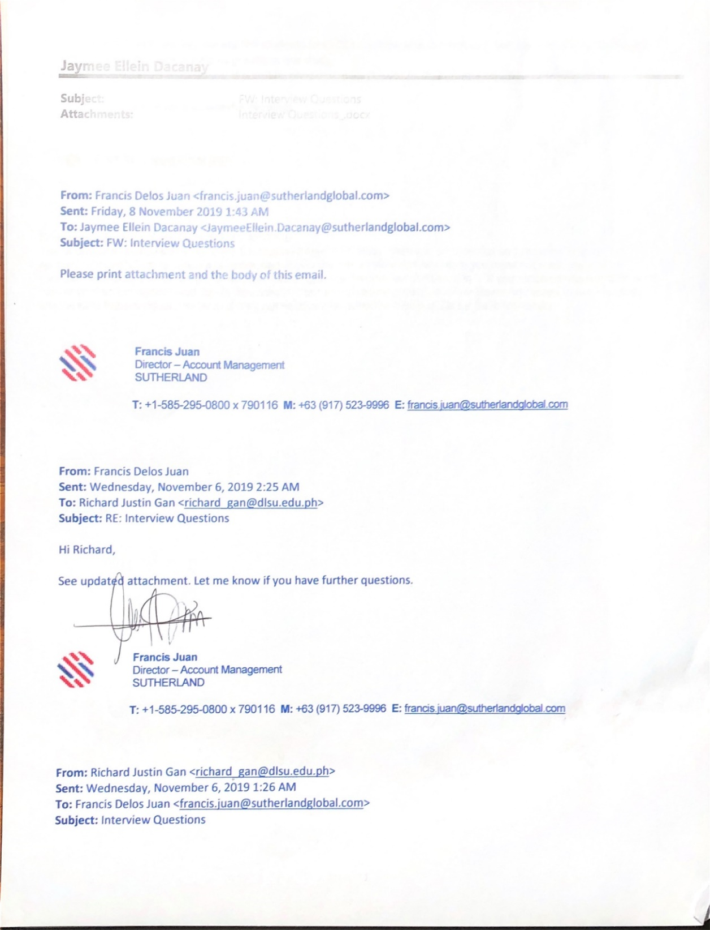



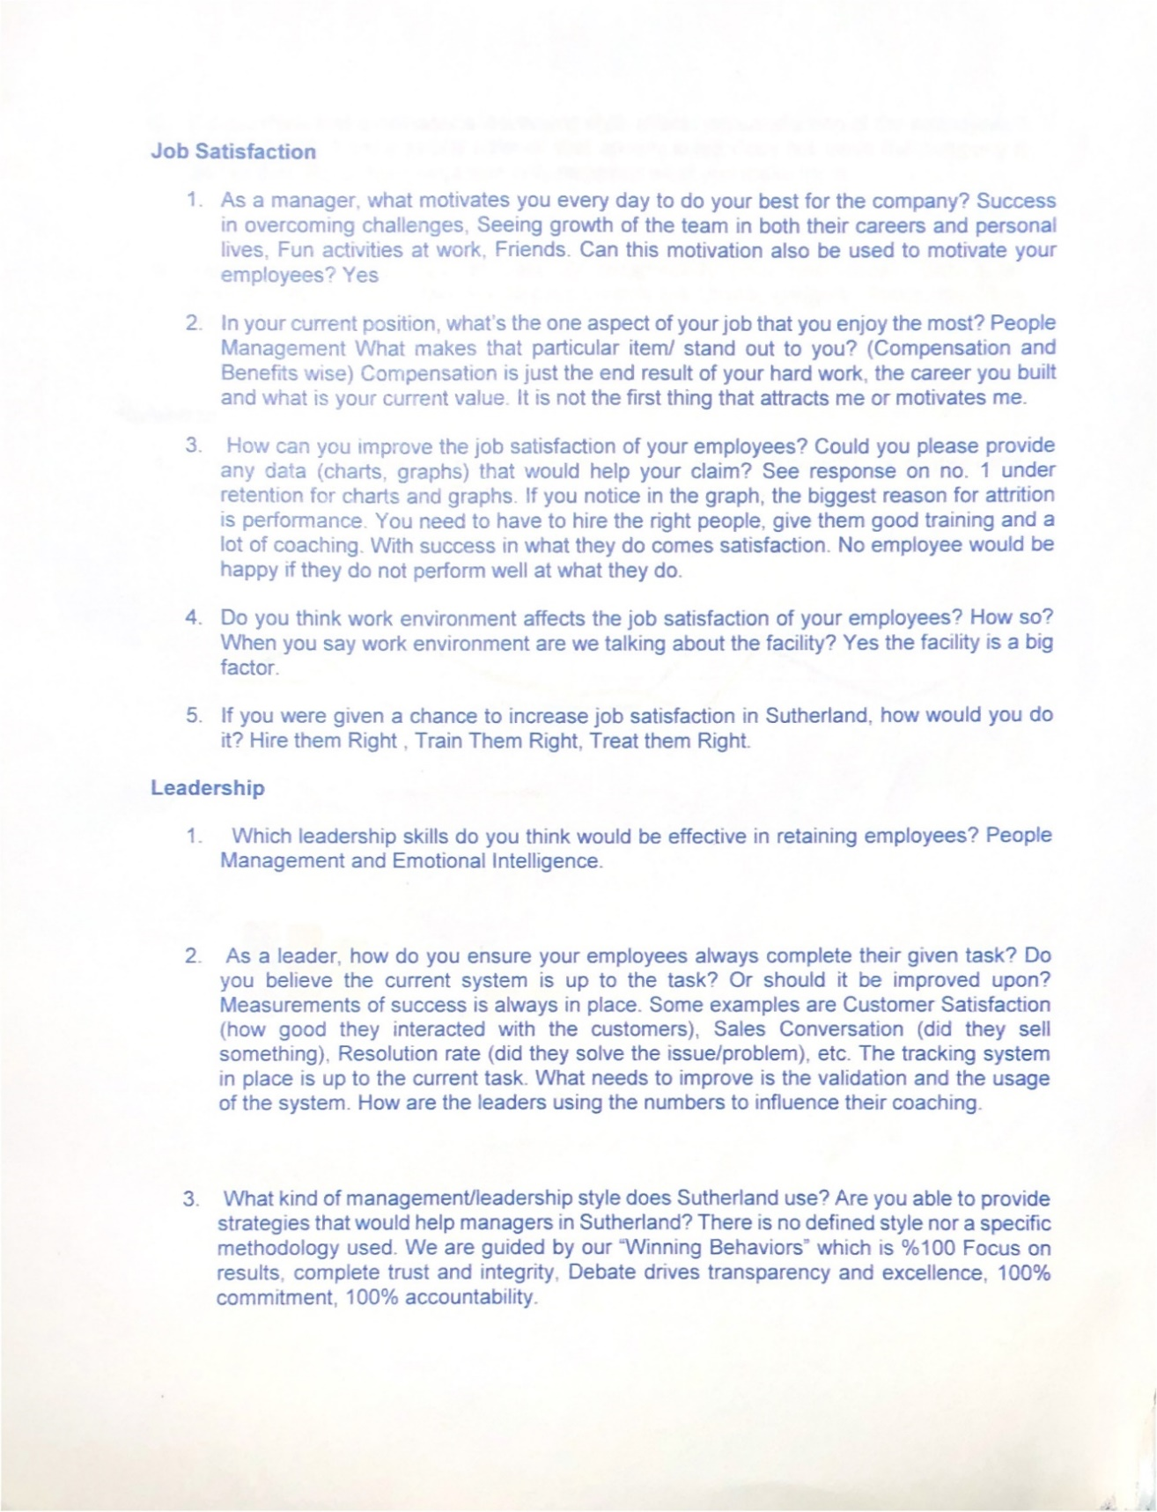

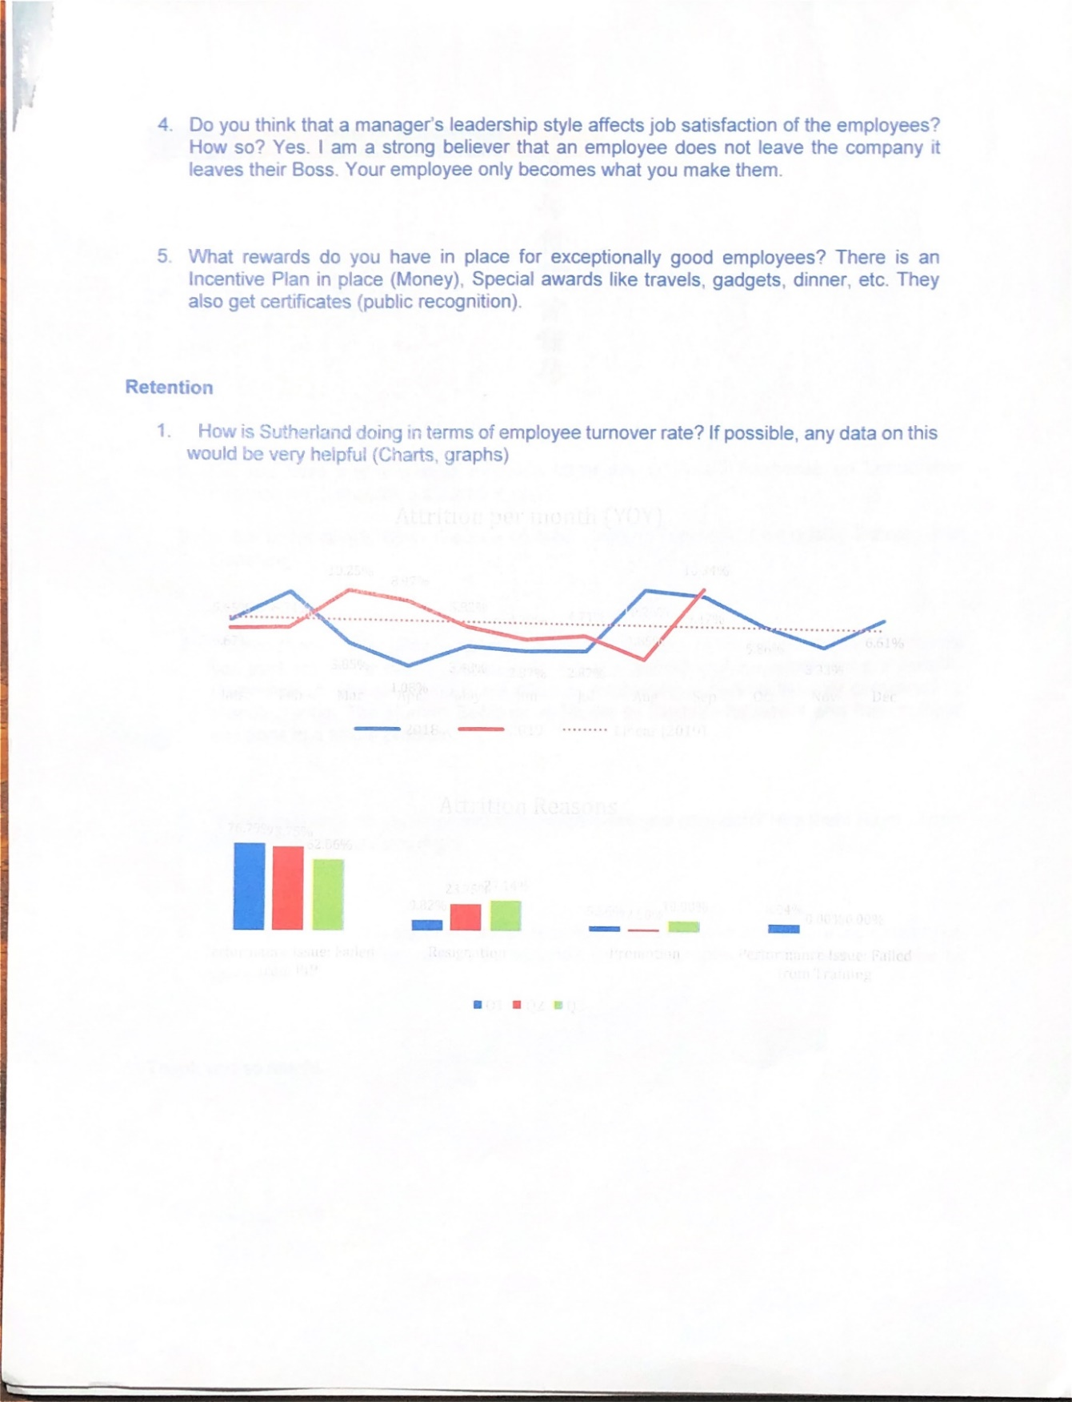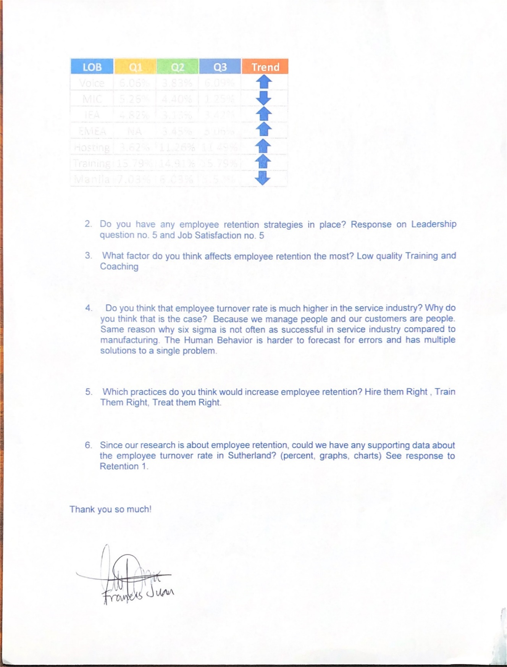

## APPENDIX C: Sample Questionnaire

*Sample Questionnaire*

*Greetings in St. La Salle!*

*We are students from De La Salle University - Manila currently taking up our first Thesis subject for the completion of our Bachelor of Science degree in Interdisciplinary Business Studies and would like to ask for your kind cooperation in completing this questionnaire regarding the Job Satisfaction, Leadership Styles, and Employee Performance in your workplace, Sutherland Global Services, Inc. Rest assured that all of the information in this questionnaire will be strictly confidential.*

*Truly yours,*

*Richard Gan*

*Miguel Dacanay*

**Name: __________________________**

|  |  |  |  |  |  |
| --- | --- | --- | --- | --- | --- |
| Department |  | | | | |
| Gender | Male | | Female | | |
| Job Tenure | Below 1 year | 1-3 years | | 4-6 years | 7 years & above. |

## APPENDIX D: Google Form - Survey Questionnaire

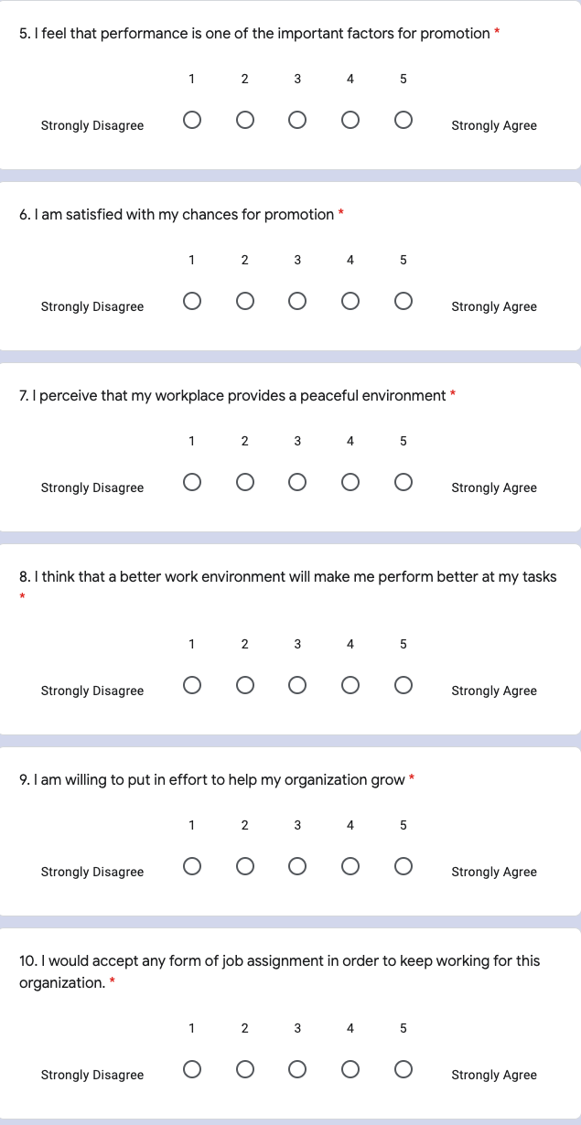

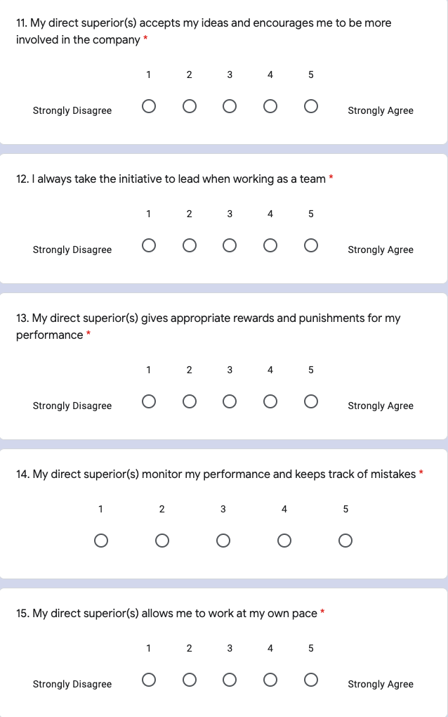

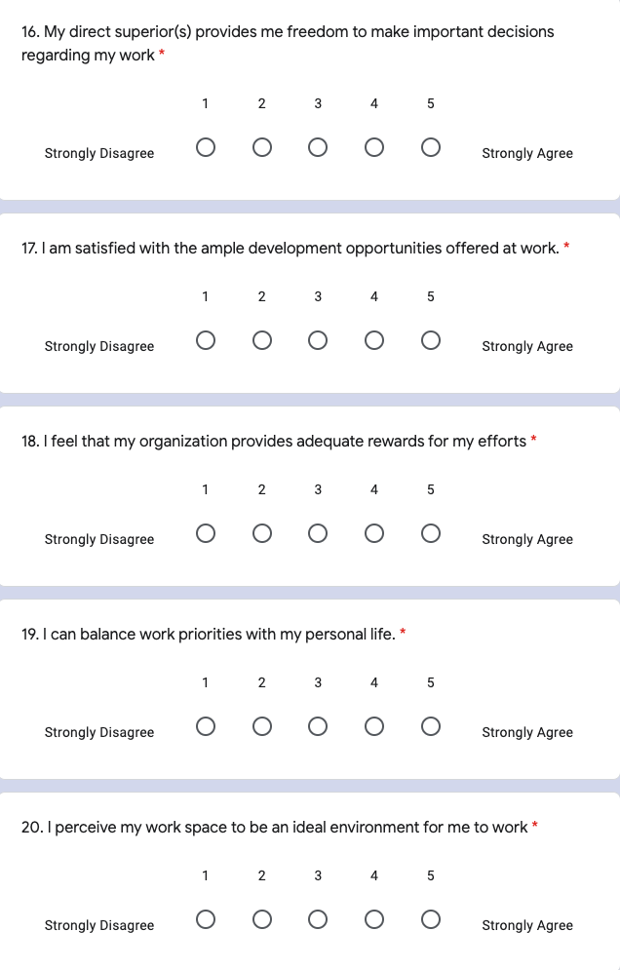

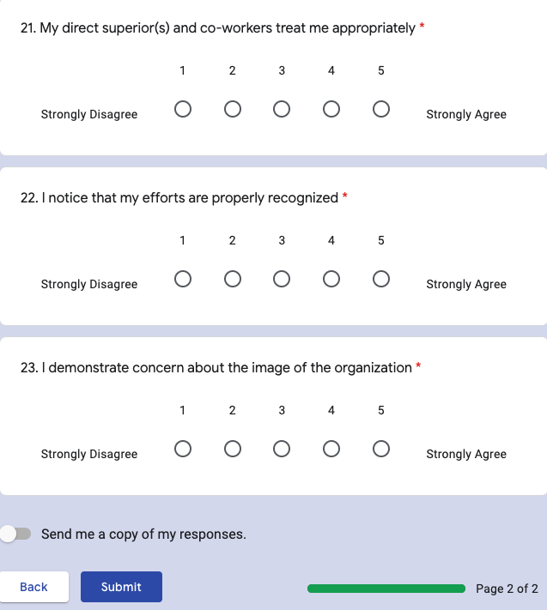

## APPENDIX E: Cronbach Alpha Test

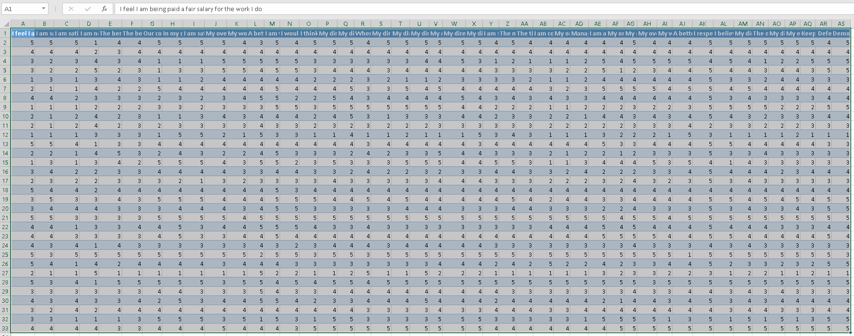



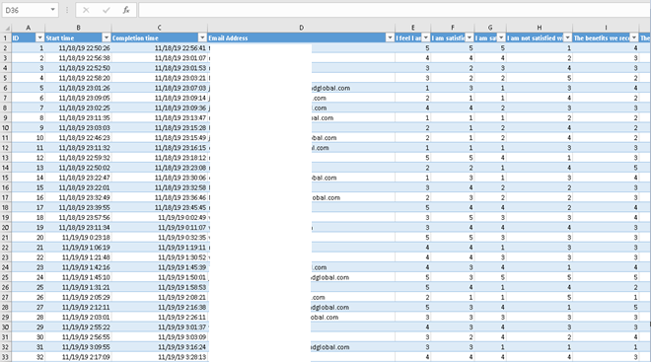

## APPENDIX F: Regression Analysis

## APPENDIX G: Pearson’s Correlation Analysis

## APPENDIX F: REO Forms



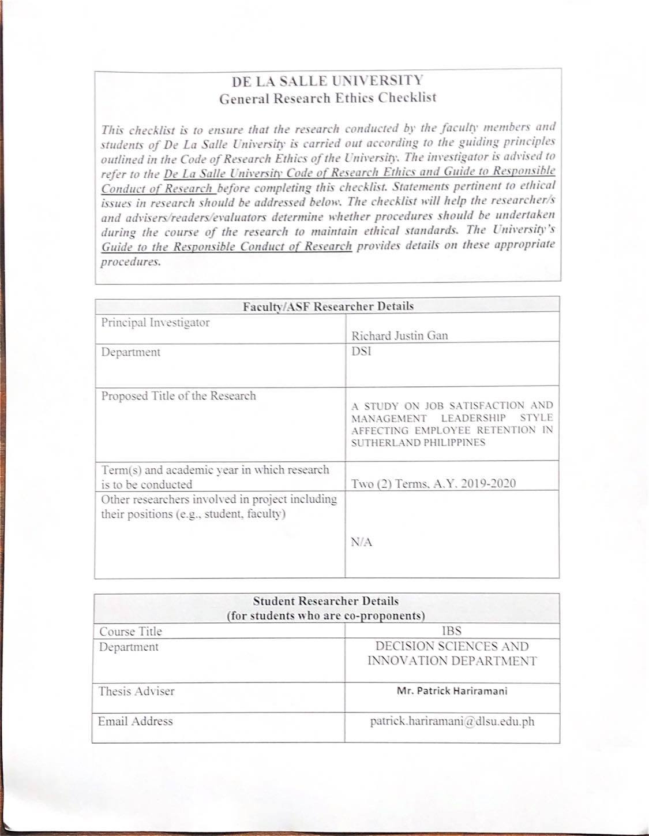 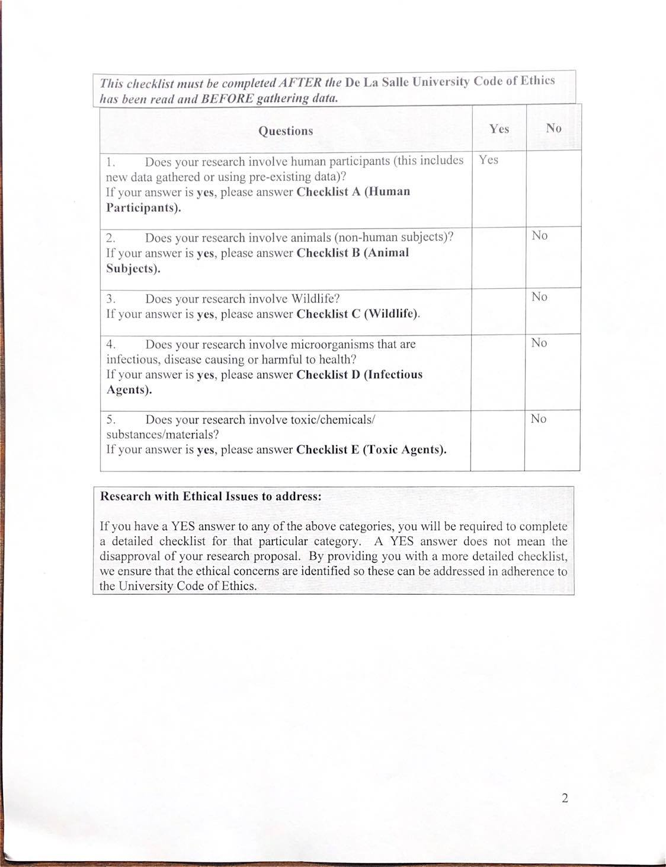







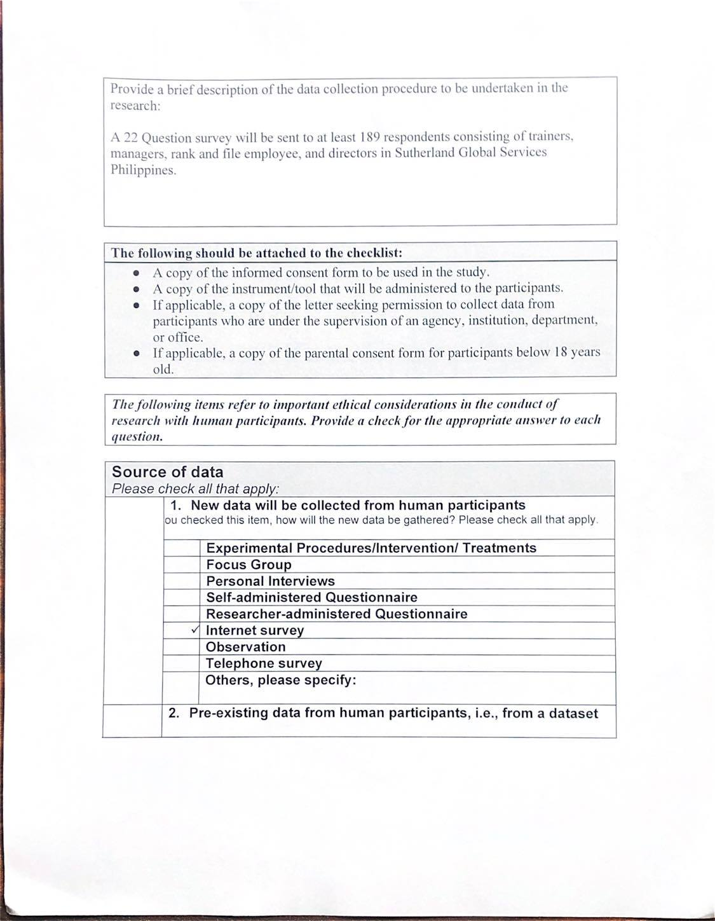

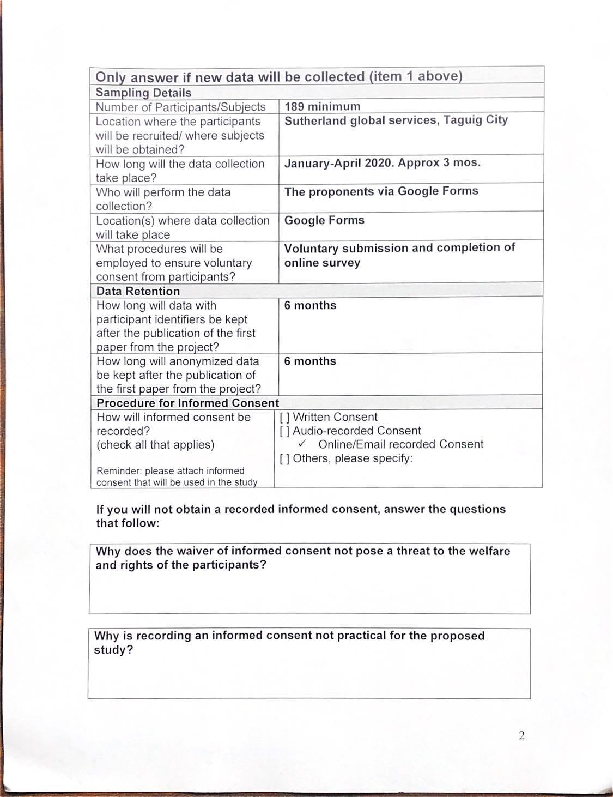

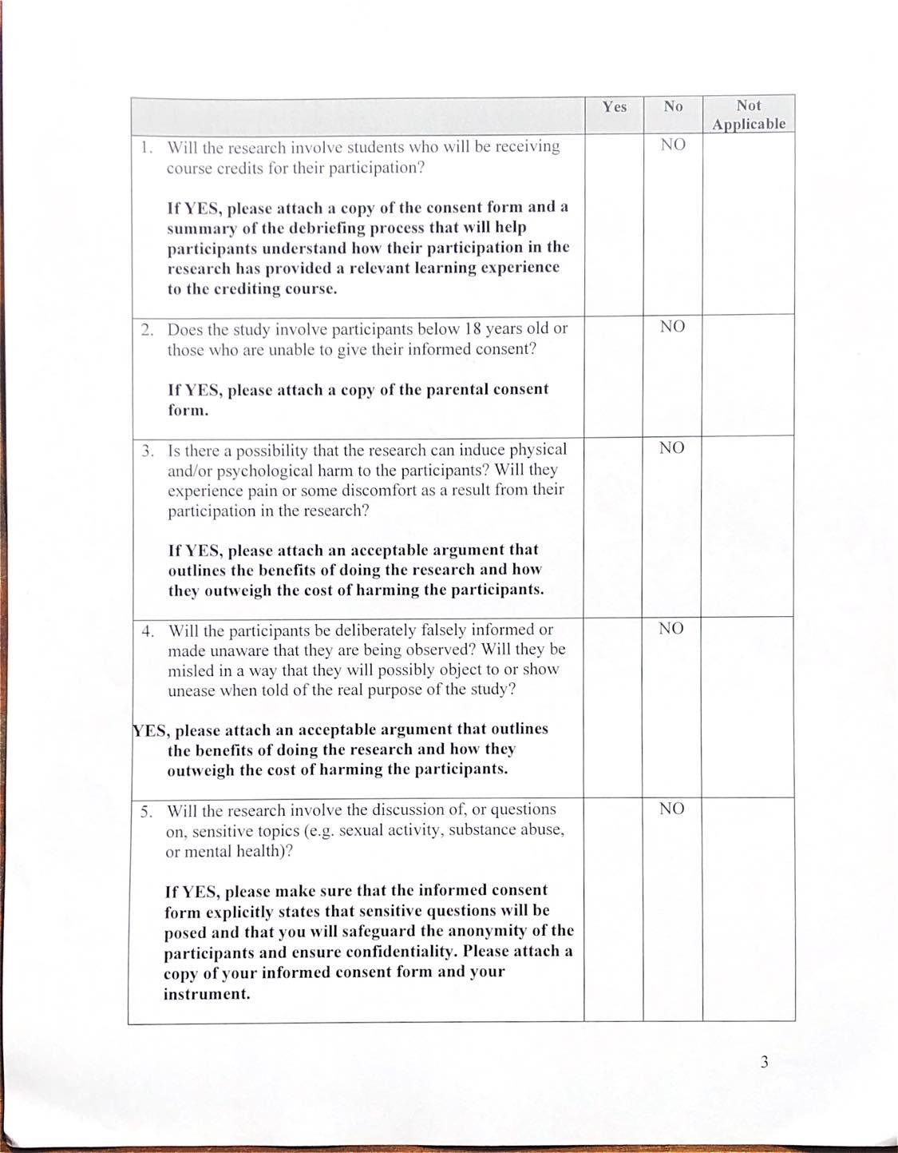

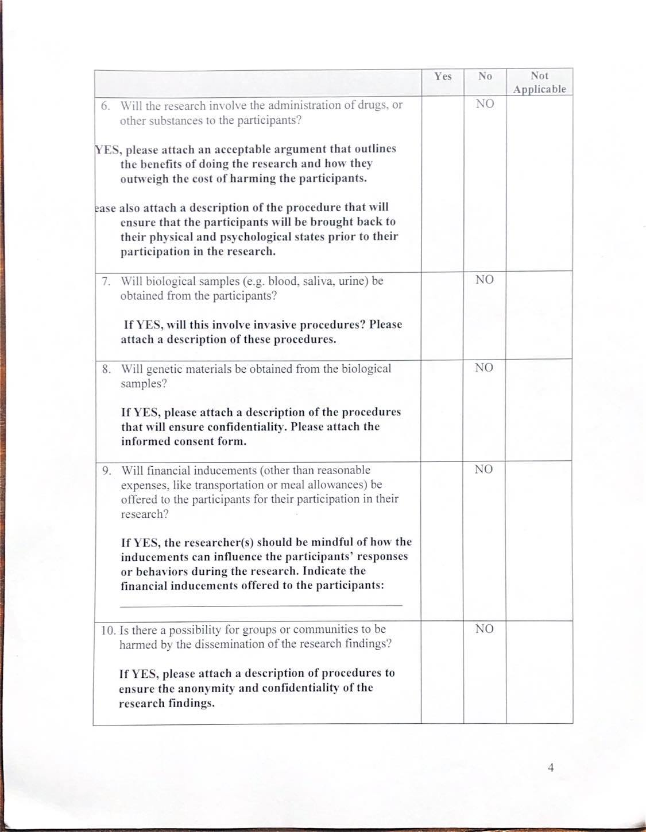

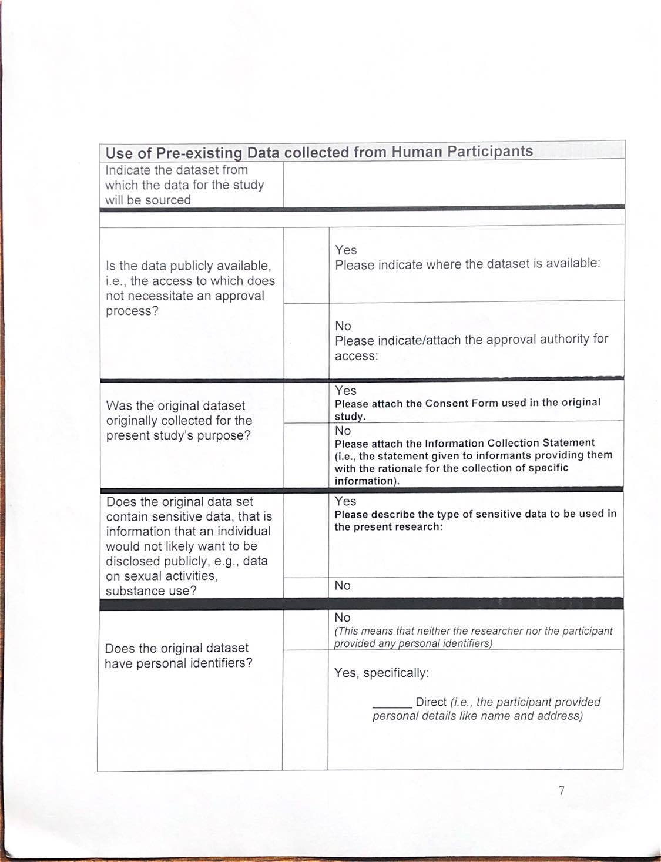



## APPENDIX H: Letter of Removal

